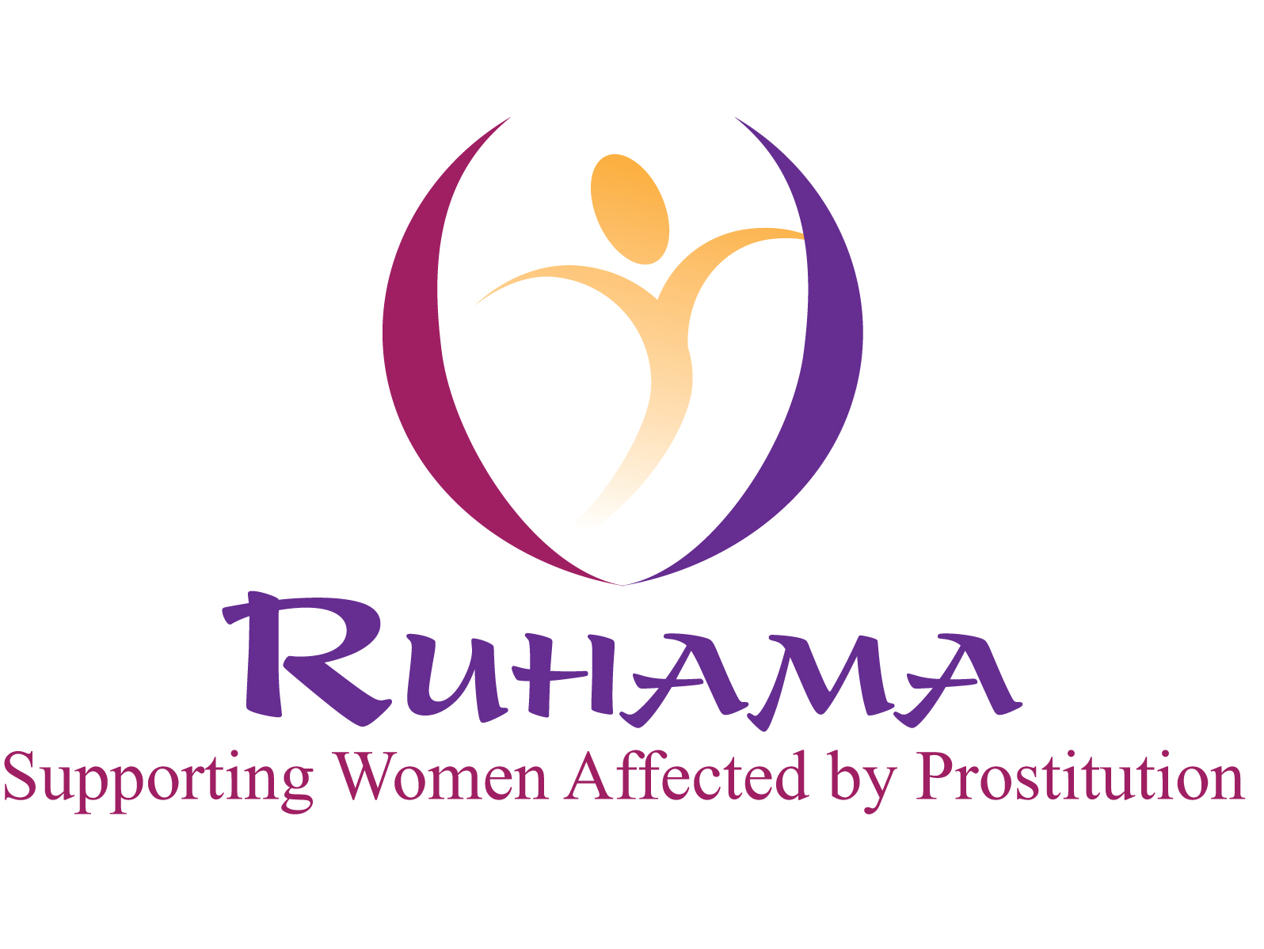

Ruhama is a voluntary agency, with over twenty years experience working directly to support women affected by prostitution, including victims of trafficking for the purpose of sexual exploitation, and lobbying and awareness raising on the issue of prostitution

Ruhama is now recruiting to fill the following position:

Outreach Caseworker (OUT/WKR)

The primary role of the Outreach Caseworker will be to engage in direct service provision with Ruhama’s target client group.

The post is based on 30 working hours per week based on a Rota system and will be contracted for one year.

Experience/skills:

- At least a primary degree in Social Science or related field or equivalent experience.
  - Minimum 3 years of working in service provision directly with women
  - A high level of knowledge and understanding of gender based violence
  - Experience of case management/person-centered care planning

A full job description and application form are available, please phone 01 8660292 or e-mail admin@ruhama.ie or download from www.ruhama.ie

Closing date for applications: first post on Monday 11th July 2011 – All applications marked clearly with reference OUT/WKR (1 hard copy required/3 hard copies of the application preferred) to: Roisin Kelly, Ruhama, Senior House, All Hallows College, Drumcondra, Dublin 9. Tel: 01 8360292.

Interviews will be held on Friday July 22nd 2011.

CVs will not be accepted

Ruhama is an equal opportunities employer

