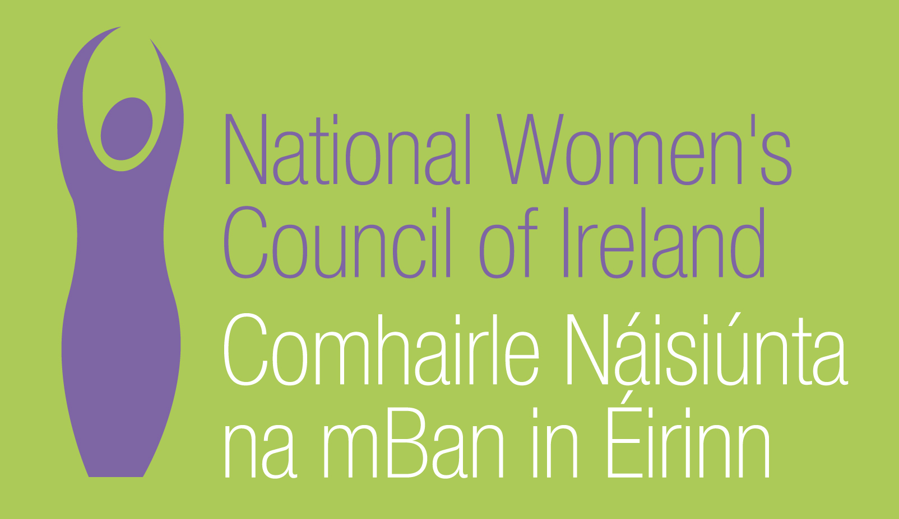

Application Form for the Post of

Women’s Health and Human Rights Worker

Please note that selection will be based on the information in the application form alone and CVs will not be considered.
PERSONAL DETAILS

NAME:
ADDRESS:

___________________________________________
TELEPHONE:
EMAIL: _________________

RELEVANT EDUCATION AND TRAINING HISTORY

PRESENT (or if unemployed most recent) EMPLOYMENT

Name and Address
of employer

Post held:

Duties of Post:

Date Appointed:___________Present salary:___________Period of notice:________

PREVIOUS WORK EXPERIENCE

Please list, starting with the latest, any previous positions you have held, with a brief description of duties and dates.

Employer:

Post held:

Period of Employment:

Reason for leaving:

Salary on leaving:

Employer:

Post held:

Period of Employment:

Reason for leaving:

Salary on leaving:

Employer:

Post held:

Period of Employment:

Reason for leaving:

Salary on leaving:

RELEVANT COMPETENCIES FOR THE POST
The job description shows qualifications, experience and skills required or desirable to be able to carry out the responsibilities of this post. Please therefore address all these elements as listed in table below, drawing upon all of your experience, whether in paid employment or in a voluntary capacity. Please add additional space as necessary

PROFESSIONAL KNOWLEDGE AND EXPERIENCE

A relevant third level degree or equivalent third level qualification
A good understanding of and commitment to working on women’s equality issues
At least 3 years experience of working in women’s rights or human rights organisations, community development projects or in related disciplines.

Social policy and political analysis with a particular emphasis on gender equality, poverty and social inclusion

Women’s health, in particular reproductive health and issues relating to violence against women

Human rights, in particular women’s human rights, in a national, European and global context

SKILLS
Communication, writing and presentation

Working with people from diverse backgrounds

Working with the media, including using new media

Social analysis, policy analysis and development
Group work, facilitation and committee skills

Project planning, monitoring and evaluation
Working imaginatively on own initiative and as part of a team

PLEASE INCLUDE HERE ANY FURTHER INFORMATION YOU WISH TO PROVIDE TO SUPPORT YOUR APPLICATION (NOT MORE THAN 500 WORDS)

Where did you hear about this vacancy?

Times Newspaper ⁪

Activelink/Community Exchange ⁪

Other, please specify _________________________________________________

REFEREES
Please give the names, addresses and phone numbers of two referees (one should be a current or most recent employer):

DECLARATION I declare that the information set forth in this application form is, to the best of my knowledge, true and complete.

Signature:

Date:

Please send your completed and signed application form in hard copy marked ‘Private & Confidential’ to:

The CEO, National Women’s Council of Ireland, 9 Marlborough Court, Marlborough Street, Dublin 1
The closing date for completed and signed application forms is Friday 20th May at 4p.m.
Interviews will take place during the week 7th to 10th June.

