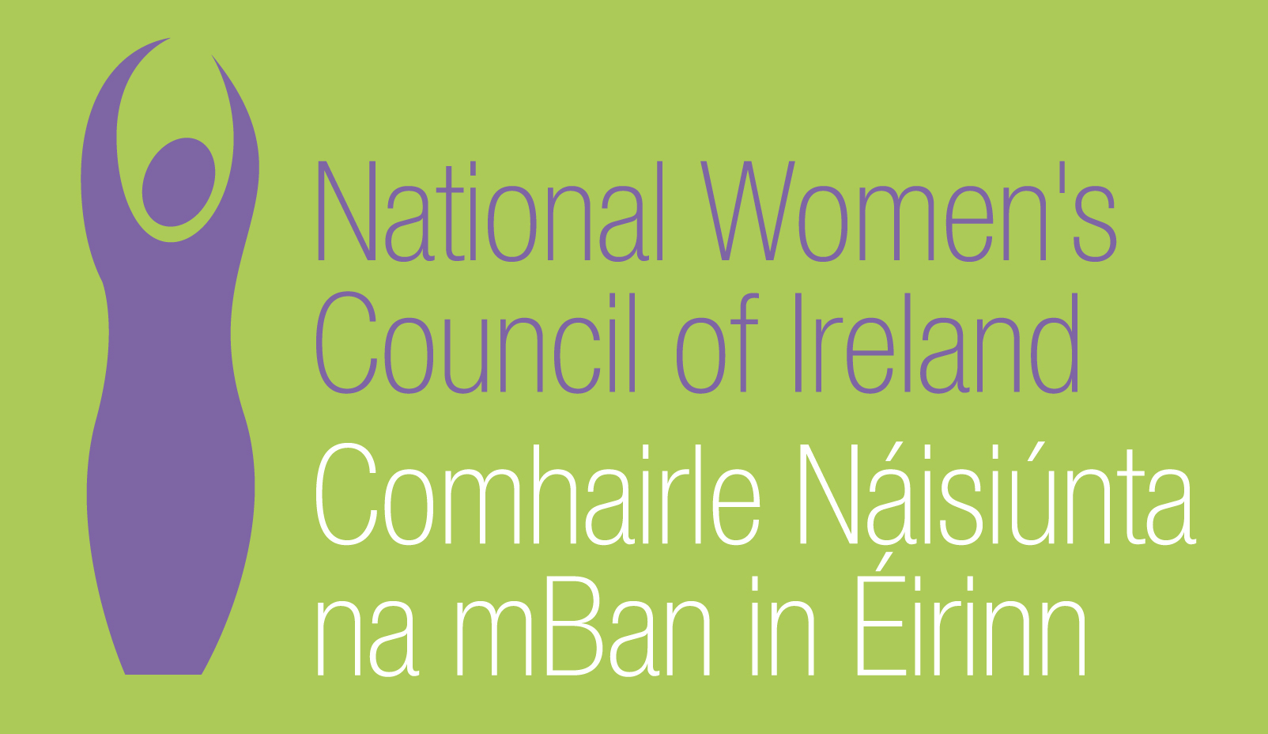

Application Form for the Post of
‘Where Are the Women?’ –Project Co-ordinator

Please note that selection will be based on the information in the application form alone and CVs will not be considered.
PERSONAL DETAILS

NAME:
ADDRESS:

___________________________________________
TELEPHONE:
EMAIL: _________________

RELEVANT EDUCATION AND TRAINING HISTORY

PRESENT (or if unemployed must recent) EMPLOYMENT

Name and Address
of employer

Post held:

Duties of Post:

Date Appointed:___________Present salary:___________Period of notice:________

PREVIOUS WORK EXPERIENCE

Please list, starting with the latest, any previous positions you have held, with a brief description of duties and dates.

Employer:

Post held:

Period of Employment:

Reason for leaving:

Salary on leaving:

Employer:

Post held:

Period of Employment:

Reason for leaving:

Salary on leaving:

Employer:

Post held:

Period of Employment:

Reason for leaving:

Salary on leaving:

RELEVANT COMPETENCIES FOR THE POST

The job description shows qualifications, experience and skills required or desirable to be able to carry out the responsibilities of this post. Please therefore address all these elements as listed in table below, drawing upon all of your experience, whether in paid employment or in a voluntary capacity. Please add additional space as necessary.

PROFESSIONAL KNOWLEDGE AND EXPERIENCE

A relevant third level degree or related qualification
At least 3 years experience of working in the field of women’s rights, within the non governmental, community development, human rights sector or other relevant fields
A proven commitment to bringing about women’s equality

Proven ability as a campaigner.

Social policy, with a particular emphasis on gender equality, poverty and social inclusion

Political analysis – with a particular emphasis on women in political systems

Public administration – including political, social, legal and economic systems
Women’s rights in a national and global context

SKILLS
Campaigning/advocacy skills

Communications, writing and presentation skills
Use of media, including new media

Working effectively with a diverse range of people including volunteers
A skilled negotiator

Social analysis, policy analysis and development
Group work, facilitation and committee skills

Project planning, monitoring and evaluation

Leadership, working imaginatively on own initiative and as part of a team

PLEASE INCLUDE HERE ANY FURTHER INFORMATION YOU WISH TO PROVIDE TO SUPPORT YOUR APPLICATION (NOT MORE THAN 500 WORDS)

Where did you hear about this vacancy?

Times Newspaper ⁪

Activelink/Community Exchange ⁪

Other, please specify _________________________________________________

REFEREES
Please give the names, addresses and phone numbers of two referees (one should be a current or most recent employer):

DECLARATION I declare that the information set forth in this application form is, to the best of my knowledge, true and complete.

Signature:

Date:

Please send your completed and signed application form in hard copy marked ‘Private & Confidential’ to:

The CEO, National Women’s Council of Ireland, 9 Marlborough Court, Marlborough Street, Dublin 1
The closing date for completed and signed application forms is Friday 20th May at 4p.m.
Interviews will take place during the week 7th to 10th June.

