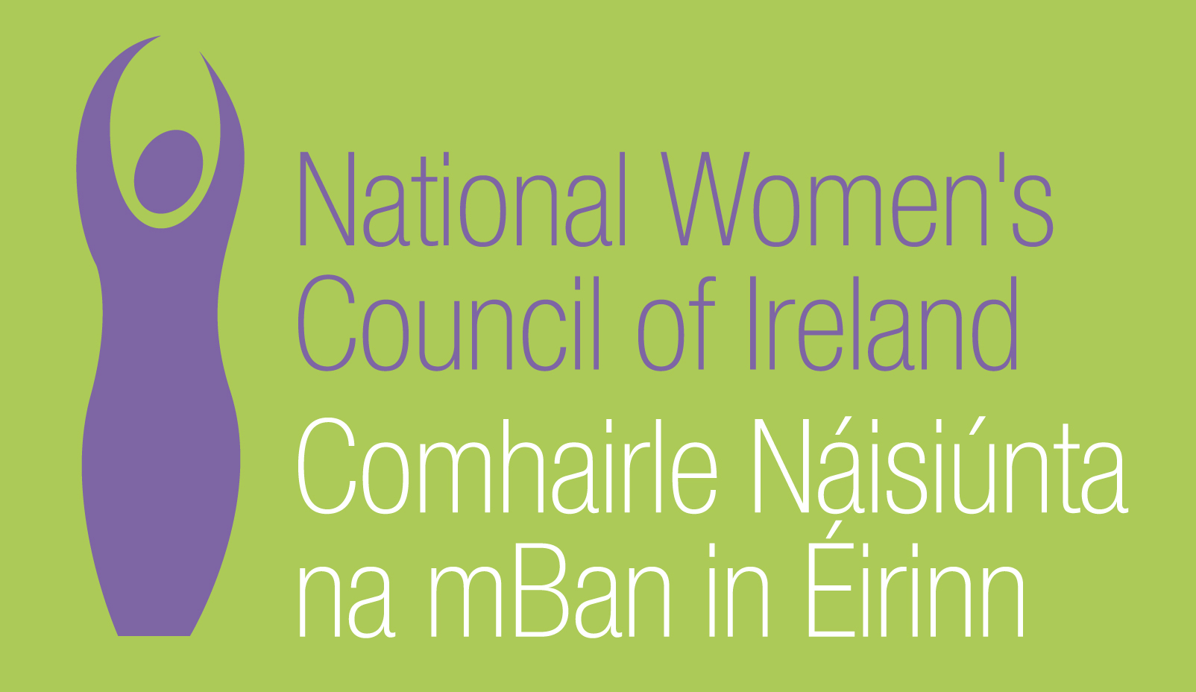

Application Form for the Post of

Senior Administration and Information Officer

Please note that selection will be based on the information in the application form alone and CVs will not be considered.
PERSONAL DETAILS

NAME:
ADDRESS:

___________________________________________
TELEPHONE:
EMAIL: _________________

RELEVANT EDUCATION AND TRAINING HISTORY

PRESENT (or if unemployed must recent) EMPLOYMENT

Name and Address
of employer

Post held:

Duties of Post:

Date Appointed:___________Present salary:___________Period of notice:________

PREVIOUS WORK EXPERIENCE

Please list, starting with the latest, any previous positions you have held, with a brief description of duties and dates.

Employer:

Post held:

Period of Employment:

Reason for leaving:

Salary on leaving:

Employer:

Post held:

Period of Employment:

Reason for leaving:

Salary on leaving:

Employer:

Post held:

Period of Employment:

Reason for leaving:

Salary on leaving:

RELEVANT COMPETENCIES FOR THE POST

The person specification shows qualifications, experience, core competencies, and attributes required to be able to carry out the responsibilities of this post. Please therefore address all these elements as listed in table below, drawing upon all of your experience, whether at work or in a voluntary capacity. Please add additional space as necessary.

PROFESSIONAL KNOWLEDGE AND EXPERIENCE

A minimum of 3 years in a key administrative role

Experience of interacting with the public and the provision of information

IT proficient and experience of all Microsoft Packages and databases.

Experience of working with new media.

Experience of or understanding of the non-profit sector and the women’s movement.

CORE COMPETENCIES
Excellent written, oral and online communication skills

Excellent skills in working with new media

Proven ability to work with diverse groups

Ability to deliver against set targets and to prioritise tasks effectively

Proven commitment to women’s equality and ability to work in a feminist way.

Ability to work as part of a team

ATTRIBUTES
Strong communicator

Taking Initiative

Flexible

Strong business acumen

Self-motivated

Well organised

Diplomatic

REFEREES
Please give the names, addresses and phone numbers of two referees (one should be a current or most recent employer):

DECLARATION I declare that the information set forth in this application form is, to the best of my knowledge, true and complete.

Signature:

Date:

Please send your completed and signed application form marked ‘Private & Confidential’ to:

The Director, National Women’s Council of Ireland, 9 Marlborough Court, Marlborough Street, Dublin 1
The closing date for completed and signed application forms is Thursday 25th February at 5p.m.
Interviews will take place on Thursday 4th March.

