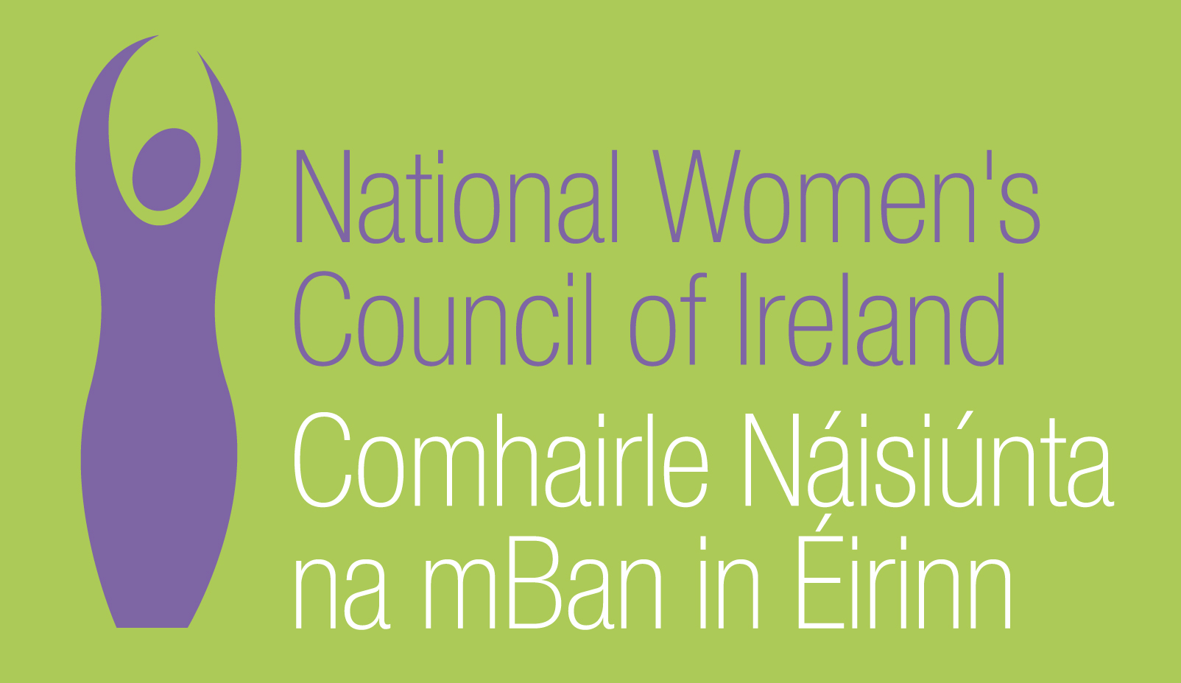

Application Form for the Post of

The “Y” Factor Project Co-ordinator

Please note that selection will be based on the information in the application form alone and CVs will not be considered.
PERSONAL DETAILS

NAME:
ADDRESS:

___________________________________________
TELEPHONE:
EMAIL: _________________

RELEVANT EDUCATION AND TRAINING HISTORY

PRESENT (or if unemployed most recent) EMPLOYMENT

Name and Address
of employer

Post held:

Duties of Post:

Date Appointed:___________Present salary:___________Period of notice:________

PREVIOUS WORK EXPERIENCE

Please list, starting with the latest, any previous positions you have held, with a brief description of duties and dates.

Employer:

Post held:

Period of Employment:

Reason for leaving:

Salary on leaving:

Employer:

Post held:

Period of Employment:

Reason for leaving:

Salary on leaving:

Employer:

Post held:

Period of Employment:

Reason for leaving:

Salary on leaving:

RELEVANT COMPETENCIES FOR THE POST

The job description shows qualifications, experience and skills required or desirable to be able to carry out the responsibilities of this post. Please therefore address all these elements as listed in table below, drawing upon all of your experience, whether in paid employment or in a voluntary capacity. Please add additional space as necessary.

PROFESSIONAL KNOWLEDGE AND EXPERIENCE

A third level degree or equivalent qualification in a relevant discipline
A good understanding of and commitment to working on women’s equality and youth issues.
Experience of working in a youth organisation or in the community development/non governmental sector or related fields
Social policy and political analysis with a particular emphasis on gender equality and youth affairs.

Knowledge of Public administration – including political, social, legal and economic systems

SKILLS
Good communication, writing and presentation skills

Ability to deal with the media, including using new media

Project planning, monitoring and evaluation

Proven ability to work effectively with people from diverse backgrounds

Youth work, facilitation and committee skills
Staff Supervision
Working imaginatively on own initiative and as part of a team

PLEASE INCLUDE HERE ANY FURTHER INFORMATION YOU WISH TO PROVIDE TO SUPPORT YOUR APPLICATION (NOT MORE THAN 500 WORDS)

Where did you hear about this vacancy?

Times Newspaper ⁪

Activelink/Community Exchange ⁪

Other, please specify _________________________________________________

REFEREES
Please give the names, addresses and phone numbers of two referees (one should be a current or most recent employer):

DECLARATION I declare that the information set forth in this application form is, to the best of my knowledge, true and complete.

Signature:

Date:

Please send your completed and signed application form in hard copy marked ‘Private & Confidential’ to:

The Manager, National Women’s Council of Ireland, 9 Marlborough Court, Marlborough Street, Dublin 1
The closing date for completed and signed application forms is 5pm on 8th December.
Interviews will take place 15th/16th December

