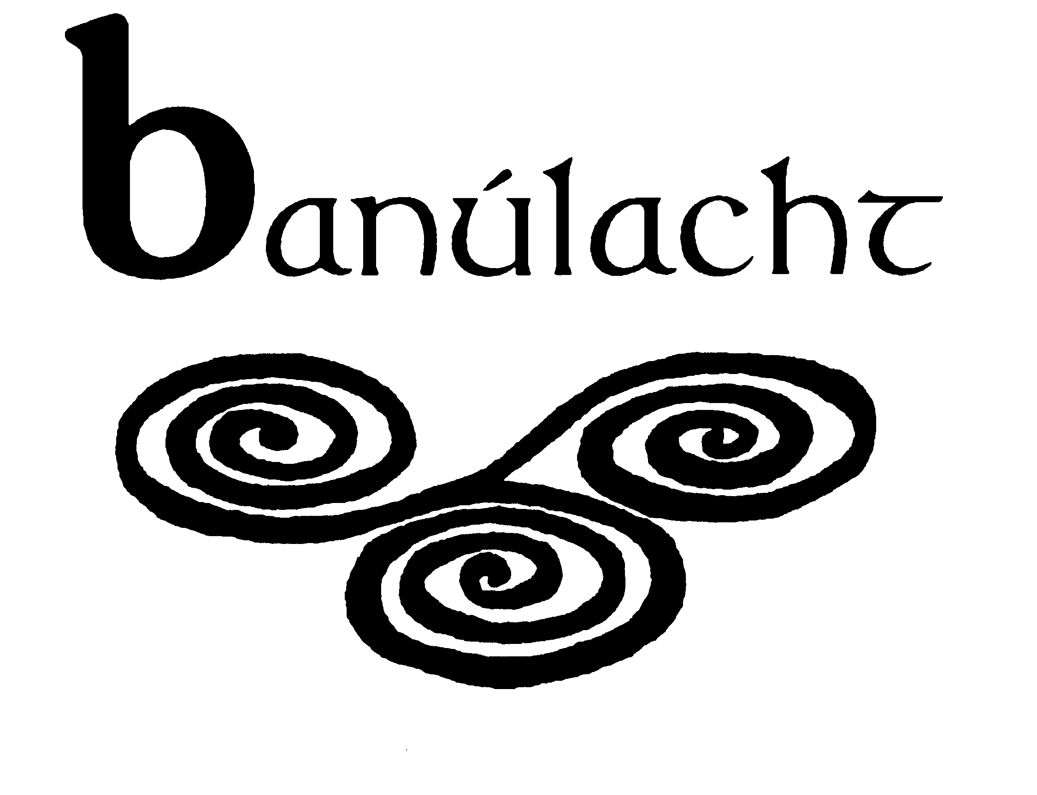

APPLICATION FORM FOR THE POST OF PROJECT WORKER

CONTACT DETAILS

Name:
Address:
Telephone:
Email:

EDUCATION AND TRAINING HISTORY

Please outline, starting with the most recent, your third level educational qualifications and any other relevant training courses you have completed. Please include the institution and the dates in each case.

EMPLOYMENT HISTORY

Name and address
of present employer
(or last employer)

Post held:

Main duties and responsibilities:

Date appointed:

Present salary:

Period of notice:

If last employer, reason for leaving:

PREVIOUS WORK EXPERIENCE

Please outline, starting with the most recent, any previous positions you have held as follows:

Employer:

Post held:

Period of employment:

Main duties and responsibilities:

Reason for leaving:

EXPERIENCE OF WORKING DIRECTLY WITH WOMEN

Please indicate, starting with the most recent, your paid / unpaid experience of working directly with women, specifying your roles/responsibilities in each case.

Nature of work and your role

Organisation:

Period of work:

EXPERIENCE OF FACILITATING AND DELIVERING TRAINING

Please indicate, starting from the most recent, your paid / unpaid experience of delivering training courses, specifying your roles/responsibilities in each case.

Name of course:

Brief description of course:

Your role:

Period of course:
WORKING WITH BANÚLACHT

Please state why you are interested in employment with Banúlacht in particular as an organisation.

RELEVANT EXPERIENCE TO THIS POST

The person specification shows knowledge, skills, experience and attributes required in order to carry out the responsibilities of this post. Please therefore address all these elements as listed in the table below, drawing upon all of your experience, whether from paid or unpaid work. Please use additional space as necessary.

PROFESSIONAL KNOWLEDGE AND EXPERIENCE

Third level degree/educational qualifications

Knowledge of women’s human rights approaches, issues and analysis at local and global levels

Experience of working on women’s human rights issues in community development and/or development organisations or related fields

Knowledge of development education

Experience of working with women from diverse backgrounds

SKILLS
Excellent written, IT and communication skills

Representation experience

Good social research skills

Skills in social analysis and/or policy analysis and development

Campaigning and lobbying skills

Website development skills

Funding proposal and report writing skills

Working on own initiative and as part of a team

Organising and managing events such as seminars and conferences

Please include here any further information you wish to provide to support your application (not more than 500 words)

Where did you hear about this vacancy?

REFEREES
Please give the names, addresses and phone numbers of two referees (one should be a current or most recent employer):

DECLARATION I declare that the information set forth in this application form is, to the best of my knowledge, true and complete.

I am available on Monday 13th of June should I be called for interview.

Signature:

Date:

How to apply
Completed application form to be sent to Banúlacht’s office or emailed to info@banulacht.ie. Closing date for applications is 5.00 p.m. on Thursday 2nd June. Interviews will be held on Monday 13th June: applications from candidates who are not available on this date cannot be considered.
NB. Start date is Monday 5th September.

Banúlacht is funded by Irish Aid and Trócaire.

