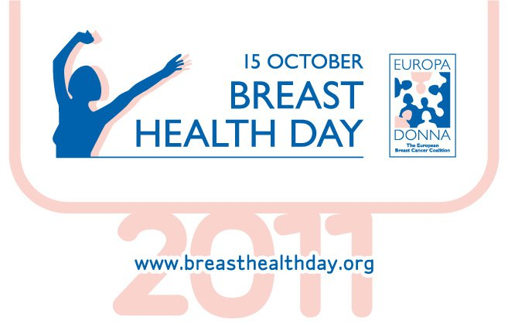
Europa Donna Ireland – the Irish Breast Cancer Campaign
This year’s theme for our Breast Health Day campaign is “lifestyle choices that can influence your future breast health and help prevent breast cancer.”

Make Healthy Choices!

Join us on Breast Health Day Saturday 15th October
Organize your local event!
Again we are encouraging groups around the country to get involved by organizing an event locally on Breast Health Day 15th October. This could be a walk, jog, swim, belly-dancing or any other physical activity! We will supply posters, leaflets and other materials for your event!
NO FUND-RAISING is involved! –as this is an awareness-raising event.
In Dublin, in the lead up to BHD, Sine Vasquez, A/Clinical Specialist Physiotherapist, Beaumont Hospital will give two presentations concerning Lymphoedema/Exercise at Buswell’s Hotel, Molesworth Street, Dublin 2 on the following dates:
Lymphoedema Awareness - Tues 4th Oct. 7pm
Exercise, during and after Breast Cancer -Tues 11th Oct. 7pm
Join us on The Anna Livia Mile on Breast Health Day, Saturday 15th October in central Dublin at 11am. The walk starts on the riverside at The O2, North Wall Quay and ends at the Grand Canal Dock, where the Plurabelle Paddlers, (www.plurabellepaddlers.com) Dragon Boat Team, will meet us at the home of the Dragon Boats and you will have a chance to try your paddling skills!
NO FUND-RAISING is involved! –as this is an awareness-raising event.
For more information about the Anna Livia Mile and other BHD events across Ireland visit www.europadonnaireland.ie.
To take part, please contact us at 087 6383609 or info@europadonnaireland.ie

