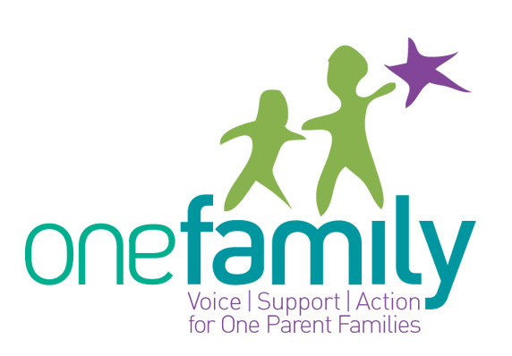

Job Description for Childcare Manager
February 2011

One Family Services
One Family Services aims to develop and provide a range of best practice programmes that support people parenting on their own or sharing parenting. The services include Welfare to Work accredited courses, Parenting supports, Childcare, Information and Counselling. The role of the Childcare Manager is to provide a legally compliant Childcare service to children of one parent families. Specific areas of responsibility include:

- To maintain the delivery of a professional Childcare Service in One Family
- To design, implement and evaluate individual and group programmes for children and their families
- To be responsible for children attending the service, including being vigilant for signs of physical, sexual and emotional abuse, neglect and social and developmental delay
- To keep regular records in relation to all aspects of work and prepare reports as required
- To work as part of a team within One Family and to work in an integrated way with other Agencies
- To manage students, volunteers and FAS Community Employment Scheme participants
- To ensure regular staff meetings, training and supervision and support of the childcare team
- To deliver and develop the One Family Social Group
- To input to the One Family Website on Parenting Matters
- To support the Services Team in meeting the needs of our clients
- To ensure that Funding requirements are met and to work closely with Office Manager in this area

other
- Commitment to the purpose of One Family and to work within the values, policies and procedures of the organisation and in the context of current legislation and regulations
- To participate in regular supervision with your line manager
- To actively participate in team and staff meetings and service reviews/ evaluations and to contribute to the development of policy and practice with your area of work and within One Family as a whole
- To report any area of concern to your line manager in a timely manner
- Have a flexible approach to the work in response to organisational change, development and review of best practice.
- To undertake other duties as may be requested by the line manager from time to time
- To undertake your work in a manner that is friendly, flexible and informal.

The Childcare Manager in One Family will be responsible to the One Family Director on a daily basis.

Person Specification for One Family Childcare Manager
Personal Attributes
- Commitment to the delivery of quality service to children and families
- Proven understanding of the needs of one parent families and an ability to support parents parenting alone
- Ability to liaise with families and carers in relation to the welfare of their children
- Ability to work as part of a team and liaise with colleagues and other agencies
Experience
- Minimum of 2 years experience of working in an early years setting and managing staff.
- Experience of working with children who face disadvantage is desirable.
- Experience of supporting parents to parent in difficult family situations.
Qualifications
- Recognised third level qualification in Early Childhood Care & Education

This is a temporary part time post (maternity cover) for 7 months (April-November 2011) subject to a probationary period. One Family offers excellent employment conditions.

A cover letter and CV addressing the required competencies should be forwarded to: Childcare & Parenting Manager, One Family, Cherish House, 2 Lower Pembroke Street, Dublin 2
or by email to: gkelly@onefamily.ie

Closing date for applications: Friday 25th March 2011
One Family is an equal opportunities employer

