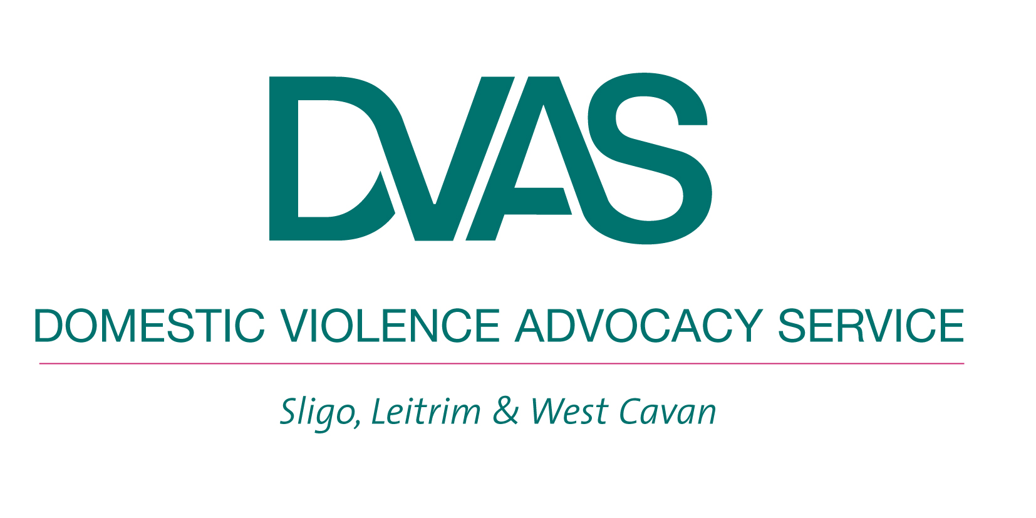
Did you know that many women and children living in Ireland and at risk of domestic violence have no recourse to state support?

DVAS work to ensure that ALL women and children at risk are supported to live lives free from violence and abuse but now, we need your help. Please come to our fundraiser on May 24th in Barry’s of Grange and donate towards the DVAS Salama Fund. Read on for further information

Q. What is The Salama Fund?
The Salama Fund has been created to ensure that migrant women with no recourse to public funds (NRTPF) who experience domestic violence can be offered immediate access to safety, including emergency accommodation.

Q. What does “no recourse to public funds” mean?
This means having no entitlement to any social welfare or community welfare payments or to Local Authority housing. This means that many migrant women experiencing domestic violence can never leave their abuser because they will be completely destitute. There are three main categories of migrant women, all of whom are lawfully resident in Ireland, who do not have recourse to public funds:
- Women who currently do not satisfy the Habitual Residency Condition, including some EU women and newly returned Irish immigrants who have lived outside of Ireland for a number of years
- Women who are living in Ireland on a Spousal Visa
- Women who are seeking protection or asylum from the Irish State
Q. Shouldn’t the state be protecting these women?
Yes, and DVAS are part of a national coalition of organisations lobbying the state to bring in measures to protect women with NRTPF by providing them with the means to access safety. We hope that this fund will be a temporary measure

Q. How can I help?
You can join with us in saying NO to Domestic Violence and YES to safety, security and peace for women and children by making a donation towards our Salama Fund

Join us at an evening of drama verse and song in Barry’s of Grange on Thursday May 24th at 8.00pm

Q. How will the fund be used?
Our guarantee to you is that every cent donated to The Salama Fund will be used directly to support migrant women and children who are at immediate risk from domestic violence. The fund will enable women to:
- access emergency accommodation
- receive emergency money for essentials (food, travel, clothing, nappies, phone credit etc.)
- pay for short-term childcare in order to attend support services
- access an emergency consultation with a solicitor
DVAS will cover the administrative costs of the fund, ensuring that 100% of The Salama Fund will go towards maximising the safety of women and children.

For more information contact Niamh or Lorna at 071-9141515, log onto www.domesticviolence.ie or Face Book DVAS at domesticviolence.ie

Thank you

Who we are
DVAS are a voluntary organisation set up in 2003 to provide support services to women at risk of violence and abuse. We are now an established organisation with two service bases in Sligo and Carrick-on-Shannon. We deliver a range of services to women in Sligo, Leitrim and West Cavan from these two centres and on an outreach basis.

