Equality Small Grants Fund 2012

Application Form
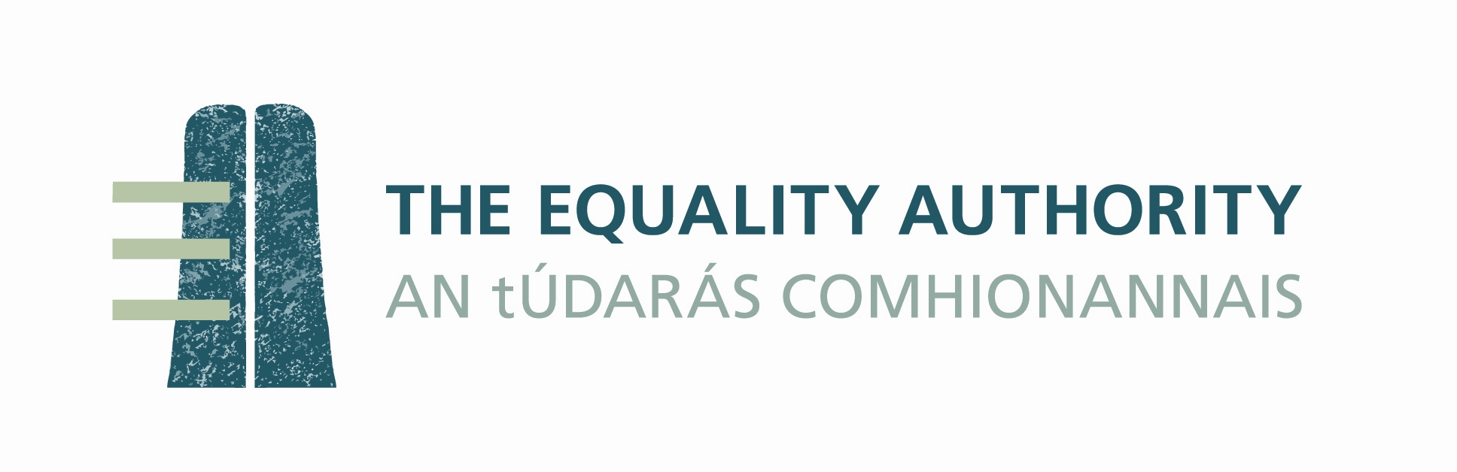

APPLICANT DETAILS

Name of applicant organisation

Postal address

Name of lead manager for this application

Telephone

Email

Partner Organisation (if any)

Name of partner organisation

Postal address

Name of lead manager for partner

Telephone

Email
[If there is more than one partner organisation, please copy and paste this box and
complete it for each partner]

Applications should be submitted by email to Caroline Jones at cnjones@equality.ie by 17:00 on Friday, 31st August 2012.

PROJECT SUMMARY

1 Brief description of the project
Please outline what you intend to do with the funding available. Please include your proposed timeline.

2 Key outputs from or main activities of the project
Please list, in bullet point form, the key output(s) or activities of your project (e.g. the design of a training course, the production of a research report, the delivery of an awards programme, expanding an existing service to accommodate a new group of users, holding a conference, conducting an awareness raising campaign, etc.).

•

•

•

•

3 Link to the nine grounds
Briefly explain the specific relevance of the project to one or more of the groups under the nine grounds named in the equality legislation

4 Impact of the project
Please explain what you anticipate to be the impact or lasting benefit of your project.

5 Equality track record

Please outline your organisation’s previous work on equality

6 Staff equality expertise

Please outline the equality expertise of staff involved in the project for which funding is sought

7 Budget

Please outline the proposed budget for your activity

Applications must be received by the Equality Authority

by 17:00 on Friday 31st August 2012

Marking scheme

Proposals will be assessed using the marking scheme shown below. The marking scheme also shows which questions in this proposal form will be used to make the primary (but not exclusive) assessment of the proposal under each of the criterion.

Criteria | Maximum mark available
Relevance to the equality agenda | 30
Likely impact of the project | 30
Feasibility of the project within the timeframe | 15
Capacity of the proposing organisation or partnership | 25
Total available | 100

