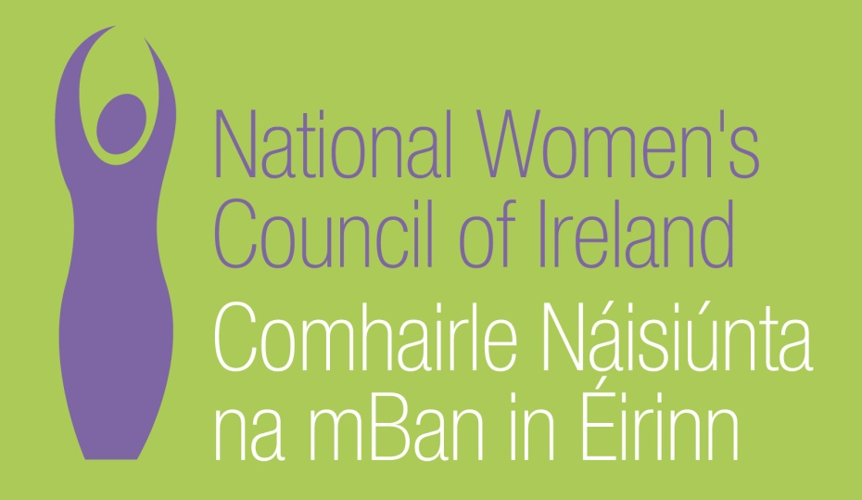

Pre-Budget 2012 Submission

September 2011

National Women's Council of Ireland
9 Marlborough Court
Marlborough Street
Dublin 1

Tel: 01 - 8787248
www.nwci.ie
Follow us on:

Our vision is of an Ireland where all women and men have equal power to shape society and their own lives. We work to promote equality and empower women.

Contents

Introduction ...................................................................4

The Impact of the Recession on Women.....................5

EU Context..................................................................... 8

Recommendations for Budget 2010...........................10

Protect All Our Children.......................................10

Protecting the Most Vulnerable Women............. 12

Women and Employment....................................17

Women with Disabilities...................................... 19

Migrant, Asylum and Integration......................... 22

Women and Health............................................. 25

Support Women’s Organisation.......................... 30

Supporting the voice of Women Nationally......... 31

Violence Against Women................................... 33

INTRODUCTION

The economic recession is effecting women in numerous ways. Greater numbers of women are unemployed and long term unemployed, many families are relying on the wages of women from low paid employment for survival, and it is women who are struggling to manage the constantly reducing household budget and debts to provide for their families.

Budget 2012 will be framed in the context of the crisis which faces the country in terms of the national budget deficit of €18 billion in 2012. The Government has committed itself to a budget adjustment of at least €3.6billion in its Memorandum of Understanding for financial support with the EU/ECB/IMF. As part of this adjustment the Government has committed itself to specific tax changes and to reductions in capital and programme expenditure including cuts to social expenditure. The impact of Budget 2012 should be assessed for its impact on women as it is vital the burden of this debt is not further pushed on the shoulders of women.

The past three Budgets have left women with significantly reduced incomes, through cuts to child benefit, cuts to earnings and indiscriminate increases in taxes. Simultaneously women are experiencing reduced support in their communities as locally based women’s organisations, frontline services and advocacy organisations have all curtailed their services and in many cases have been forced to close, due to cuts in their funding, at a time when these services are needed more than ever.

Impact of the Recession on Women

Unemployment : Women’s unemployment has increased by 10.1% in the last year in comparison to 6.8% for men. There are now 470,284 people on the Live Register. In July an additional 1,300 women and 300 men signed on. The number of women claimants rose by 3.7% (6,150) to 172,4514 over the year while the number of men fell by 0.9% (2,690) to 297,770.

Poverty : Women’s Poverty is growing. The CSO Survey of Income and Living Conditions shows that consistent poverty levels increased from 4.2% to 5.5% between 2008 and 2009 while the level of deprivation of two or more items increased by almost 25% in the same period. The increase was similar for women and men. The percentage of people in consistent poverty in 2009 was 5.5%, an increase of 1.3 percentage points on the 4.2% recorded in 2008. Almost 17% of people living in lone parent households were in consistent poverty in 2009, the highest rate recorded among household types.
(see Lone Parents below)

Employment: The EU target rate for women in employment is 60% by 2010, a target that was met by Ireland in 2007 and 2008, but not in 2009 or 2010, when the rate had fallen to 56.4%. In 2010 46% of those in employment were women. The employment rate for men in Ireland stood at about 75% over recent years, but in 2009 it plummeted to 67.3% and dropped again in 2010 to 64.5%. Men worked an average of 39.4 hours a week in 2010 compared with 30.9 for women.

Debt: Women are struggling in families to manage household debt and reduced income. Over 24% of households are in arrears with one or more of the following items: utility bills, rent or mortgage payments, hire purchase agreements or other loans/bills in 2009 which is a 14% increase since 2008. In 2009, almost 48% of households stated that they would be unable to meet an expense of €1,085 without borrowing.

Lone Parents: Lone parent households reported the highest levels of deprivation with almost 63% of individuals from these households experiencing one or more forms of deprivation compared with almost 29% at state level. Over 44% of individuals in lone parent households experienced two or more of the forms of deprivation. 98% of lone parents are women.

Older Women: Households where the head of household was aged 75 or over reported the lowest net disposable household income at €24,792, down from €26,388 (-6.0%) in 2008. The Older Women’s Network, (OWN), representing and lobbying on behalf of older women has had its core funding totally withdrawn, which will further make older women’s poverty and life experiences invisible to policy makers. OWN performs an important role in making the life experiences of older women visible to policy makers.

Women Headed Households: The biggest percentage decrease in average net disposable household income was recorded for households where the head of household was on home duties(primarily female carers and lone parents), down more than 11% between 2008 and 2009. This change was primarily driven by a decrease of over 30% in direct income for this type of household.

Women in Employment: Companies seeking cost saving measures are increasingly targeting supports for women, e.g. supports to statutory maternity payments. In 2010, the Equality Authority reported that gender was the most frequent ground for employment related queries to its Information Centre. Gender (along with disability) accounted for the largest share of case files under the Employment Equality Act, an increase from 2009. This will put continued pressure on women to leave the workforce, with serious personal and social consequences.

Locally based Women’s Projects: The Women’s projects, working from a community development ethos, are spread countrywide. They provide vital community based services to women, families and communities, supporting disadvantaged women through community education programmes and affordable childcare provisions. The Projects advocate on behalf of women at local and national policy making levels. Funding has been cut by 15% and this has reduced the level services that the organisations can provide. Some of the Women’s Networks have closed while others have been forced to cut back on staff and on services.

Violence Against Women: In the past 3 years the domestic violence services have experienced significant cuts. This is despite the fact there was an increase in demand for services of over 40% and this continues to grow. Domestic violence costs this country socially and economically to an enormous extent. The range of cutbacks inflicted on Rape Crisis Centres (RCCs) varies across HSE regions. In the North East there have been cuts of 30% in funding. The cuts to funding have resulted in reduced services in education and prevention work with schools, helpline hours and provision of counselling – one service can only support survivors of rape fortnightly as a result of severe under-funding. RCCs are more dependent than ever on volunteers e.g. volunteers are providing 24 hour cover for emergency support to Sexual Assault Treatment Unit around the country. The cuts have now meant that the survival of SAFE Ireland and Rape Crisis Network Ireland is threatened.

EU Context

Alongside the Governments EU loan agreement, this Budget must also be placed in the context of commitments within the EU.
The European Pact for Gender Equality 2011-2020 reaffirms the importance of integrating a gender perspective into all policies and particularly urges member states to
- eliminate gender stereotypes, ensure equal pay for equal work and promote the equal participation of women in decision-making;
- improve the supply of affordable and high-quality childcare services and promote flexible working arrangements;
- strengthen the prevention of violence against women and the protection of victims, and focus on the role of men and boys in order to eradicate violence.

The Government also made commitments to eliminate consistent poverty by 2016 in the National Action Plan for Social Inclusion 2007-2016 and the National Reform Programme which was submitted to the European Commission under Europe 2020.

The 2010 Report of the EU Commission Advisory Committee on Equal Opportunities for Women and Men in 2010 stated that ‘This is an even greater challenge in the current economic downturn, as many women and men might find themselves in a weaker position in the labour market which presents a greater risk of poverty, especially for women and men who belong to already vulnerable groups..
The Committee recommends ‘Member States should renew their commitment to create more and better jobs under the successor to the Lisbon Strategy for Jobs and Growth recognising women’s employment and gender equality policies are a key factor for the growth of employment and competitiveness in the EU and a necessary contribution to respond to labour shortages and new skills needs’.

The European Commission asserted in its 2009 Report on equality between men and women: ‘the economic slowdown is likely to affect women more than men’. Understanding and addressing the impact of the recession on women must be central to the decisions regarding Budget 2012. It is critical that Budget 2012 seek to alleviate the worst consequences of this, by protecting the most vulnerable women and ensuring that progress that has been made towards equality for women is not reversed. With a more progressive gender mainstreaming approach, supporting and promoting women’s economic participation, women can play a valuable and positive role in contributing to Ireland’s recovery.

NWCI RECOMMENDATIONS FOR BUDGET 2012

PROTECTING ALL OUR CHILDREN
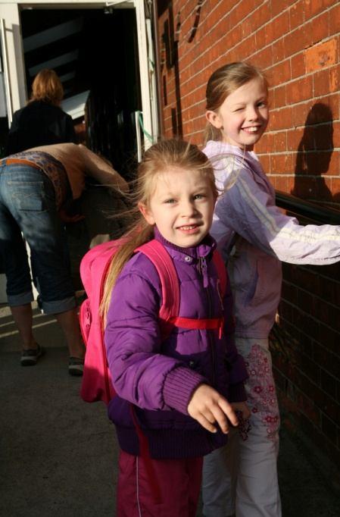

Child Benefit

Child Benefit is the only payment that automatically goes directly to the mother in the family. In the current recession, parents need Child Benefit more than ever. Child Benefit has now been cut in three successive Budgets and is causing significant hardship to mothers as it is the only payment that mothers receive for all child related costs. It is neither effective nor appropriate to use Child Benefit as a mechanism for redistribution of wealth in Ireland. Government policy has established Child Benefit as the ‘one size fits all payment’; Child benefit is now used by parents towards paying for all of the basic costs related to children - food, clothing, school activities and childcare. Support for parents to pay for childcare is critical for women and their families to survive in the recession. The low level of Government investment in childcare has lead to an increasing high level of childcare costs in Ireland. The National Consumer Agency and the Growing Up in Ireland Study show childcare costs ranging from €800-€1000 per month for a full time childcare place. The report shows that families in Ireland are paying an average of 29% of their total income on childcare costs. This is higher than the majority of member states with Germany and France spending just 8% and 11% respectively on their childcare costs.
Child Benefit should not be targeted as the mechanism for redistribution of wealth in Ireland. The universalist nature of the payment ensures that the wellbeing of all children is recognised by the state. It is neither effective nor appropriate to use Child Benefit as mechanism for redistribution of income. The taxation of earned income and assets provides a clear mechanism for the redistribution of wealth in Ireland and should be used as such in these recessionary times.

Early Childhood Care and Education (ECCE)
Recommendation
Child Benefit remains universal and payment levels are maintained at current rate.

The National Women’s Council welcomed the introduction of a year’s free childcare for pre-school children. The introduction of the ECCE pre-school year is critical for child development and also for the development of quality ECCE infrastructure in Ireland.
The OECD’s 2010 report Doing Better for Children argued that public spending on services for children should be front-loaded on children’s early years (0-5):
“Countries should invest more resources early when outcomes are more malleable and foundations for future success are laid. Well designed, universal interventions concentrated early in the life cycle can enhance both social efficiency and social equity. Concentrating investment early means that it is also most likely to be effective in breaking the dependence of children’s outcomes on those of their parents –inter-generational inequality.”

The NWCI has made a series of recommendations to build a quality ECCE infrastructure from 1yr to school going years.

Recommendation
Extend the pre-school year so that all children can enter ECCE at the age of three years.

PROTECTING THE MOST VULNERABLE WOMEN



Social Welfare Rates
There have been continuous commitments that the current recession should not hit the most vulnerable. The Programme for Government has clearly committed to maintaining the social welfare rates and it is critical that Budget 2012 uphold this commitment. Maintaining social welfare rates at current levels will ensure that the recession does not increase the numbers of people living in poverty and negate the government’s stated aim of reducing poverty. The majority of social welfare claimants are women, and women have a greater reliance on means-tested payments than men. Inflation is now estimated at 2.3% and by the end of the year, it is likely that women relying on social welfare will have suffered a fall in the real value of their income. It is imperative that basic social welfare rates are at least maintained at their current levels.

Recommendation
Maintain the earnings disregard for the One Parent Family Payment and maintain its recognition for Community Employment.
Recommendation
At a minimum, maintain all social welfare payments at current levels.

Qualified Adults
The vast majority of Qualified Adults are women (95%); this status is assigned to those who are not registered independently and are dependant on their partner for their income. This reinforces female dependency and makes women vulnerable to poverty and exploitation. Independent, direct and full payment to both adults in a household will address women’s poverty, support their economic independence and increase their personal autonomy.

With the exception of Jobseeker’s Allowance, where a person meets the criteria for a given payment, they receive the full personal rate in their own right. But in jobless households, the value of the payment is ‘limited’: even where women meet the unemployment criteria, they are still treated as a dependent and paid at a lower rate. This acts as a disincentive to women signing on the Live Register. If not registered as unemployed, women may not get access to labour market supports to help them return to work.
In the context of the current crisis, this is a short-sighted policy. As unemployment continues to rise, it is crucial that every opportunity is taken to address joblessness in households. Women are a vital resource in this regard.
Recommendation
An end to the limitation rule.

Recommendation
All qualified adults to be paid the same rate as main claimant and paid directly to the individual.

Proposal to Introduce a Single Working Age Payment
The Report on the Single Working Age Payment by the Department of Social Protection will have far reaching consequences for all women on social welfare, including adult dependants. The introduction of a Single Working Age Payment would affect 70,000 adult dependants; over 90% of these are women. There is currently no data on adult dependants. It is neither credible nor cost effective to develop a new payments system and introduce activation for women without any information on the women with regard to their age, education and training background, employment profiles and care responsibilities.

Recommendation
A short qualitative study of adult dependants be completed as a matter of urgency in the next 6 months which would give vital information to inform the development of the single payment and the accompanying activation of adult dependants.

Supporting workers with reduced hours
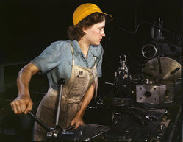
The National Women’s Council has long campaigned for a modern social welfare system. The social welfare system is poorly equipped to address current labour market challenges. Many women are engaged in shift work and atypical employment, and they are more likely to be low paid and on reduced hours. Provision for systematic short time workers is extremely complex and rigid, excluding more workers than it covers. To claim an unemployment payment, a person must have lost at least one day’s work, and be unemployed on at least 3 out of 6 consecutive days. These conditions exclude many shift workers, e.g. in the retail and services sectors, where an employee’s hours are organised around the busiest parts of the day – they can have less hours, but still have to work on the same number of days per week, meaning they are ineligible for Jobseeker payments (and unable to take up another part-time job). Almost 80% of Jobseeker claimants do not receive additions for child dependents. For them, a supplementary Jobseeker payment is the only support which would make such jobs viable.
To be eligible for Family Income Supplement (a top up for low paid families), a person must be employed for at least 19 hours a week, leaving those whose hours have been cut below this level without support. Because of women’s patterns of employment, they are more likely to be affected by these provisions than men. 60% of FIS claimants in 2010 were women, and over half of claimants are lone parents, a group with an exceptionally high poverty rate. The FIS hours threshold is intended to promote a minimum level of labour market attachment. But many workers are now denied the required hours as a consequence of the recession. It is undoubtedly better to keep these workers in employment, and the social welfare system has a crucial role to play in this regard. Introducing greater flexibility with regard to the hours threshold as a temporary measure would play a valuable role in promoting much needed job retention.
Recommendation
Recognise atypical work patterns by calculating unemployment on the basis of hours rather than days per week.
Recommendation
As a temporary provision, reduce the hours threshold for FIS to support job retention during the recession.

Pensions

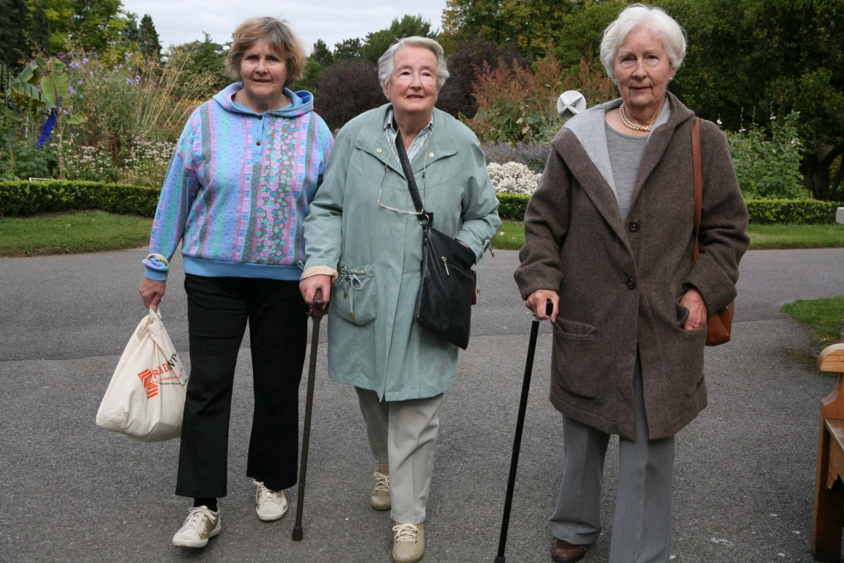
Women significantly rely on the state pension system as a result of not being in a financial position to invest in a private pension. Unfortunately, for both men and women, the implications of the near collapse of the private pension system now means that there will be an increase in the reliance on the state pension for all people in their older years. This makes the need for reform of the state system more urgent. While over 80% of male pensioners are entitled to a State Contributory Pension based on their social insurance entitlements, less than 60% of female pensioners qualify for this payment.

The thrust of Government policy regarding pensions has been to encourage people to invest in private pensions and the state has supported people to take out pensions by providing tax reliefs of €2.9 billion per annum. Clearly a new direction is urgently required to ensure that all people have a decent standard of living in their older years. The NWCI has documented the discrimination against women in the state system and has developed a women friendly model of pensions in Pensions: What Women Want – a model of pensions that guarantees independence, (NWCI 2008).
Recommendation
Maintain the rate of the Contributory and Non Contributory Pensions.

Recommendation
Introduction of a universal pension for all, funded through the removal of tax reliefs for private pensions.

TAXATION REFORM


It is clear that the impact of narrowing the tax base in previous budgets has contributed significantly to the current fiscal crisis. The NWCI has consistently advocated for a wider tax base so that a high level of public services can be delivered and maintained. In reforming the taxation system, basic principles of redistribution must apply where those who have the most wealth and earnings contribute most to the state finances.

Recommendation
Provisions of all tax reliefs at the standard rate tax band.

Recommendation
Widen the tax base through the introduction of a third tax band for higher earners.

WOMEN AND EMPLOYMENT

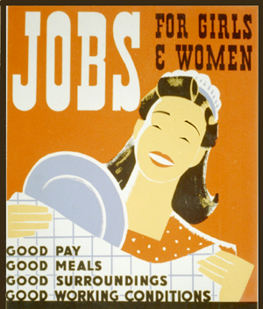

Welfare to Work
In addressing the economic crisis and the alarming increases in our unemployment rates, this Budget must provide a clear strategy to sustain employment. Supporting women workers to remain in their jobs is central to this strategy. The creation of SOLAS under the Department of Education and Skills and the National Employment and Entitlements Service provides an opportunity to develop and include clear gender equality strategy to the provisions and measures under each body. This will also realise our commitments under the EU pact for Gender Equality 2011-2020
With the right supports – education, training and relevant labour market experience – women will play a critical role in Ireland’s recovery. In order to develop a new ‘Smart Economy’ therefore, it must specifically support women to access employment which matches their skills and working patterns.

Women in Low paid Employment
Forfás (2010) estimates that between 170,000 and 300,000 workers in Ireland are covered by either Joint Labour Committees (JLCs) or Registered Employment Agreements (REAs), regarding the terms and conditions of their employment. These workers work in Retail, Cleaning, Catering, Hotel, Security and Agricultural (fruit and vegetable pickers). The majority of these workers are women. The review of the wage setting mechanisms commissioned by the previous government and prepared by Kevin Duffy and Frank Walsh was published on 21st May and recommended that the system be reformed rather than dismantled. Within days, Richard Bruton announced his own set of proposals which threatened the future effectiveness of the entire wage setting system. The threat to the JLC/ERO system was further heightened by the High Court judgement in July.

Recommendation
The restructuring of the JLCs/RES’s should not lead to a reduction to worker’s pay, terms and conditions, including cuts to payments for weekend work or unsocial hours and actions which aim to set lesser terms for new entrants.

Women in Low-Paid Employment

Recommendation
Adoption of a Gender Equality Strategy within SOLAS and National Employment and Entitlements Services that will;

- Introduce innovative welfare to work strategies which have specific gender dimension and account for women’s work patterns.
- Introduce flexible education and training provision on high skill training programmes
- Provide supports to women, particularly women with care responsibilities to enable them to access the full range of education and training options.

WOMEN WITH DISABILITIES

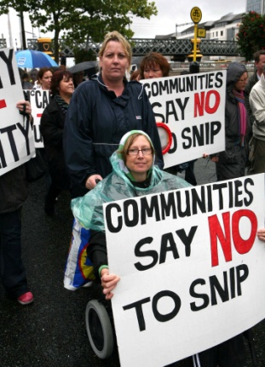
Since 2008 people with disabilities have been suffering cumulative reductions in essential income and service supports. The National Disability Survey (2006), reports that a higher proportion of women (52%) than men (48%) have a disability. Its findings indicate that women with disabilities can suffer greater disadvantage than men. For example, amongst the over 35s, a higher proportion of women with disabilities have to pay for help with everyday activities. Across all age groups, more women than men felt hindered in their activities by the attitudes of others to their disability. Women were far more likely to report difficulties using public transport. More women than men with disabilities have difficulties doing routine tasks in their homes and experience accessibility difficulties outside their home. With the exception of those aged 55-74, a higher proportion of women than men could not keep their home adequately heated. The multi-dimensional nature of discrimination is illustrated by the finding that amongst people with disabilities who were working, men were far more likely than women (under 55) to have been promoted since they had a disability.

The Survey on Income & Living Conditions (SILC) provides information on income and poverty in Ireland; however, the SILC no longer gives a gender breakdown of different population groups. Given that women have a higher incidence of disability, and the evidence of greater disadvantage among women, this is a regrettable development.

The SILC 2009 demonstrates the high level of disadvantage people with disabilities face in Ireland. People who are not at work due to illness or disability have the lowest income of all socio-demographic groups, and are overwhelmingly concentrated in amongst those poorest: 4 in 10 are in the fifth of the population with the lowest incomes, and 6 in 10 in the three lowest deciles. More than a fifth were found to be at-risk-of-poverty in 2009. Almost half of people with disabilities (47.2%) were deprived of basic necessities.

It is clear that people with disabilities continue to lack the level of support they require to access mainstream services, and a lack of coordination of services persists across issues such as employment, education, housing and social security. This is a result of the Irish state’s historical failure to give equal weight to the rights of people with disabilities. Inadequacy in the provision of public services is met by those who provide unpaid care for people with disabilities, the majority of whom are women.

The current government has made clear commitments to improve the situation of people with disabilities:

“We will ensure that the quality of life of people with disabilities is enhanced and that resources allocated reach the people who need them. To achieve this, we will reform the delivery of public services to bring about back office savings that will protect front line services. We will also facilitate people with disabilities in achieving a greater level of participation in employment, training and education”

The Irish state failed women with disabilities during good economic times; it cannot compound this failure by exposing them – and those who care for them, mostly women – to further disadvantage because of the current economic situation. Income supports and crucial services for people with disabilities must be protected from further cutbacks in Budget 2012.
Recommendation
At the minimum, existing services and supports for people with disabilities and carers should be maintained at current levels.
Recommendation
Maintain current social welfare entitlements for people with disabilities and carers.

Migration, asylum and integration
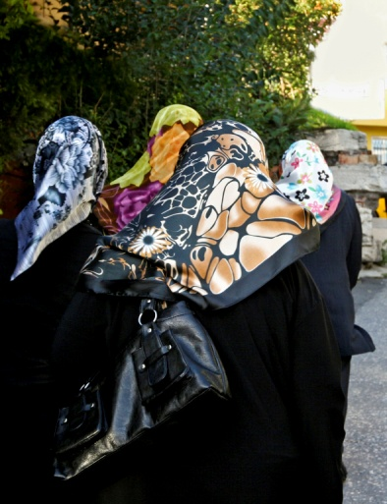
Women from minority ethnic groups continue to suffer high levels of disadvantage, and are particularly vulnerable during recession. There are indications that ethnic minorities have been disproportionately affected by the recession and continue to experience discrimination in accessing employment. In this context, restrictions placed on migrants’ access to social supports impact severely.

Migrant workers face a plethora of charges and levies in negotiating the migration process e.g. a work permit application costs €1,000 ( or €1,500 for new migrants), €1,500 for a renewal, an application for long-term residency €500 and an application for citizenship costs €950.

Migrant women who fail to qualify for access to social services under the Habitual Residence Condition (HRC), or who have a residency permit precluding them from accessing social welfare (‘stamp 3’) are particularly vulnerable. The HRC places an additional burden on migrants and returned Irish immigrants who are trying to access social welfare. The criteria for determining habitual residence are not clear and are open to some discretion, so meeting the standard of proof can be extremely difficult. Without access to social services and social welfare, those affected can face extreme poverty. This can also mean they are refused access to refuges, as without access to social welfare supports, they cannot move on once the immediate crisis has passed.

For migrant women who have been trafficked or who have become homeless as a result of exploitation, sexual or domestic violence, the situation is particularly difficult. National Women’s Council members working with these groups report increased rigidity in the system and reducing access to discretionary transitional payments, further affecting poverty and social exclusion. The result is destitution, fear and isolation.

Where women have become unemployed and are entitled to access social welfare, anecdotal evidence shows that women chose not to do so as they are afraid that this will impact negatively on an application for citizenship, if they are seen to be a burden on the State. Instead they live in poverty. This situation arises as a result of unclear criteria for citizenship and a lack of appeal mechanisms to be made. There is no access to disaggregated data to enable an accurate analysis of the gender breakdown for application for or refusal of citizenship.
Recommendation
No new charges or levies on immigrants to Ireland should be introduced.
Recommendation
Abolish the Habitual Residency Coalition.

Dispersal and Direct Provision
Asylum seekers in Ireland continue to be accommodated in direct provision centres, with minimal financial support and poor, inappropriate accommodation as they await the decision on their asylum application. Their only income source, a social welfare payment of €19.10 per adult and €9.60 per child, has not been increased in over a decade. At December 2009, there were 1,859 women and 987 girls living in these centres. Over half of all residents have lived in centres for two years or more and almost one third have lived in centres for three years or more, with some women living in centres for up to seven years.

For women seeking asylum, the experience is all too often one of isolation, violence, vulnerability, poverty, racism, abuse, exploitation, physical and psychological distress. In addition the extreme difficulties associated with childrearing and family care are consistently highlighted, with some women trapped in domestic violence situations and others experiencing sexual abuse.

NGOs including NWCI members as well as healthcare professionals argue that dispersal and direct provision is having a negative impact on the mental health of asylum seekers, including women. While the human cost is evident, it also costs the exchequer through associated medical costs. The longer term impact on children growing up in these centres, including associated financial costs, need to be considered.

Women and Health

HEALTH SERVICE REFORM

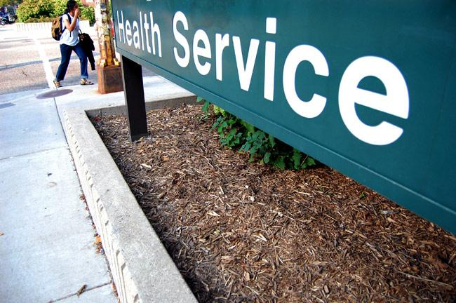
The NWCI has been to the fore in campaigning against Ireland’s inequitable two-tier health system and welcomes the ambitious commitment in the Programme for Government to the creation of a universal health system where “access will be according to need and payment will be according to ability to pay. The principle of social solidarity will underpin all relevant legislation.” While the necessary reforms are undertaken to achieve the goals government has set for itself, the NWCI makes three recommendations on health services in the context of Budget 2012.

BreastCheck
The National Women’s Council welcomes the national roll-out of BreastCheck, and notes that the National Cancer Screening Service (NCSS) has committed to addressing anomalies in access to services. To bring the BreastCheck service into line with international best practice, the NCSS proposal to extend the age bracket to 69 years should be implemented as a matter of priority. Ireland has an aging female population and the over 64 age group has the second highest incidence rate of breast cancer in Ireland. The Government has also committed in its Programme to extend screening to women aged 69yrs.

Raising awareness among GPs and women of breast cancer risk for women up to age 50yrs is also an important part of encouraging early detection amongst younger women.

Recommendation
Deliver on the commitment in the Programme for Government and extend the eligible age bracket for BreastCheck to cover women aged 65 – 69

Recommendation
Raise awareness amongst GP’s and women for early detection of breast cancer particularly in the 40 – 49 age group.

BreastCheck

Recommendation
Maintain supports for community-based women’s organisations that are assisting the NCSS in improving uptake rates in disadvantaged or isolated areas.

General Medical Services Card
The income guidelines governing access to a GMS card are currently lower than basic social welfare rates for people of working age. They have not been raised since 2006, when the guideline for a single adult was €18.20 above the social welfare rate. Had that relativity been maintained, the current threshold would be €209, rather than €184.

While people whose sole income is comprised of social welfare are granted a medical card, those in low paid employment are very unlikely to qualify. The current unemployment crisis means that many unemployed workers have to accept a much lower wage if they are to return to work. Concern about their ability to meet medical costs on lower wages may cause some to reconsider, or even refuse, offers of low paid employment. This is particularly so for those with children, for whose medical costs can be both high and frequent.

The NWCI believes that this unemployment trap warrants urgent attention. Income guidelines for people of working age should be increased so as to restore the previous relationship with basic social welfare payments.

Further, awareness should be raised – amongst both staff and the target groups –about the provision enabling unemployed people and lone parents who have been out of work for at least a year to retain entitlement to the Medical Card for three years regardless of means. Understanding this entitlement could be the difference between making a good decision about returning to work, or a badly informed one.

The introduction of a prescription charge on medical card holders was a direct attack on the poorest in our society. It particularly effects those who have children and older people.
Recommendation
Raise income guidelines on the GMS card to restore the 2006 relationship with social welfare payments.

Recommendation
Resource an information campaign to raise awareness of Medical Card retention arrangements

Recommendation
Remove the prescription charge of 50 cent per item.

Gender mainstreaming
Gender is a key determinant of health.

Despite the National Women’s Strategy commitment to gender mainstreaming in health service planning, the NWCI was disappointed that the last major report on the health system, the Report of the Expert Group on Resource Allocation and Financing in the Health Sector failed to take account of gender differentials.

Women’s and men’s experience of, and needs for, healthcare differ. Sexual and reproductive health needs. Sexual and domestic violence is an example of how women’s health is socially determined and this must be considered when framing access to health services. The current mental health strategy is also gender blind, and fails to recognise gender differentials in presentation and treatment for mental illness.

The planning, provision, delivery, and access arrangements of health services take gender differences into account. Gender proofing and gender mainstreaming are vital tools in achieving this objective, and require appropriate expertise and resourcing.

The National Women’s Council has previously welcomed the establishment of a Gender Mainstreaming Steering Group within the HSE. We are currently working with the HSE to develop a Gender Mainstreaming Strategy for the HSE and tools for implementation in health service policy, implementation and delivery.
Budget 2012 represents an opportunity to provide the required resources to ensure that the development of the radically transformed health service promised in the Programme for Government builds in gender mainstreaming across the full complement of services from the start.
Recommendation
Provide a specific budget line to implement the HSE Gender Mainstreaming Strategy.
Recommendation
Establish a Gender Mainstreaming Unit in the Department of Health and Children, as per the National Women’s Strategy.
Traveller Women
The situation of the Traveller Community in Ireland remains characterised by profound disadvantage. The situation of Traveller women is documented by Traveller organisations which highlight extremely low levels of educational attainment and high levels of long-term unemployment. Investment in the education and skills of Traveller women can have multiple positive impacts, including supporting better educational outcomes for children, a central component of any strategy to tackle poverty among the Traveller population.

Findings from the recent Traveller Health study, Our Geels, reveal startling statistics and the persistently poor health status of Traveller women. The gap between life expectancy for Traveller women and settled women is 11 years and Traveller women have three times the mortality rate of the general population. On the other hand, there is clear evidence of the value of Primary Health Care for Traveller projects, with proportionally more Traveller women than settled women accessing breast screening and smear tests.

Recommendation
Ensure adequate and continued funding of Primary Health Care to Traveller projects.

Recommendation
Ring fence resources to promote Traveller education with a specific budget for training and education for Traveller women.

Recommendation
Provide resources to address unequal health outcomes for Traveller women, as identified in the All Ireland Traveller Health study.

Supporting Women’s Organisations

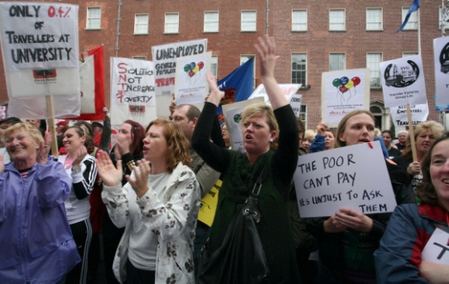
LOCALLY BASED WOMEN’S ORGANISATIONS
The funding to the locally based women’s projects has been cut by 15%. The organisations provide vital services to women and their families in their communities at a time when women need these services more than ever. The women’s networks provide advice and counselling services, health information, community education programmes and accessible childcare supports. They enable women to organise together and speak out on the issues affecting their lives, highlighting gaps in service provision and identifying solutions to address inequalities for women in their communities.

The experience of Women’s Projects reveals that women are experiencing higher levels of disadvantage and discrimination in the current economic crisis. The impact on women experiencing disadvantage results in increased poverty, stress, mental health difficulties, incidence of domestic violence, and ill health. Retaining the focus on gender equality at grassroots level is essential.
The networks in the NCCWN with the help of the NWCI, have successfully come together and pooled skills and resources to form a women’s sector LCDP. It is imperative that this model of good practice is adequately resourced and supported.

Recommendation
To extend the contract for the Women’s Local and Community Development Programme (LCDP) to the National Collective of Community Based Women’s Networks for the next three years.
Recommendation
Provide additional funding to NCCWN under any future Funding Scheme to Support National Organisations in the Community and Voluntary Sector.

SUPPORTING THE VOICE OF WOMEN NATIONALLY
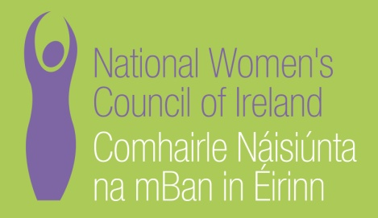
Over the past three years Government funding to the National Women’s Council of Ireland has been cut by 15%. This will rise to 18% in 2012 (even if funding remains constant). The NWCI has 158 member organisations, representing tens of thousands of women throughout the country. It has a small staff and is cost effective and responsible. The NWCI is currently offering an increased level of support to our members and the demands from members has increased significantly due to the impact of cutbacks to their organisations. The NWCI has also succeeded in securing funds from philanthropic sources for projects to advance the cause of women’s equality. The NWCI must be supported to run these projects.

Women’s organisations need a national voice to represent their views and concerns. The importance of the role of the NWCI, as the national representative body of women in Ireland was reaffirmed in the National Women’s Strategy. In the current economic crisis and recession it is clear that women’s organisations need a national organisation which can advocate on their behalf and also that the Government needs an organisation which can articulate the concerns, fears and expectations of women. It is also clear from the Programme for Government that much remains to be done to achieve equality for women in Ireland, particularly with regard to increasing the numbers of women in senior decision making levels and in politics. The NWCI is committed to continuing to support the Government in its attempts to improve the situation of women in Ireland.

Recommendation
Increase the core grant to the National Women’s Council of Ireland by €140,000 so as to compensate for any cuts.

Recommendation
Resource the NWCI to ensure that all political parties can reach the new target set of at least 30% of women candidates for the next general election.

Recommendation
Resource the National Women’s Council to provide a national talent bank of women as envisaged in the Renewed Programme for Government and as suggested in the Joint Oireachtas Report on women in politics.

VIOLENCE AGAINST WOMEN

Supporting the Services

Services for violence against women have been chronically under-funded for years. This situation has reached crisis point as there have been additional cuts to funding in the last three years. The consequences are that more and more women are not being accommodated in refuges or are on waiting lists for support services. Services have been forced to cut positions, programmes or hours of operation. Moreover, domestic violence frontline services have not been able to develop adequate initiatives to better respond to the needs of marginalised women such as migrant, refugee, asylum seeking, Traveller women and women with disabilities.

In 2009 more than 7,512 individual women and 2,462 individual children received support from Domestic Violence Support Services.

In times of recession, options for women experiencing domestic violence dwindle, as their access to financial support may be further restricted by unemployment and increased poverty. It is essential that services that assist women in this situation are adequately funded to be able to respond appropriately.

Refuge provision also remains inadequate and many women and children are denied access to refuges each year. The experience of the Women’s Aid National Helpline is that many women and children cannot access the emergency accommodation and support they need when they need it. It is shocking that many women seeking refuge from a violent partner are unable to access the safety of a refuge. On over 2,300 occasions in 2009 refuges could not accommodate women because they were full to capacity.

There is also clear evidence to show the negative impact on women’s physical and mental health as a result of violence. Services are consistently working with women who have either been referred from mental health services or whose mental health support needs are identified when they access domestic violence services.
Supporting the Services
Recommendation
Funding for existing specialist services working on violence against women must at a minimum be protected from further cuts and should as a matter of urgency be increased at the earliest opportunity.

Recommendation
To ensure access to safe, emergency accommodation for women experiencing male violence a target of at least 1 refuge place (defined as number of rooms providing bed spaces for a woman and her children) per 10,000 of population should be agreed and a time-frame for achievement set.
Recommendation
High Dependency Units for women who experience domestic violence and have alcohol and drug dependencies should be developed.

Recommendation
Provide funding for national organisations working on violence against women, e.g Resource the Rape Crisis Network Ireland, the Dublin Rape Crisis Centre, SAFE Ireland, Irish Traveller organisations (Pavee Point and National Traveller Women’s Forum) and AkiDWA (African Women’s Network)
SAVI 2
Recommendation
Government to allocate resources to fund a SAVI 2 Report

The SAVI Report which was commissioned and delivered in 2002 by the Dublin Rape Crisis Centre and Royal College of Surgeons Ireland is the most comprehensive piece of research done in Ireland on attitudes and beliefs, in relation to sexual violence. It has informed policy and made recommendations which have been, in the main, delivered over the past 10 years. Since it was published significant changes and events have occurred. In the past 10 years we have seen the publication of the Ferns, Ryan and Murphy reports. In order not to lose the very important impact of the SAVI Report (2002), Attitudes and Beliefs to Sexual Violence in Ireland, SAVI 2 is needed as a comparative study 10 years on. SAVI 2 would also meet the commitment in the National Women’s Strategy which set an indicator regarding the development of ‘an effective and appropriate response is available to victims of violence against women’.

Central Statistics Office , http://www.cso.ie/releasespublications/documents/labour_market/current/lreg.pdf
CSO, Women and Men in Ireland 2010 www.cso.ie
http://www.cso.ie/releasespublications/documents/silc/current/silc.pdf
ibid
ibid
Equality Authority (2001) Annual Report 2010. Roscrea: Equality Authority
http://www.consilium.europa.eu/uedocs/cms_data/docs/pressdata/en/lsa/119630.pdf
http://ec.europa.eu/justice/gender-equality/other-institutions/advisory-comittee/index_en.htm
http://www.lex.unict.it/eurolabor/en/documentation/com/2009/com(2009)--‐77en.pdf
http://www.oecd.org/dataoecd/52/11/42004407.pdf
OECD (2010) Doing Better for Children, Paris: OECD, p.16.
NWCI, An Accessible Model of Childcare in Ireland, 2004, NWCI.
Central Statistics Office (2010) National Disability Survey, 2006, Volume 2. Dublin: Stationary Office
Central Statistics Office (2010) Survey on Income and Living Conditions, 2009. Dublin: Stationary Office.
See Christian Blind Mission Ireland (October 2011) Submission to UN’s Universal Periodic Review of Ireland; and Disability Federation of Ireland (January 2011) Submission to the UN Independent Expert on the Question of Human Rights and Extreme Poverty.
Programme for Government October 2011
Expet Group on Resource Allocation and Financing in the Health Sector (2010) Report, Dublin Stationary Office
All Ireland Traveller Health Study: Our Geels was published in September 2010 and is available at http://pavee.ie/ourgeels/wp-content/uploads/2010/09/AITHS2010_SUMMARY_LR_All.pdf.
Renewed Programme for Government, October 2009. Available at: http://www.taoiseach.gov.ie/eng/Publications/Publications_2009/Renewed_Programme_for_Government_October_2009.html
Joint Committee on Justice, Equality, Defence & Women’s Rights (2009) Women’s Participation in Politics, Second Report. Available at: http://www.oireachtas.ie/viewdoc.asp?fn=/documents/Committees30thDail/J-JusticeEDWR/Reports_2008/20091105.pdf

