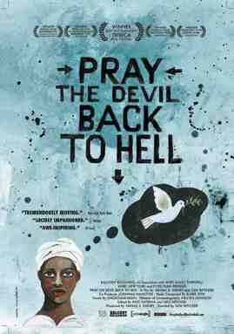



Feminist Film Night

Wednesday 29th June, 7-10pm
Hanna’s House would like to invite you to a film and networking event in the BeanBag Cinema, Donegall Street, Belfast on Wednesday 29th June 2011.
‘Pray the Devil back to Hell’ is a powerful anti-war documentary about the Liberian women’s peace movement and the pressure they brought to bear on the creation of peace in Liberia.
The film will be followed by a Question & Answer session and a wine reception.
Please invite family and friends and RSVP to hannashouse@nwci.ie by 27th June.


