National Women’s Council of Ireland
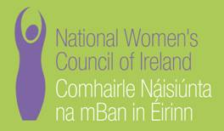

Members Meeting
Women in the Media NOT

Saturday 14th May 2011
CLARION HOTEL, DUBLIN

A G E N D A

10.30am Registration, Tea/Coffee

11.00am Welcome – Clare Treacy NWCI

11.10am Presentation from Margaret Ward, Journalist and founder of Women on Air

11.30am Panel Discussion with
Jennifer O’Connell, Freelance journalist with the Sunday Business Post
Dr. Barbara O’Connor, Senior Lecturer of Communications in DCU
Orla Barry, Broadcaster and Print Journalist who has presented with Newstalk since 2003
Suzy Byrne, Onscreen personality and author of the excellent Blog “Maman Poulet”
Chaired by Susan McKay, CEO, NWCI
12.30pm Questions & Answers Session
1.15pm Closing Remarks – Susan McKay

1.30pm L U N C H

The Clarion Hotel is a 10 minute stroll along the River Liffey from O'Connell Street and Temple Bar and just a few minutes walk from the O2 Arena and the Dublin Convention Centre, with easy access to Croke Park, Aviva Stadium. There is a Luas stop three minutes walk from the hotel and there is a car park around the corner.

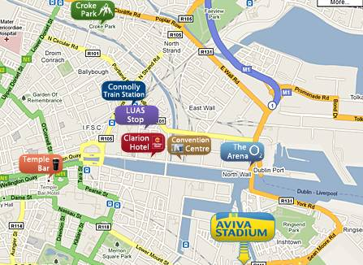

If you wish to attend, please book your place by sending an email to me at anneg@nwci.ie
This promises to be a great event so book early to avoid disappointment!

