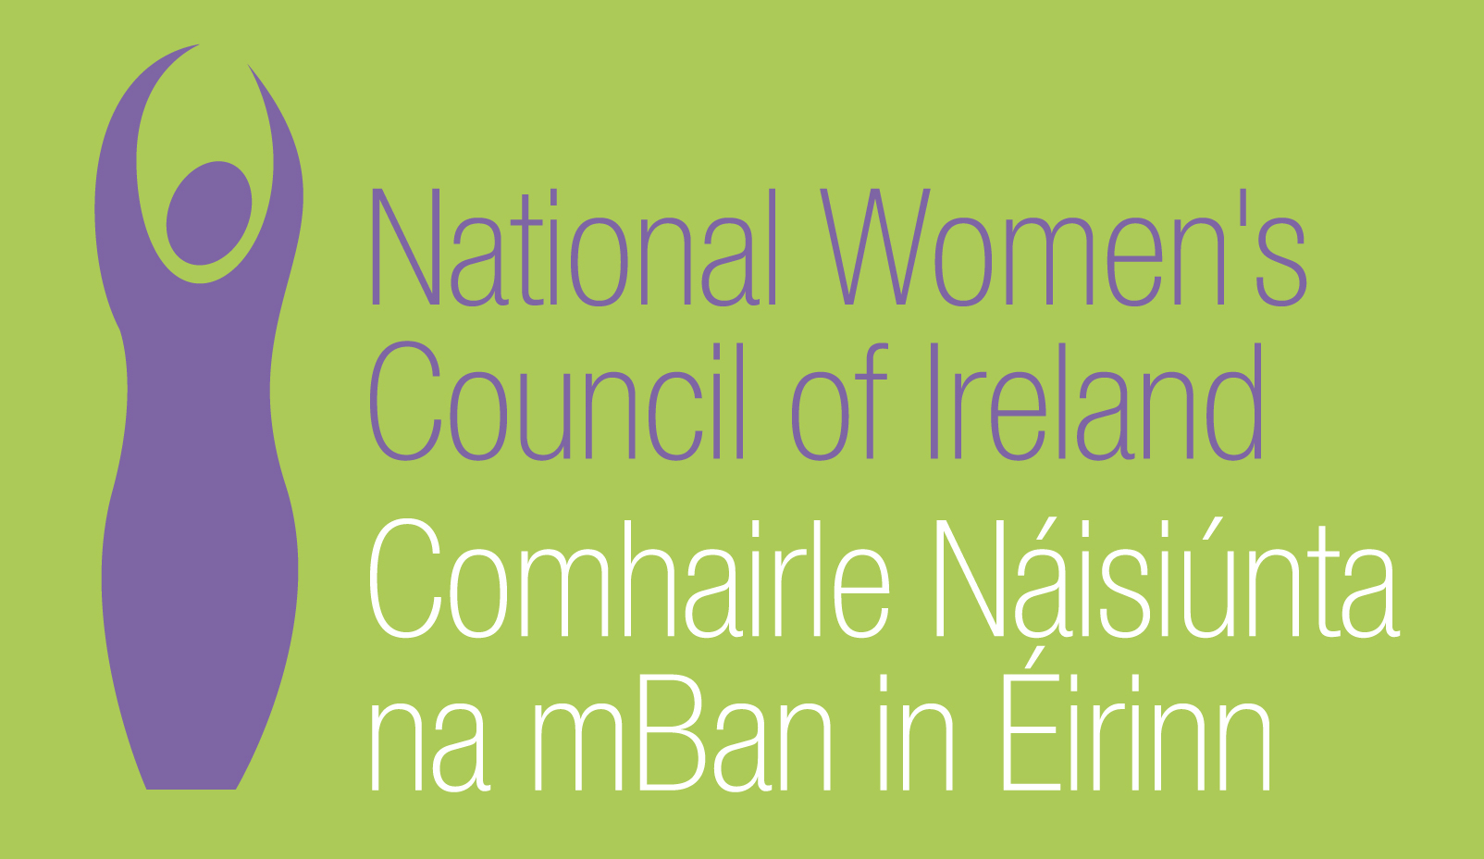

Submission on the
NEW HUMAN RIGHTS AND EQUALITY COMMISSION:
CONSULTATION
November 2011

National Women's Council of Ireland
9 Marlborough Court
Marlborough Street
Dublin 1

Tel: 01 - 8787248
www.nwci.ie

Introduction
The National Women’s Council of Ireland (NWCI) is the national representative organisation of women in Ireland. Our mission is to achieve women’s equality, empowering women to work together, while recognising and mobilising difference, in order to remove structural political, economic, cultural and affective inequalities.
The National Women’s Council of Ireland welcomes the opportunity to make a submission to the new human rights and equality commission consultation process. We hope that this evolves into a dialogue, and working together in partnership to achieve the objectives of both the HREC and women experiencing inequality.
We are particularly concerned to ensure that membership of the HREC is reflective of the diversity that exists in Irish society and that the membership of the Commission reflects the Government target of 40%-60% gender balance. We also propose that membership of the HREC be selected through an independent, transparent process and structure.
Women, equality and human rights
The priority issues for women’s equality and human rights are focused around the following issues;
Low levels of women in key decision making arenas
Women make up 50% of the Irish population. Yet just over 15% of TDs are women. The most recent General election has made no improvements to the representation levels of women. Without a critical mass of women at key decision making levels in Irish society, women’s issues will not be prioritised.
The impact of care responsibilities on women’s participation in society
Women’s unpaid informal caring responsibilities are arguably, the most significant factor that reinforces and reproduces women’s subordination in society. Caring in Irish society is ‘culturally constructed women’s work’ which attracts low status, low public policy priority and is resource deficient . The moral imperative on women to undertake the bulk of the caring is a significant factor that disadvantages women and advantages men in the public world of work, politics and culture. The cost and inflexibility of childcare provision still remains a significant barrier to women’s participation in our society.
Impact of the recession and austerity cuts on women and the women’s sector:
Women today are represented in unprecedented numbers in the labour market and contribute to household incomes to a far greater degree than during past periods of economic downturn. Their integration into the work-place means not only that the crisis is having a greater impact on women themselves, but also on their families. It is also the case that women “entered the recession on an unequal economic footing”.
The cuts to social welfare payments, child benefit and social services have impacted on women to a greater degree as they are the managers of family incomes and household debt. Much of the work done to address the concerns of women takes place at grass roots level within locally based women’s groups and community projects. This work includes the provision of training and employment opportunities, the provision of services (counselling , childcare, information, referral and frontline services for women experiencing violence) and the provision of opportunities for individual and collective empowerment - making the voice of women who are most marginalised heard within local decision making structures. This work is under constant threat in terms of funding cuts and lack of a co-ordinated strategy to ensure the survival of these women’s groups.

Violence against Women
Violence against women remains a deep rooted and persistent form of human rights violations which affects one in 10 women in this country. Since 2008, NWCI members providing services to women experiencing domestic and sexual violence are reporting increases in demand for their services of up to 80% whilst at the same time experiencing cuts in their funding of up to 20%. The situation is at crisis point.
Women and Health
Access to quality affordable health care remains a key equality and human rights issue in Ireland. Gender is a key social determinant of health and while official government health policy sets out principles of equity, quality, person centeredness and accountability (yet) there are no direct legal protections to ensure that this policy is delivered. Legislating for the rights to health and housing, in particular, would be a vital step in the move to balance the protection of economic, social and cultural rights in Ireland
Women and Social Welfare
The social welfare system continues to be based on a male breadwinner model with over 90% of those on adult dependant payments being women economically dependant on their male partner. The NWCI has long recommended reforms to the social welfare system.
HREC Proposed Work Areas
Case Work
The Case work currently being undertaken by the Equality Authority is crucial in terms of supporting individuals to take cases of discrimination to the Equality Tribunal and should continue to be a core part of the HRECs work. Providing an analysis of the outcomes of the case work which would be publicly available would enhance this aspect of the work and act to build awareness on the potential of the Equality legislation.
EU Progress Initiative
The Progress Initiative continues to be a very positive programme facilitating the development of innovative ways to tackle inequality and provided new models for working with groups experiencing inequality under the nine grounds. It has also enabled and provided new opportunities for cross-sectoral working which without the Initiative may not have happened. It has also been an important resource for community sector organizations to develop new ways of addressing inequality.
Research and data collection
The research published by the Equality Authority and the Human Rights Commission to date have played a critically important role in highlighting the experience of groups experiencing inequality and human rights violations. In the current economic times this role is even more important as it essential to provide an analysis of the changing situation with regard to inequality and human rights concerns in Irish society.
Good Practice Work
The good practice work undertaken by the Equality Authority to date provides concrete and user friendly support in developing initiatives for the promotion of equality. It is important that this work continues. Reviewing the levels of usage and effectiveness of these tools to date is important as is the development of new and up to date resources which meet the articulated needs of organisations throughout a range of sectors.
Promoting a Culture of Human Rights and Equality
The Irish Human Rights Commission and the Equality Authority both stress the importance of developing a culture and ethos of inclusiveness and respect for diversity. This work is crucial in advancing a human rights and equality agenda including but not limited to; human rights and equality education, awareness raising, public relations work and engagement with policy makers including political representatives. In addition, NGOs should be supported by the HREC to engage in a proactive way with UN human rights treaty monitoring processes and shadow reporting.
Women’s Equality
The NWCI is particularly concerned at the lack of understanding regarding the issue of women’s inequality within a wider equality and human rights agenda. We believe, current analyses of inequality and human rights issues do not give due weight to the depth of discrimination against and oppression of women in Irish society or to the multiple forms of discrimination and human rights violations against particular groups of women.

The HREC should undertake substantive research to develop an understanding and awareness of the structural inequality women experience in Ireland, the human rights issues that they face and how to address these within a wider equality and human rights agenda.

Gender and Human Rights Proofing
In the current time of economic recession, it is critical that the decisions that government makes takes into account the impact on women and groups experiencing inequality. The new EU Pact for Gender Equality 2011-2020 states ‘it is important that the Member States and the EU find ways to integrate a gender equality perspective into the analysis of the impact of the crisis and into all policy responses to the recession’.

The HREC should support gender proofing and human rights proofing across all areas of its own work, and that of the government, the public, private and community and voluntary sectors.

Health
The relationship between equality and health needs to be re- prioritised by the HREC. This would include the development of an analysis and understanding of the how health inequalities intersect and the implications of inequalities in health from a human rights perspective.
HREC address the prevalence of health inequality through the development of policy positions, liaising with the Department of Health and supporting the further development of equality and gender mainstreaming and human rights proofing within the Irish health system.

Supporting Groups Working For Human Rights and Equality
The NWCI has long experience of working to progress the rights and vision of women, and we believe that the work of both the HREC and the NWCI can be strengthened by working in partnership. The NWCI offers to support the work of the HREC in whatever ways are found to be appropriate.
Mechanisms should be developed for groups working to overcome inequality and human rights violations to input into the work of the HREC on a regular, on-going basis.
The HREC should support groups working to overcome inequality and address human rights violations:
- By lobbying for their direct participation in relevant policy fora;
- By promoting their campaigns and entering into joint campaigns;
- By supporting them to carry out relevant research and entering into joint research projects.

An annual Equality and Human Rights publication should be produced in user-friendly style which presents the key facts and figures on inequality and human rights in Ireland; including gender disaggregated data and followed by a national dialogue with relevant agencies/NGOs on progress in advancing an equality and human rights agenda.

Promote the extension of the Equality Legislation
The Equality legislation needs to be more comprehensive with regard to the relationship between a person’s status in society and the impact of inequality and associated human rights violations.

The HREC should promote the inclusion of new grounds into the Equality Legislation including;
- Socio economic status
- Criminal Conviction
- Trans people

Cullen, K., Delaney, S., Duff, P. (2004) ‘Caring, Working and Public Life’, in Equality Research Series. Dublin: The Equality Authority, p. 18; O'Sullivan, S., (Ed.) (2007) Contemporary Ireland: A Sociological Map. Dublin: University College Dublin Press
Women’s care responsibilities are recognized as a significant obstacle to gender equality in the National Women’s Strategy 2006-2016.
Submission to the Office of the High Commissioner for Human Rights On the occasion of Ireland’s examination Under the 12th session of the Universal Periodic Review Report on the right to health and the right to housing by Age Action Ireland, Disability Federation Ireland, Make Room Campaign Alliance, Mental Health Reform, Women’s Human Rights Alliance March 2011
EU Pact for Gender Equality 2011-2020 http://www.consilium.europa.eu/uedocs/cms_data/docs/pressdata/en/lsa/119628.pdf
Katherine Rake (2009): Are women bearing the burden of the recession? A Fawcett Society report, available at: http://www.fawcettsociety.org.uk/documents/Arewomenbearingtheburdenoftherecession.pdf

