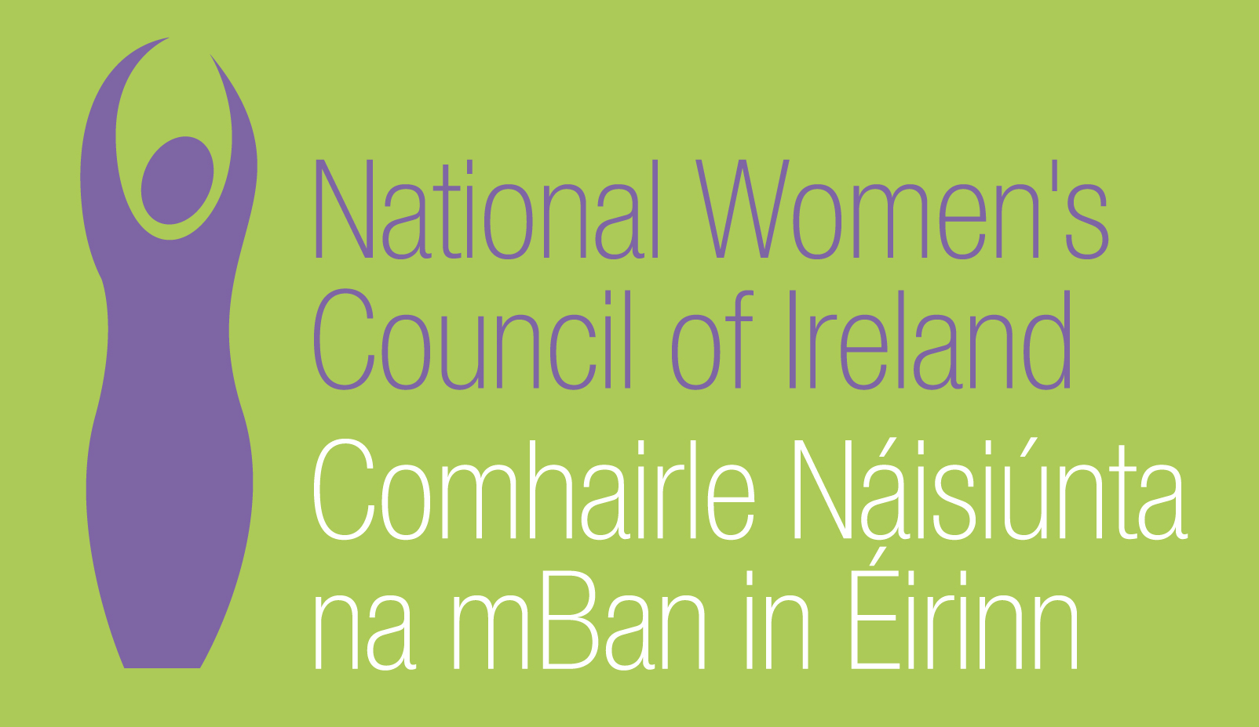

National Women’s Council of Ireland
Stakeholder Submission
Universal Periodic Review

Ireland (6th October 2011)

Submitted 21st March 2011

Contact:
Rachel Doyle
Head of Outreach and Support
National Women's Council of Ireland
9 Marlborough Court
Marlborough Street
Dublin 1

Tel: 01 - 8787248 / 087 - 2998619
Fax: 01 - 8787301
email: racheld@nwci.ie
www.nwci.ie

1. Introduction

The National Women’s Council of Ireland is the representative body for women in Ireland with 170 member organisations http://www.nwci.ie/members/ . We are feminists and support and lead our members and women throughout Ireland in advocating for justice and equality for women in Ireland and globally. This submission highlights the key human rights concerns for women as articulated by them at NWCI members meetings, Annual General Meetings, surveys, and in the ratification of our policy submissions to Government Departments. The NWCI is a member of the Your Rights Right Now UPR Cross Sectoral Steering Group.
2. Right to life liberty and security of the person: Violence Against Women - Services for women experiencing violence have been chronically under-funded for years. There is an urgent need for research into the wider social impacts of domestic and sexual violence. The providers of services to women experiencing sexual and domestic violence are reporting dramatic increases in demand for their services since the start of the recession in Ireland. Safe Ireland reports that in just one day (4th November 2009): 368 women and 291 children were accommodated and/or received support from a domestic violence service; 194 helpline calls were received from women; 11 women and 6 children were admitted to a refuge; 6 women couldn’t be accommodated in a refuge due to lack of space. Some refuges have noted an increase in demand of over 40%. Demand for Ruhama’s (support service for women in prostitution) services increased by 22%in 2009, with half of cases involving sexual trafficking. At the same time, services are having funding cuts of 10% to 30%.
Recommendations
- A minimum target of 1 refuge place per 10,000 of population needs to be agreed, and a timeframe set, so as to ensure women’s access to safe emergency accommodation;
- Additional funding previously announced by Minister Barry Andrews must be made available as a matter of urgency to Rape Crisis Centres to deliver much needed services;
- Provide funding for a new SAVI report on the extent of sexual and domestic violence in Ireland, and for other research.
- Funding for national organisations working on the issues of sexual and domestic violence against women must be protected against further cutbacks.

3. Right to participate in public and political life: Women’s Participation in Politics - The 2011 general election saw an increase of 1% in female representation in the 31st Dail, with 25 women out of 166 members of parliament (15.1%) elected. This will marginally push Ireland up the world rankings to 79th place (Inter-Parliamentary Union, 2011).
Recommendation
- Introduce positive action measures in the form of legal quotas for the selection of candidates in parliamentary elections, with sanctions for non-compliant parties.

4. Right to privacy, marriage and family life - Lesbian and gay couples in Ireland do not have the right to marry, in a civil registry office, or gain the same legal rights associated with marriage for themselves and their families. The right to marry is essential for securing equal rights and protections for LGBT parents and their children.
Recommendation
- Introduce legislation affording gay and lesbian couples the right to marry in a civil registry office, and gain the same legal rights for themselves associated with marriage for themselves and their children.

5. Right to work and to just and favourable conditions of work: Employment Strategy - Almost 14%, and rising, of the labour market is unemployed. The continuing disastrous rise in unemployment shows no signs of abating. While male construction workers initially dominated the rise in unemployment, in 2010 the increase in women on the Live Register has exceeded the increase for men, and women are concentrated in the lowest paid jobs.
5.1 Minimum Wage and other protections- The minimum wage along with other protections must be protected as any cuts would make many of these jobs unviable for women. The last Irish Government cut the minimum wage rate from €8.65 per hour to €7.65, and employers are currently seeking to dismantle protections.
5.2 Childcare - A key barrier to women’s participation in the work force is the lack of Government investment in an affordable childcare infrastructure. Net childcare costs are 45% of the average wage in Ireland, compared to 16-17% in EU and OECD countries.
Recommendations
- Adopt a sustainable employment strategy to; provide a range of labour market programmes on a flexible basis appropriate to women’s skills needs and working patterns.
- Reverse the cut to the minimum wage and protect wage agreements.
- Establish an affordable accessible and quality publicly funded childcare system

6. Right to social security and to an adequate standard of living: Poverty - In 2008: Households headed by women experienced greater poverty, almost 17% having incomes below the poverty line, and suffered twice the rate of consistent poverty as those headed by men. 36% of one parent families, (overwhelmingly female), lived below the poverty line.. The EU has warned that “the economic slowdown is likely to affect women more than men”. “Women still work part-time more than men; they predominate in less valued jobs and sectors; they are on average paid less than men and they occupy fewer positions of responsibility”.
6.1 Child Benefit - Child Benefit provides a vital support for parents struggling to meet the costs of raising children – food, clothing, school activities and childcare. Families with children account for more than three-quarters of those in consistent poverty: Budget 2011 saw Child benefit cut by €10 for the first and second child, €20 for the third child, and another €10 for each subsequent child.
6.2 Social Welfare - A great number of women remain hidden in the social welfare system as ‘qualified adults’ (QAs): they do not receive a social welfare payment in their own right, but as the dependent of their partner and receive a lower payment on that basis (limitation rule). In 2008, there were more than 145,000 QAs in the social welfare system; the current figure is likely to be considerably higher. Because of women’s concentration in low paid employment, they are more likely to be on the minimum wage.
6.3 Pensions - The near collapse of the private pension system highlights the importance of strong state pension provision, and makes the case for reform more urgent. It is particularly important for women, half of whom have no other pension than the State Pension; only 7% of women have a personal pension, compared to 18% of men. Women are more likely to have to rely on a means-tested pension: as the social insurance system does not recognise care work, they often fail to meet the contribution requirement.
Recommendations
- Maintain universality of child benefit and reverse cuts to child benefit and all other social welfare payments imposed in budget 2011
- Make Homemaker’s Credits retrospective to 1973 to allow women affected by the marriage bar culture access a State Pension in their own right.
- End the limitation rule for Job seekers allowance and administer payments individually to women
- Introduce a universal pension, funded through the removal of tax reliefs for private pensions;

7. Right to health: The consistent failure of the Department of Health to develop a women’s health strategy is a major issue raised by women’s organisations, which militates against a gender and human rights based approach to health. The HSE have provided resources to the National Women’s Council of Ireland to develop a Gender Mainstreaming Strategy for the Irish Health Services. Costs of GP services, the two tier health system, and lack of access for many women to cervical and breast screening, are key issues of concern.
Recommendations
- Implement a gender mainstreaming strategy arising from the outcomes of the gender mainstreaming project being undertaken by the NWCI.
- Develop and implement a Women’s Health Strategy in consultation with women’s organisations and including a specific focus on women who are most marginalized, and including women’s rights to reproductive health.

8. Right to housing: Traveller women - Traveller organisations in Ireland continue to fight for the right for culturally appropriate accommodation for the Traveller community. Travellers are subject to forced evictions; 594 Traveller families remained on unauthorised sites in 2007. Traveller women, those experiencing violence and those who are pregnant are particularly vulnerable
Recommendation
- Under take a gender impact assessment of the implementation of the Housing (Miscellaneous Provisions) Act 2002

8. 1 Asylum seeking women - Direct provision centres were meant to be for a maximum of 6 months – many people have now been housed in them for over 4 years. They are particularly unsuitable for women and children and poor living conditions are impacting on the social and emotional development, health and well-being of children in the asylum process. Victims of trafficking are accommodated in direct provision centres, which breaches their right to appropriate accommodation, security and safety under the Palermo Protocol and the European Convention against Trafficking.
Recommendations
- Review the system and as a matter of urgency provide adequate and appropriate accommodation for victims of trafficking.
- Provide separate accommodation for women parenting alone and single women.

9. Women’s Rights: National Women’s Strategy
There is considerable uncertainty in relation to existing funding for implementation of the National Women’s Strategy (NWS). The NWS could prove vital to tackling the structural inequality that generates inefficiency and waste of valuable human capacity. These initiatives are more, not less, important in the current context.
Recommendation
- Undertake an independent assessment/evaluation of the the National Women’s Strategy and ring-fence funding to implement a revised National Women’s Strategy in light of the recession.

10. Sexual and reproductive rights: - Abortion - Access to the right to legal, safe abortion is still not available for women in Ireland, despite the comments from the CEDAW Committee in 2005. In December 2010 the EU Court of Human Rights ruled that a woman with cancer who travelled out of Ireland to terminate her pregnancy while in remission had her human rights violated.
Recommendation
- Introduce legislation to give effect to the EU Court of Human Rights Ruling

10.1 Female Genital Mutilation - Female Genital Mutilation continues to blight the lives of many women living in Ireland. Research undertaken by AkiDwA in September 2010 found that the number of women that have been subjected to FGM has increased from 2,585 to 3,170 within four years. The State has no legislation making Female Genital Mutilation an offence in Ireland.
Recommendation
- Introduce legislation outlawing FGM as a matter of urgency.

11. Situations particular to Ireland: Locally based women’s organizations These organisations provide a range of services, for education and training, and childcare supports. They enable women to organise together and speak out on the issues affecting their lives. They help to hold families and communities together and help women marginalised by violence to gain the confidence to leave dangerous situations. Their funding is under constant threat.
Recommendation
- Ring fence funding for the continuation of work with grass roots community based women’s groups;

11.1 National Organisations - We will not recover from this recession unless women’s voices are heard in all of the debates surrounding the future of our society and our economy. There is ample evidence from other countries that strong national representation of women’s concerns and affirmative measures lead to better policy development and implementation, and enhanced outcomes for women, families and for all of society.
Recommendation
- Maintain funding for the National Women’s Council of Ireland at its 2010 level.
- Resource the National Women’s Council to provide a national talent bank of women as envisaged in the Renewed Programme for Government and as suggested in the Joint Oireachtas Report on women in politics

11.2 Irish Constitution Article 41.2 - states that “In particular, the State recognises that by her life within the home, woman gives to the State a support without which the common good cannot be achieved” This reinforces the continued perception of women as dependents and been commented on by the CEDAW Committee. “The Committee is concerned at the persistence of traditional stereotypical views of the social roles and responsibilities of women and men in the family and in society at large which are reflected in article 41.2 of the Constitution and its male-oriented language, as recognized by the All-Party Oireachtas Committee on the Constitution, in women’s educational choices and employment patterns, and in women’s low participation in political and public life.”
Recommendation –
- Abolish Article 41.2 and Replace male-oriented language with gender-sensitive language in the Constitution to convey the concept of gender equality more clearly as recommended by CEDAW.

Appendix 1 References

National Women’s Council of Ireland Pre Budget submission 2011
Housing Statistics Bulletin, 2007, p.88.
WHRA Interview with National Traveller Women’s Forum April 2011
The Housing (Miscellaneous Provisions) Act 2002 gives local authorities the right to evict Traveller families from illegal encampments without providing alternative accommodation.
WHRA A Women’s Right to Health Report of consultation with women on the right to health Dr. Jane Pillinger 2010 (unpublished)
ibid
The concluding comments of the CEDAW committee (2005) stated that “the Committee reiterates its concern about the consequences of the very restrictive abortion laws under which abortion is prohibited except where it is established as a matter of probability that there is a real and substantial risk to the life of the mother that can be averted only by the termination of her pregnancy (paragraph 38). The Committee urges the State party to continue to facilitate a national dialogue on women’s right to reproductive health, including on the very restrictive abortion laws. It also urges the State party to further strengthen family planning services, ensuring their availability to all women and men, young adults and teenagers (Paragraph 39).
http://www.irishhealth.com/article.html?id=18706 http://www.irishtimes.com/newspaper/ireland/2011/0207/1224289183429.html
Committee on the Elimination of Discrimination against Women Thirty-third session 5-22 July 2005
Safe Ireland (2010) In Just One Day: on the 4th November 2009. Available at: http://www.safeireland.ie/pdf/si-census-on-4th-Nov09.pdf
Defined as number of rooms providing bed spaces for a woman and her children
Central Statistics Office (2010a) ibid.
Central Statistics Office (2009) Survey on Income and Living Conditions (SILC) 2008. www.cso.ie
European Commission (2009) Report from the Commission to the Council, the European Parliament, the European Economic & Social Committee, and the Committee of the Regions: Equality between women and men – 2009. COM(2009) 77 final. Available at: http://www.lex.unict.it/eurolabor/en/documentation/com/2009/com(2009)-77en.pdf
Central Statistics Office (2009) ibid. One parent families account for 29% of those in consistent poverty, couples with 1-3 children for 24%, and other families with children for 22%
Department of Social & Family Affairs (2009) ibid.
Central Statistics Office (2010c) Women and Men in Ireland, 2009. www.cso.ie
Available at: http://www.taoiseach.gov.ie/eng/Publications/Publications_2009/Renewed_Programme_for_Government_October_2009.html
Joint Committee on Justice, Equality, Defence & Women’s Rights (2009) Women’s Participation in Politics, Second Report. Available at: http://www.oireachtas.ie/viewdoc.asp?fn=/documents/Committees30thDail/J-JusticeEDWR/Reports_2008/20091105.pdf

