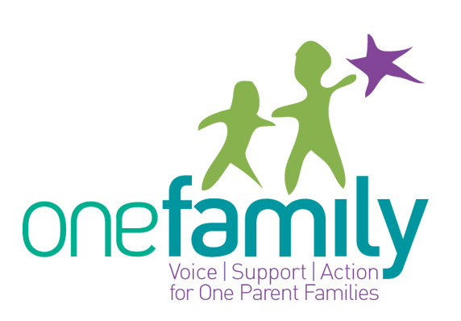

One Family Training Programme Booking Form

Name
Role
Organisation
Work Address
Contact Telephone
Email

1. Please indicate which programme(s) you are applying for by completing the information below.

Programme | Programme of interest | Date
Positive Parenting Training for Trainers (Euro 450)
One Parent Families – Issues, Diversity & Rights (Euro 160)
Crisis Pregnancy Training for Counsellors (Euro 450)
Crisis Pregnancy General Awareness( Euro 160)
Family Communications (Euro 450)

2. Please give a brief account of your work with one -parent families.

3. What, if any experience and or training do you have in-group facilitation?

4. How did you hear about One Family Training?

Booking forms should be submitted as soon as possible as places are allocated on a first come basis. To secure your place on the course full payment must be enclosed with each application. Please make cheques payable to One Family. Please return your cheque and booking form to The Training Manager, One Family, Cherish House, 2 Lower Pembroke St Dublin 2. Please note cancellation charges apply if you cancel your booking 72 hours before the event

Thank you for your booking and we look forward to seeing you at the programme!

