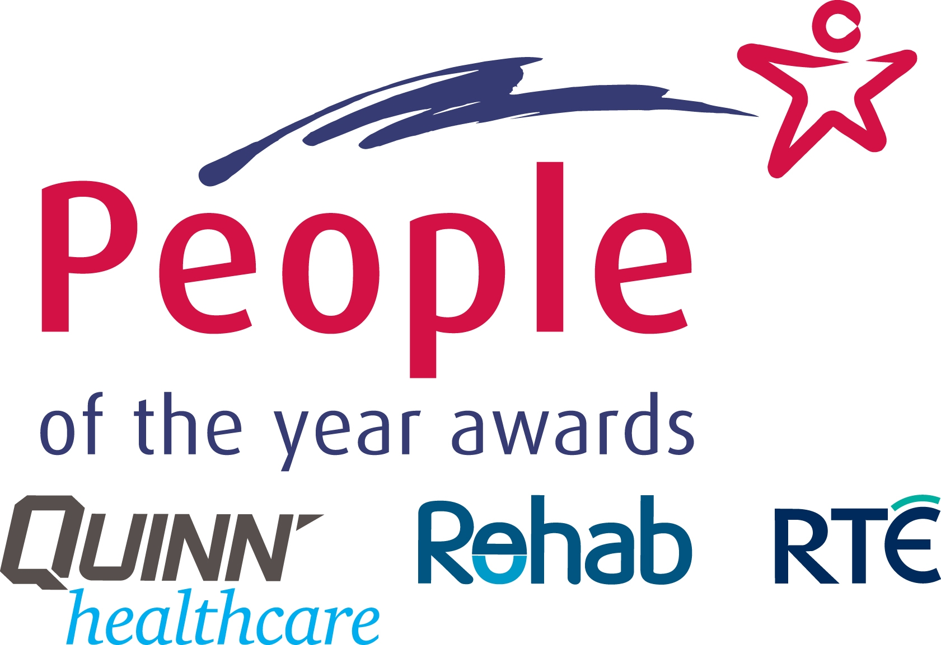

People of the Year Awards 2011

Who is your Person of the Year?

Nominate those who inspire! The People of the Year Awards, now in its 37th year, is seeking nominations for this year’s Awards. Each year, the Awards seek to honour those who have made a real difference in people’s lives, whether they be unsung heroes or household names.
Do you know someone whose achievements are inspiring and whose contribution to society deserves recognition?
You can nominate an individual or a group in a particular category for a People of the Year Award including:

- International Person of the Year
- Young Person of the Year (under 25)
- Sports Person of the Year
- Community Group of the Year
- General People of the Year Awards

Special Award 2011
Best Friend of the Year is a special category in 2011 which pays tribute to a true friend who goes far beyond the call of duty to help and support you – a soul mate whose great efforts deserve acknowledgement
How to Nominate: Tell us as much as you can about why your chosen person or community group should receive an Award. Please include as much relevant information as possible to support the nomination, which you can submit in one of the following ways:
1. Log on to www.peopleoftheyear.com and complete the online nomination form.

2. Write to us at People of the Year Awards, Rehab Group, Roslyn Park, Sandymount, Dublin 4

For more information on the Awards, log on to www.peopleoftheyear.com or call 01-2057339.
CLOSING DATE FOR NOMINATIONS: Monday, 20th June 2011

The winners of the People of the Year Awards are selected by an adjudicating committee from nominations received from members of the public.

The People of the Year Awards, which are organised by Rehab, sponsored by QUINN-healthcare, and televised live on RTÉ One, will take place on Saturday 10th September. Tickets for this glittering gala occasion are available by contacting our fundraising team on 01 2100 520.

