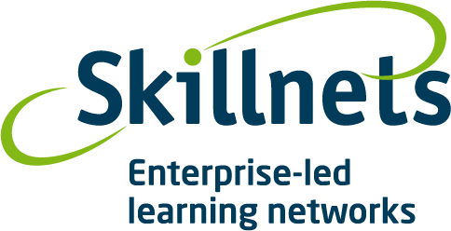

Personal Development
Programme 11

- Training will take place over 2 days
- 19th and 20th Oct 2010
- Training is free to participants(places are limited)

This course is designed to help you build your internal strength in communicating with others, your personal effectiveness in a group situation, your negotiation and conflict management skills with individuals and groups across your union organisations.

The objective of this two day course is to provide you with tools and techniques that will allow you to be more effective in any work or group situation, where you need to communicate more clearly or effectively to get better results and co-operation.

- Communication
- Assertiveness
- Negotiation
- Conflict Resolution

Benefits to You, Your Employer and Union:
Communication Skills and greater co-operation are built across your organisations. You add more value to your team and create more effective results within your teams and groups, and build on your skill levels and confidence as an effective communicator.

Trainer Enda Brennan - Oyster Coaching, www.oystercoaching.com
Where: CWU, 575 North Circular Road, Dublin 1.
Time: 9.30 to 17.00 hrs – 19th 20th Oct.
Contact: Women at Work Skillnets. alacoque@womenatworkskillnets.ie with full contact details or contact your union.

While the primary aim of the Skillnet is to upskill women, please note that men are welcome to attend. This training course is free of charge to Union members. Nevertheless there are considerable tutor costs and other costs associated with running the course and places are limited. So please do not apply for a place unless you are sure that you will attend.

