Women and children at risk in Sligo/
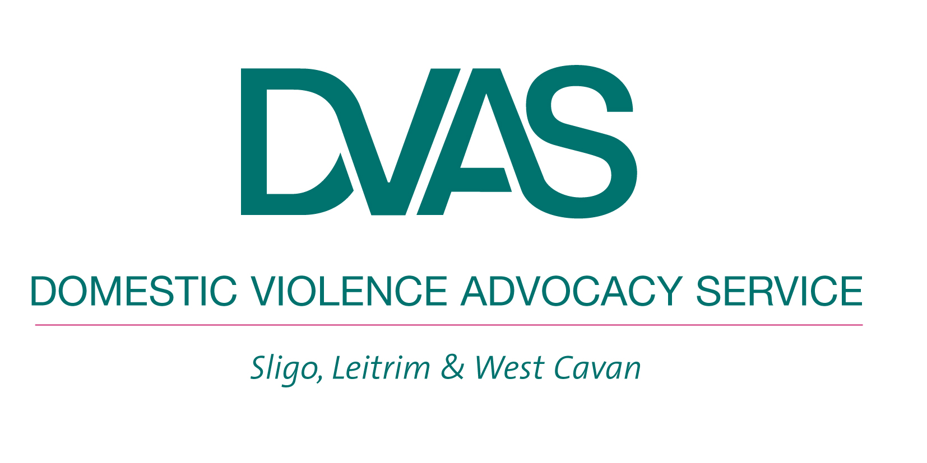
Leitrim have no safe place to go
when fleeing domestic violence

Please ask your general election candidates to commit to standing up for abused women and children in this constituency by promising that if elected, they will work to ensure a refuge service is established in Sligo/Leitrim

Two out of every three women who approach DVAS to seek crisis accommodation return home to the abuser because there is no safe place for them to go. Despite consistent lobbying by DVAS and the support of local state bodies, there has been no commitment at national level to provide the funding needed to establish a crisis refuge in Sligo/Leitrim.

It is unacceptable that women and children have to continue to experience violence and abuse in their own homes and have no safe place to go when they need to access safety. It is often too dangerous or impossible for a woman to try and initiate separation proceedings or apply to the courts for a protective order when they are still living with the person who is abusing them and who poses such a risk to them. We would not ask any other victim of a violent crime to live with the perpetrator of that crime whilst they took them to court. Why should domestic violence victims be treated any differently?

We need your support to make this an election issue!

The following are some questions we would suggest you to ask your general election candidates when they canvass you for your vote.

- Do you support the call for a crisis refuge service for victims of domestic violence in Sligo/Leitrim?

- If elected to Dail Eireann, will you actively work to ensure that additional funding is allocated for the establishment of the refuge in this area? How will you do this?

It is useful if you can follow up your direct questions to the candidates with an e-mail. Their e-mail addresses will be on their election literature.

It would also be helpful if you could inform us on infodvas@eircom.net about what kind of response you got from candidates. We will use this information to secure the active support of the new TD’s for a refuge in Sligo/Leitrim

For more information about the need for refuge and to read 16 case studies on women who needed refuge but did not get it, go to www.domesticviolence.ie
Thank you for you support

DVAS - Phone: 071 914 1515. Fax 017 914 0842. Email:infodvas@eircom.net. Registered Charity CHY 15625.

