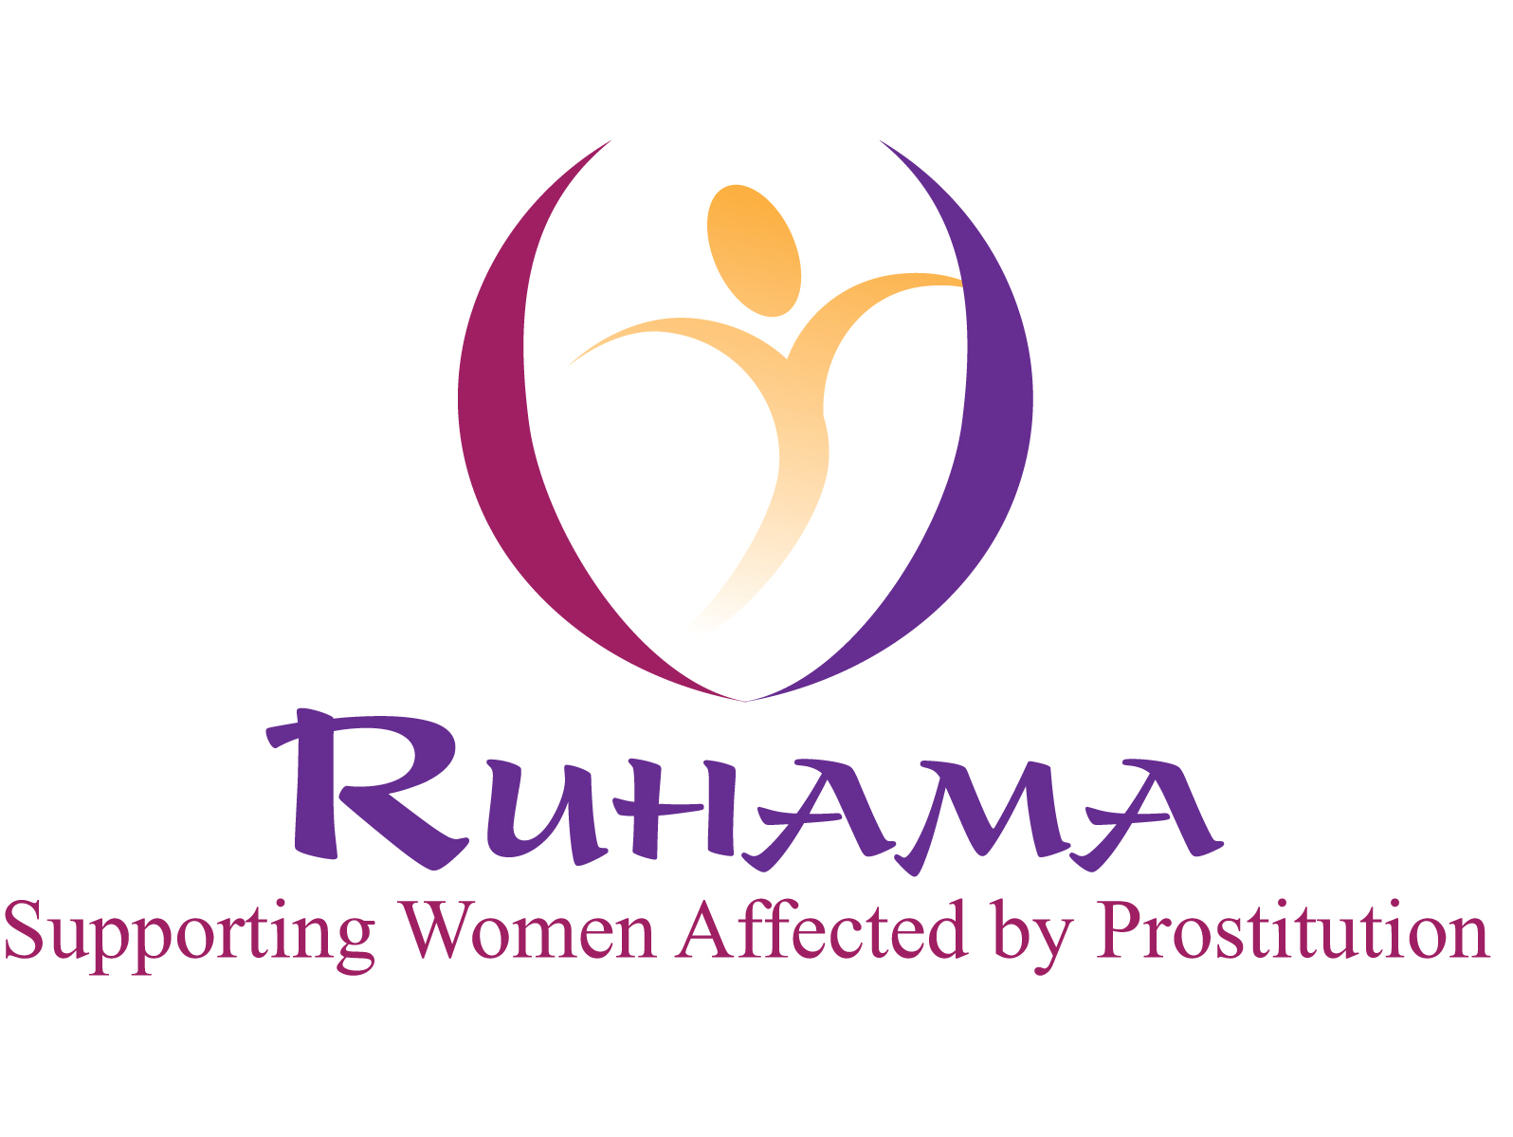

Role: Ruhama Volunteer Development Intern

Duration: 6 Months, part time internship. 21 hours per week (flexible working hours negotiable).

Reports to: Service Manager

This is an exciting opportunity for the right candidate to contribute to and engage with the work of Ruhama. They will be developing and providing a range of innovative supports and systems to support women wishing to engage in Ruhama’s training and development programme. The Development & Education intern will have the opportunity to work directly with the Ruhama practice team, to develop project planning and data collection skills and engage with the broader staff and volunteers on the issues relating to Ruhama’s work. This post will be formally referenced by Ruhama to support further employment opportunities.

Person specification:
The Volunteer Intern will:
- Have an excellent ability to work on own initiative and also as a part of a team.
- A strong interest in the area of development, social justice & human rights.
- An understanding of the exploitative nature of the commercial sex trade and the complex overlapping issues that may be present for Ruhama’s client group.

Main Responsibilities.

- In conjunction with the Service Manager: Develop and document the groundwork for an innovative work placement project for Ruhama’s client group with the objective of making this project a reality in 2012.
- Play a key role in the development and enhancement of file management/data collection systems for the development team.
- Assist in the planning and organisation of development training programmes.

Additional duties.
- Engage in all tasks related to the organisation of classes and training or other developmental/ therapeutic programmes for women.
- Collaborate closely with development colleagues to ensure smooth running of the development programme.
- Attend team meetings and other meetings as required.
- In conjunction with the Practice team create an environment which will support/facilitate women on their individual journeys.
- Collaborate with other organizations to ensure optimum supports for the women.
- Ruhama is a small organisation, to ensure that a high quality of service is offered to its client group all members (staff and volunteers) have to be flexible and prepared to work outside the remit of their individual role descriptions.

This role description may be changed in response to developments within the project. This will be done in conjunction with the role holder.

Expenses: While there is no payment for this role expenses including a lunch allowance will be provided in accordance with Ruhama’s volunteer policy. Additional resources will be available to the Volunteer Development Intern such as access to Ruhama’s reference library and the full support of the Volunteer Co-ordinator in their role.

Application can be made by submission of a CV with Cover Letter by Monday 5th September to: Roisin Kelly, Ruhama, Senior House, All Hallows College, Drumcondra, Dublin 9. Application can also be made by e-mail to admin@ruhama.ie with “Development Intern” in the subject line. Enquiries to 01 8260292.

