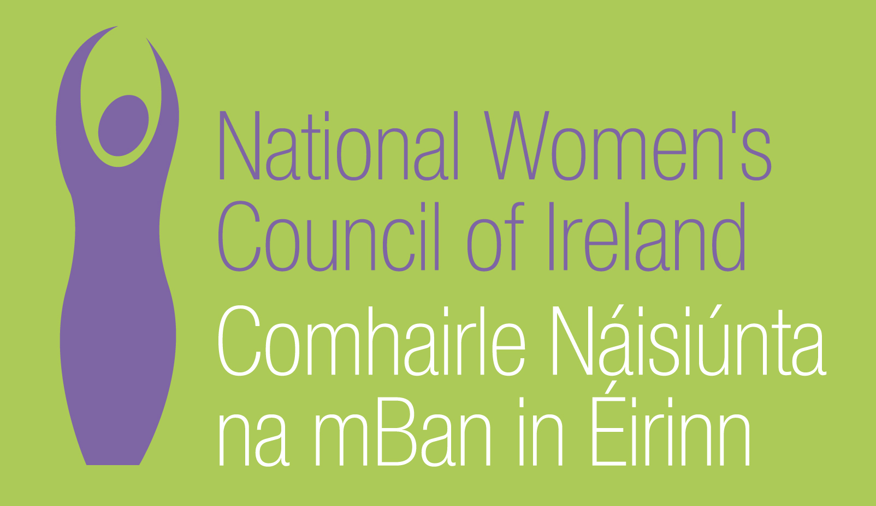

Submission to
Equality Authority Strategic Plan 2011-2014

May 2011

National Women's Council of Ireland
9 Marlborough Court
Marlborough Street
Dublin 1

Tel: 01 - 8787248
www.nwci.ie

Introduction
The National Women’s Council of Ireland (NWCI) is the national representative organisation of women in Ireland. Our mission is to achieve women’s equality, empowering women to work together, while recognising and mobilising difference, in order to remove structural political, economic, cultural and affective inequalities. The NWCI is a feminist organisation which works to promote equality for women, primarily in Ireland, but which also works in solidarity with women around the world. As the representative body for women in Ireland, we support and lead our members in advocating for justice and equality for women.
The National Women’s Council of Ireland welcomes the opportunity to make a submission to the Equality Authority on the Strategic Plan and the consultation process regarding the development of the Plan. We hope that this evolves into a dialogue, and working together in partnership to achieve the objectives of both the Equality Authority the NWCI and our members.

Priority issues for groups experiencing inequality
The priority issues for women’s equality are focused around the following;
Low levels of women in key decision making arenas
Women make up 50% of the Irish population. Yet just over 15% of TDs are women. The most recent General election has made no improvements to the representation levels of women. Without a critical mass of women at key decision making levels in Irish society, women’s issues will not be prioritised. The international evidence shows that countries with greater gender balance in decision making develop and sustain better policies for women and society generally. This gender imbalance is a core priority of the NWCI and we will be initiating in 2011 a two year project to increase the numbers of women in politics.

The impact of care responsibilities on women’s participation in society
Women’s unpaid informal caring responsibilities are arguably, the most significant factor that reinforce and reproduce women’s subordination in public life. Caring in Irish society is ‘culturally constructed women’s work’ which attracts low status, low public policy priority and is resource deficient . The moral imperative on women to undertake the bulk of the caring is a significant factor that disadvantages women and advantages men in the public world of work, politics and culture.
While the availability of childcare has improved in Ireland, the cost of childcare provision and the lack of flexibility still remains a significant barrier to women’s participation in our society.
Impact of the recession and austerity cuts on women and the women’s sector:
Women today are represented in unprecedented numbers in the labour market and contribute to household incomes to a far greater degree than during past periods of economic downturn. Their integration into the work-place means not only that the crisis is having a greater impact on women themselves, but also on their families. It is also the case that women “entered the recession on an unequal economic footing”. Women’s employment patterns are characterised by higher levels of part-time work and high concentration in the so called informal sector with lower earnings and less social protection. In short, women are in a less advantageous position to weather this economic crisis.
The cuts to social welfare payments, child benefit and social services have impacted on women to a greater degree as they are the managers of family incomes and household debt.
Much of the work done to address the concerns of women takes place at grass roots level within locally based women’s groups and community projects. This work includes the provision of training and employment opportunities, the provision of services (counselling, childcare, information, referral and frontline services for women experiencing violence) and perhaps most crucially, the provision of opportunities for individual and collective empowerment - making the voices of women who are most marginalised heard within local decision making structures. This work is under constant threat in terms of funding cuts and lack of a co-ordinated strategy to ensure the survival of these women’s groups. The benefits of the work of women’s organisation, from a social cohesion and equality perspective, far exceed the cost of their maintenance and yet their future is uncertain.

Violence Against Women
Violence against women remains a deep rooted and persistent form of oppression which affects one in 10 women in this country. Since 2008, NWCI members providing services to women experiencing domestic and sexual violence are reporting increases in demand for their services of up to 80% whilst at the same time experiencing cuts in their funding of up to 20%. They note that the issue is receiving little public attention as the situation reaches a crisis point.

Women and Health
Equality proofing in health was a core objective of the Equality Authority’s strategic plan in 2005-6. A number of Equal Status Reviews have been carried out to asses the role of health service providers in meeting the goals of equality across the nine grounds, and to put in place equality proofing of services. The framework for these reviews and a template for equality proofing in health was established under the first demonstration project carried out in partnership with the Equality Authority, the Department of Justice Equality and Law Reform with the HSE in 2005 (Pillinger 2005). This review also recommended that specific policies on gender mainstreaming be integrated into the equality proofing process in order to draw out the specific issues related to gender.

The Equality Authority’s publication ‘Equal Status in Health’, subsequently provided guidance to policy makers and service providers on how to implement equal status policies and practices. Despite a longstanding commitment by the Department of Health and Children to develop a women’s equality strategy, this was dropped as a goal in mid 2000. However, a strategy on men’s health has been developed with goals to improve men’s access to health (HSE, 2003).

The NWCI is currently embarking on a new initiative with the HSE to develop a gender mainstreaming strategy for the Irish health service.

Women and Social Welfare
The social welfare system continues to be based on a male breadwinner model. Over 90% of those on adult dependant payments are women who are reliant on their male partner for an income for them and their children. Care work is not sufficiently recognised and this places women at a long term disadvantage in relation to establishing a social insurance record for eligibility for pensions. The NWCI has long recommended reforms to the social welfare system which would address these gender equality issues and which would move away from trying to resolve all of these issues through one payment.

Current work of the Equality Authority which needs to be continued developed and enhanced.
Case Work
The Case work of the Equality Authority is crucial in terms of supporting individuals to take cases of discrimination to the Equality Tribunal and should continue to be a core part of the Equality Authority’s work in the new Strategic Plan. Providing an analysis of the outcomes of the case work which would be publicly available would enhance this aspect of the work and act to build awareness on the potential of the Equality legislation.

EU Progress Initiative
The Progress Initiative continues to be a very positive programme of the Equality Authority. It has facilitated the development of innovative ways to tackle inequality and provided new models for working with groups experiencing inequality under the nine grounds. It has also enabled and provided new opportunities for cross-sectoral working which without the Initiative may not have happened. It has also been an important resource for community sector organizations to develop new ways of addressing inequality. Under Progress, the NWCI developed the Charter for Women’s Equality, which has become an important tool and resource to encourage organisations to commit to the promotion of women’s equality within their organisations.

Research and data collection
The research published by the Equality Authority has played a critically important role in highlighting the experience of groups experiencing inequality under the nine grounds. In the current economic times this role is even more important as it essential to provide an analysis of the changing situation with regard to inequality in Irish society.

Good Practice Work
The good practice work undertaken by the Equality Authority to date provides concrete and user friendly support in developing initiatives for the promotion of equality. It is important that this work continues. Reviewing the levels of usage and effectiveness of these tools to date is important as is the development of new and up to date resources which meet the articulated needs of organisations throughout a range of sectors.

New initiatives required of the Equality authority to address issues
Women’s Equality
The NWCI is particularly concerned at the lack of understanding regarding the issue of women’s inequality within a wider equality agenda. From an NWCI perspective, the current understanding and analysis of inequality does not give due weight to the depth of discrimination against and oppression of women in Irish society or to the multiple forms of discrimination against particular groups of women. Older women, asylum seeking women and Traveller women in Ireland for example, as is well documented, suffer multiple forms of social exclusion and discrimination because of their gender, age, ethnicity, legal status or a combination of these factors..

Attempting to address inequality for women as simply one of a list of groups experiencing inequality fails to recognise or reflect the fact that women make up half of all of these groupings and experience multiple forms of discrimination and oppression on that basis.
NWCI Recommends: The Equality Authority would undertake substantive research to develop an analysis and awareness of the structural inequality which women experience in Ireland and how to address it within a wider equality agenda.

Gender Proofing
In the current time of economic recession, it is critical that government decisions take into account their impact on women and groups experiencing inequality. The new EU Pact for Gender Equality 2011-2020 states ‘it is important that the Member States and the EU find ways to integrate a gender equality perspective into the analysis of the impact of the crisis and into all policy responses to the recession’.

NWCI Recommends: The Equality Authority should support gender proofing and equality proofing of policy across all areas of its own work, and that of the government, the public, private and community and voluntary sectors.

Health
The relationship between equality and health needs to be re- prioritised by Equality Authority. This would include the development of an analysis and understanding of the how health inequalities intersect with each of the grounds.

NWCI Recommends That the Equality Authority address the prevalence of health inequality amongst those communities covered by equality legislation through a series of actions including the development of policy positions, liaising with the Department of Health and supporting the further development of equality and gender mainstreaming within the Irish health system.

Supporting Groups Working To Challenge Inequality
The NWCI has long experience of working to progress the rights and vision of women, and we believe that the work of both the EA and the NWCI can be strengthened by working in partnership. The NWCI offers to support the work of the EA in whatever ways are found to be appropriate. At the same time, it is our view that the EA should develop clear parameters and commitments to co-ordinating with, and supporting, the work of groups that challenge inequalities. Most of these groups are working within the Community and Voluntary Sector.

The NWCI Recommends: The Equality Authority supports groups working to overcome inequality:
- By lobbying for their direct participation in relevant policy fora;
- By promoting their campaigns and entering into joint campaigns;
- By supporting them to carry out relevant research and entering into joint research projects.

The NWCI Recommends: An annual EQUALITY publication be produced in user-friendly style which presents the key facts and figures on inequality in Ireland in relation to each ground and encompassing gender disaggregated data.

Promote the extension of the Equality Legislation
The Equality legislation needs to be more comprehensive with regard to the relationship between a person’s status in society and the impact of inequality. It is time to reform the legislation so as to make it appropriate to the experience of inequality. In particular the ground of socio-economic status needs to be incorporated as the distribution of power and resources in society impacts on the experiences, opportunities and outcomes for people and on their life choices.

The NWCI recommends: The Equality Authority promote the inclusion of new grounds into the Equality Legislation including;
- Socio economic status
- Criminal Conviction
- Trans people

Cullen, K., Delaney, S., Duff, P. (2004) ‘Caring, Working and Public Life’, in Equality Research Series. Dublin: The Equality Authority, p. 18; O'Sullivan, S., (Ed.) (2007) Contemporary Ireland: A Sociological Map. Dublin: University College Dublin Press
Women’s care responsibilities are recognized as a significant obstacle to gender equality in the National Women’s Strategy 2006-2016.
NWCI Briefing Document – Jane Pillinger December 2010
Ibid
EU Pact for Gender Equality 2011-2020 http://www.consilium.europa.eu/uedocs/cms_data/docs/pressdata/en/lsa/119628.pdf
Katherine Rake (2009): Are women bearing the burden of the recession? A Fawcett Society report, available at: http://www.fawcettsociety.org.uk/documents/Arewomenbearingtheburdenoftherecession.pdf

