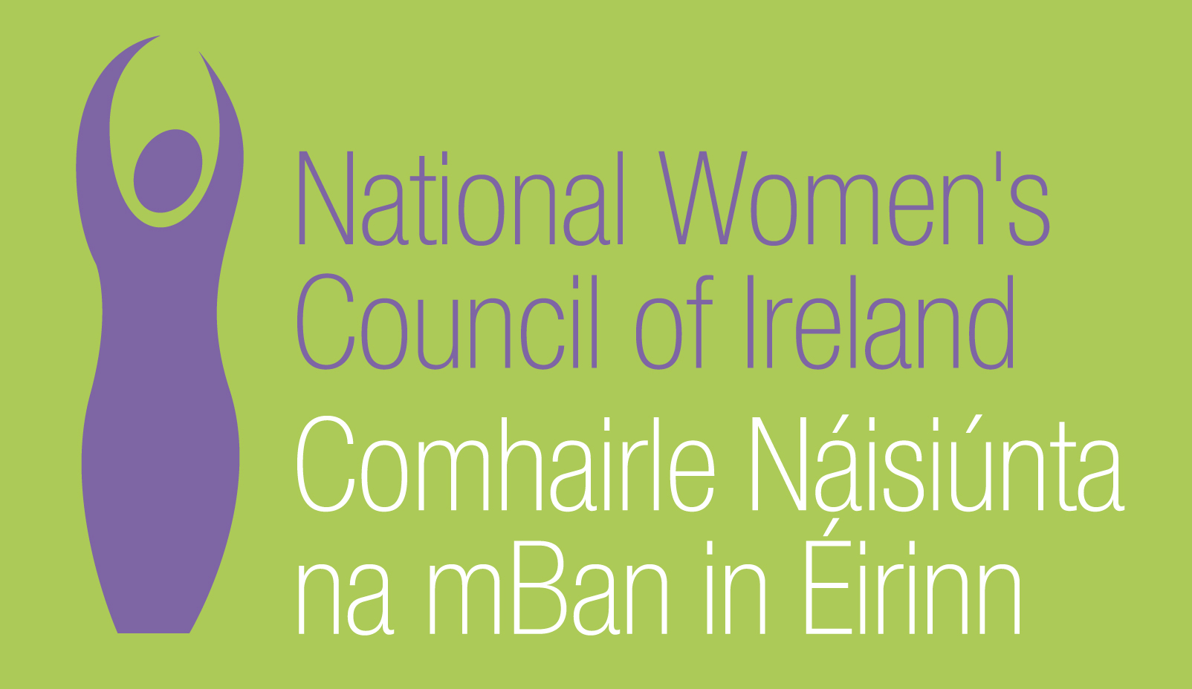

NATIONAL WOMEN’S COUNCIL OF IRELAND
INVITATION TO REQUEST FOR TENDER

Aim of the Project

- To identify gender equality issues for women in the social welfare system who will be activated under the new Single Age Working Payment (SWAP) and the new National Employment and Entitlements Service (NEES) under the Department of Social Protection (DSP).

- To identify how gender equality issues can be mainstreamed into the development and implementation of the NEES and the SWAP and to develop and enhance the institutional capacity.

The final publication will be used as an NWCI lobbying tool to inform and influence policy on the activation of women and mothers from welfare into employment.

Background to the Project

The NWCI has been established since 1973, the organisation currently has 170 affiliated members, representing over 300,000 women in Ireland. Reform of the social welfare system has been a central component of the work of the NWCI to achieve economic equality for women in Ireland. In 2004 the NWCI launched ‘A Woman’s model for Social Welfare Reform, which set the direction for the policy and campaigning work of the NWCI with regard to social welfare over the last decade. The issues of social welfare reform have also been to the forefront of the membership who have actively engaged locally and nationally in campaigns to bring about a social welfare system that facilitates women’s economic independence and incorporates an ethic of care.

The current proposals to activate women and particularly mothers provide an opportunity to develop a women friendly model of activation.

SIPTU, trade union are partnering the NWCI in this project. It is critical that the model of activation that is developed is focused on moving women from welfare to quality secure employment. The project will seek to ensure that the activation of women has the potential to lead to quality employment as opposed to low paid vulnerable employment. The NWCI and SIPTU are currently working together in the Coalition to Protect the Low Paid and successfully campaigned to have cuts to the Minimum Wage reversed. We are also working to protect low paid women workers in the contract cleaning sector.

Policy Context

- The Department of Social Protection in 2010, published its Report on the desirability and feasibility of introducing a single social assistance payment for people of a working age.

- The Department of Social Protection has established the National Employment Entitlements Service and its remit was set out in the Programme for Government “We will replace FÁS with a new National Employment and Entitlements Service so that all employment and benefit support services will be integrated in a single delivery unit managed by the Department of Social Protection. This integrated service would provide a ‘one stop shop’ for people seeking to establish their benefit entitlements; looking for a job; and seeking advice about their training options…This service will offer users a higher level of personalised employment advice, with more frequent face-to-face interviews.”

- The Department of Social Protection introduced changes to the Lone Parents Allowance in Budget 2010 and 2011 and have proposed in the 2012 Social Welfare Bill to activate lone Parents when their youngest child reaches 7years.

- The Oireachtas Joint Committee on Jobs, Social Protection and Education launched its ‘Report on the Single Working Age Payment Proposal’ in March 2012

- The Department of Education and Skills are in initial stages of establishing SOLAS, the new further education and training authority.

The proposals to develop a single working Age Payment and the establishment of the NEES will be the first large scale activation of women, particularly mothers, from welfare into the labour market.

There are three groups of women who are primarily affected.

- Women on Unemployment payments – 172,451
- Women on Lone Parent Allowance – 90,000 (98% are women)
- Women on Qualified Adult Payments (spouses and partners of recipients of unemployment payments) – 70,000

Women on social welfare experience discrimination and poverty. Lone parents face the highest risk of poverty in Ireland - 16.6% in consistent poverty. As sectors which predominantly employ women are being curtailed e.g. retail, services, financial sectors, women’s unemployment has increased - by 10.1% in the last year.

The status of qualified adult continues to reflect the male breadwinner model on which the Irish social welfare system was developed. Qualified adults, a large proportion of them mothers, depend on their partners for their income and their children’s. The employment status of mothers is a significant factor in determining child poverty.

Currently women form the majority of part-time employees, are more likely to be employed in sectors that are characterized by low pay, and in vulnerable employment. There are over 300,000 workers in retail, catering and cleaning and the majority of these workers are women and paid just above the minimum wage.

The scope of the project

Research

Aim: To develop a women friendly model of activation. It will achieve this by;

Identifying and making recommendations on the following
- barriers for women to progression,
- supports required in the process of activation
- Institutional changes required to enhance the implementation of gender mainstreaming in the NEES and the SWAP.

- Draw on International evidence on positive models of activation
- Include a Literature Review of gender mainstreaming strategies in processes of employment activation
- Draw on outcomes of Interviews with Key stakeholders
- Integrate outcomes of two consultation focus groups. (The NWCI will be responsible for the costs of the focus groups. The focus group process must be integrated into the tenderers.)
- Produce a model of practical supports required by women to access and progress within the labour market which can be adopted by the state institutions.

Additional Project activities
- Present findings at launch of the publication and seminar and identify international experts to speak and discuss international good practice and experience.

- Present findings to Roundtable with key stakeholders of high level civil servants engaged with the implementation of NEES and the SWAP.

All costs for the publication, seminar and roundtable will be covered by the NWCI.

- Project Management

The NWCI shall be responsible for the management of the project and final approval of the report. The NWCI will also establish an Advisory Group to advise on the general orientation of the research and to comment on drafts of the research.

TENDERING PROCESS

Tender requirements

Proposals should include the following

- A statement or narrative demonstrating the tenderers understanding of the project aims and intended objectives
- A demonstrated understanding and track record in social welfare and activation policy
- A demonstrated understanding and awareness of the requirements of the scope of the project
- An outline of skills, qualifications and experience in the research area and in management of research.
- A work plan
  - identifying the approaches and methodologies to be used in carrying out this tender
  - demonstrating how the scope of the research will be achieved
  - including a timeframe for focus groups process

- Demonstration of the arrangements for effective communication with designated personnel so as to ensure that the objectives of the project are being achieved, that the project does not overrun on time or cost and that any other problems that arise can be resolved

- Costs
  - Set out any issues which may impact on the cost
  - All costs must be inclusive of VAT
  - Demonstrate value for money
  - Breakdown of costs showing the number of days required to complete the task, the number of days each person will be employed on the task, the cost per day.
  - The fee quoted should include travel and subsistence costs

- The tender must include a list of recent clients who may be contacted for references in connection with the tender

- Ability to meet the timeframe of the Project.

Project Budget
The total budget for the Project is €12,000 inclusive of VAT and all expenses.

Timescale
The final deadline for the completion of the Report will be the end of September 2012. A draft report will be required in August 2012.

- Conditions of Tender
  - The NWCI reserves the right not to award a contract in the event that no proposal is deemed to be suitable. The lowest tender may not necessarily be accepted.
  - The NWCI requires that suppliers will treat all information provided pursuant to this Invitation to tender in strict confidence.
  - Information supplied by tenderers will be treated as contractually binding. However, the NWCI reserves the right to seek clarification of any such information.
  - All material gathered and all outputs arising out of the proposed contract will remain the sole property of the NWCI. Tenderers must agree to this condition in their proposals. All information and knowledge acquired in the course of the research will be treated as confidential and should not be divulged to any unauthorized person or used for any purpose whatsoever without the prior approval of the NWCI. The NWCI will ensure that the final report gives due credit to the consultants for research, textual and editorial work undertaken in its preparation. Any subsequent use of the material shall also give due credit.
  - It will be a condition for the award of a contract that the successful contractor (and agent, where appropriate) will be promptly required to produce a Tax Clearance Certificate from the Irish Revenue Commissioners. In addition, contractors must retain records of tax reference numbers for any sub-contractors, whose payments exceed €5,000 including VAT. All payments under the contract will be conditional on the contractors being in valid possession of valid certificates at all times.
  - Tenders that are delivered late will not be considered.
  - Any conflicts of interest involving a contractor (or contractors in the event of a group or consortium bid) must be fully disclosed to the NWCI, particularly where there is a conflict of interest in relation to any recommendations or proposals put forward by the tenderer.
  - The NWCI will not be liable for any costs incurred in the preparation of the tender.

  - Payment for all services covered by this Invitation to Tender will be on foot of appropriate invoices. Invoicing arrangements will be agreed with the successful supplier(s), subject to the terms of the Prompt Payment of Accounts Act (27 of 1997).

  - Payment of all services covered by this invitation to tender will be on the basis of the agreed contract price, completion of agreed stages of the work plan and upon the submission of the appropriate invoices.

40% - at the beginning of the project:
40% - at 3/4 stage
20% - once final report produced and agreed

  - The NWCI will own the completed research and will retain copyright.

  - The NWCI will retain the right to publish as deemed appropriate.

- Evaluation of Tenders
Tenders will be evaluated initially with reference to the following qualification criteria:
- Completeness of tender documentation
- Stated ability of tenderer to meet the requirements of the Invitation to Tender
Only those tenders, which meet both of these qualifying criteria, will be eligible for inclusion in the award process.

The contract will be awarded from the qualifying tenders on the
basis of the most economically advantageous tender applying the
following award criteria, not necessarily in this order:

- Cost effectiveness
- Understanding of the project
- Relevant experience of the designated personnel
- Reference sites, and
- Timeframe for completion

Tenderers are advised that they may be required to make a formal presentation of their proposal.

Three sealed copies should be returned to

The National Women’s Council of Ireland
2-3 Parnell Square East
Dublin 1

To Arrive not later than 9th of May 2012. The Proposals should be made for the attention of Anne Gibney, Tender for Activation and Gender Mainstreaming Project’.

All information provided to NWCI in response to this request will be treated in strict confidence.

Funded by the Equality Mainstreaming Unit which is jointly funded by the European Social Fund 2007-2013 and by the Equality Authority”
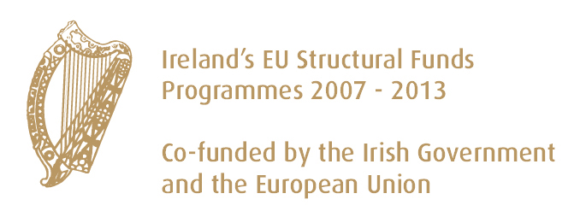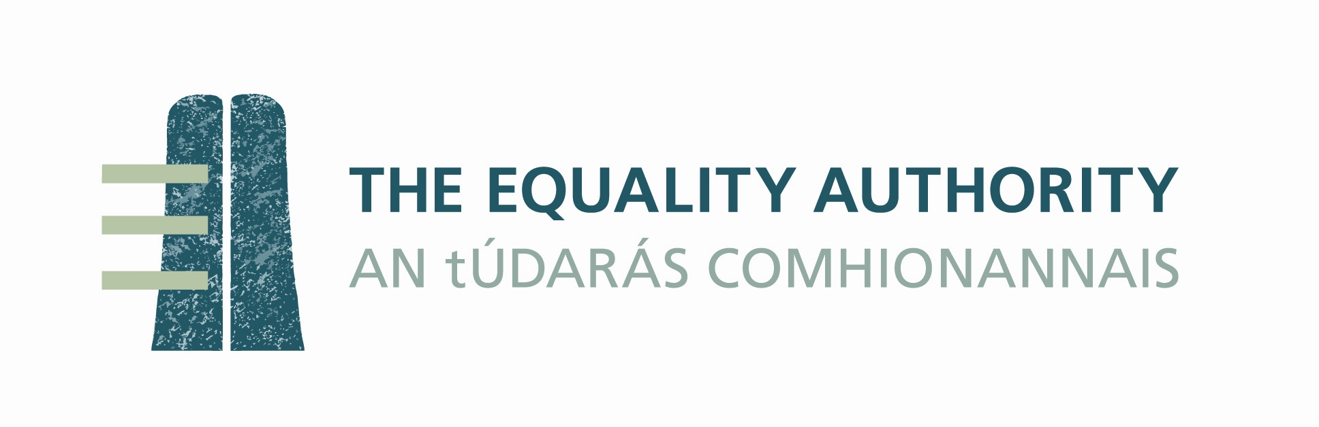
Investing in your future

The SWAP is intended to bring together all social assistance payments for the working age population – unemployment, lone parents, disabled and partners under Qualified Adult payments under a single means test and conditional on actively seeking work.

