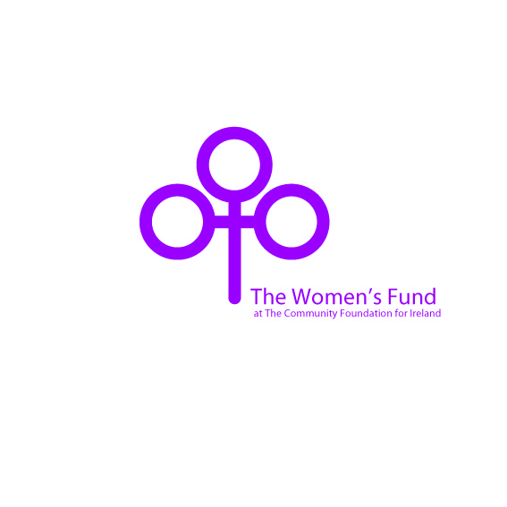
APPLICATION FORM

The Women's Fund at The Community Foundation for Ireland
Please ensure you have read the Full Criteria before completing this form
Section 1
Name of the Organisation (this is the name of the organisation to whom payment is made)

CHY number of the Organisation (if applicable)

Name of the Contact Person (please give the name of the person who will be responsible for the grant)

Details of Contact Person
Position (Job title)
Address
Email address
Daytime phone number

Address of the Organisation (if different to that of the Contact Person)

Please state the main aims and activities of the Organisation. What year was it founded?

Section 2
Please describe the project for which you require funding

To which Measure does it apply? (Please tick the relevant box)
- Measures aimed at Preventing Violence against Women  The development of community based approaches   --------------------------------------------------------  Early childhood interventions   --------------------------------------------------------  Working with men and boys on changing gender norms   ---------------------------------------------------------  School based interventions   ---------------------------------------------------------  Influencing policy  | - Measures empowering Women to take leadership roles  Developing the capacity of locally based women’s groups to set a clear agenda and influence decision-making processes, including building women’s understanding of an equal society   ---------------------------------------------------------  Building solidarity and support amongst young women from different backgrounds and communities   -----------------------------------------------------------------------  Promotion of the inclusion of young women as leaders in communities and at political level 

How does the project address the above measure?
Give a brief account of the need for it
How does it contribute towards either
- Preventing Violence against Women
or
- Empowering Women to take leadership roles ?

What will the outcome be? What will be different as a result?
Tell us about how you will share the learning from the project
Are you working in partnership with other groups on this project?

Section 3
Please provide a breakdown of the costs involved

How much are you applying for?

What funding (if any) have you already secured for this work?

When will the project begin? What will be the duration?

Please indicate if you would like us to share
your information with another potential funder YES/NO
Please indicate whether you have read the Women’s Fund
Full Criteria which accompany this form YES/NO
Please indicate whether you understand the reporting
requirements should your grant application be successful YES/NO

Please return the completed Women’s Fund Application Form
By email: info@foundation.ie
By post: The Women’s Fund at The Community Foundation for Ireland
32 Lower O’Connell Street,
Dublin 1

Tel: 01 874 7354
www.communityfoundation.ie

Registered in Ireland. No.338427.
Registered Office: One Spencer Dock, North Wall Quay, D1
The Community Foundation for Ireland is a company limited by guarantee. CHY 13967

