FULL CRITERIA
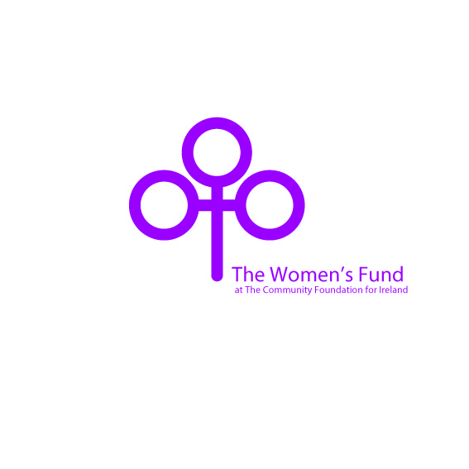

The Women's Fund at The Community Foundation for Ireland
Background:
In April 2010 a major seminar on women’s philanthropy took place in Dublin. At this, The Women's Fund for Ireland was launched by The Community Foundation for Ireland.
When women and girls prosper, entire communities succeed. The Women's Fund for Ireland fuels change in our communities by supporting the most innovative and positive solutions to the issues facing women in Ireland today. It’s mission is to encourage philanthropy among women, improve the lives of women through social change grantmaking, and educate the entire community about the benefits to society when the the potential of women is realised.
Women’s Funds have developed around the world in recent years. They seek to transform individuals and tackle invisible problems. Women play a crucial role in creating and sustaining strong communities but there are often barriers which prevent their participation or engagement with local opportunities, or stop them fulfilling their potential to play a role within the broader community. They may struggle to get their voice heard in order to influence decisions that affect them, their families and communities.
The need to establish new sources of funding for initiatives for women in Ireland is critical, in part as a result of reducing public sector subsidies. The new Women's Fund creates a unique opportunity for donors to provide financial support to benefit women’s initiatives in Ireland now and for generations to come.
The Fund is being run under the umbrella of The Community Foundation for Ireland. Grant-making priorities will evolve as needs change and the fund grows. The Fund will focus on problems encountered by women but will also look at empowerment opportunities for women.
In the early stages, smaller projects will be supported but over time, as the Fund grows, there will be a focus on ‘systemic’ solutions in a long term strategic manner. Initially, the majority of this funding will be available for locally focused projects. Initial fundraising efforts for the Fund have focussed on building an initial endowment of a scale that can make a difference for future grant-making.

Criteria (October 2010)
Grants will be made to charities or not-for-profit organisations working with women. Grants will initially range between €1,000 and €5,000. The Women’s Fund has two main priority areas which it will fund initially. As the fund grows these areas will be reviewed and/or expanded.
- Measures aimed at Preventing Violence against Women
“Violence against women and girls is one of the most widespread violations of human rights. It can include physical, sexual, psychological and economic abuse, and it cuts across boundaries of age, race, culture, wealth and geography. It takes place in the home, on the streets, in schools, the workplace, in farm fields, refugee camps, during conflicts and crises.” (United Nations Development Fund for Women (UNIFEM))

The Women’s Fund will make grants for Preventing Violence against Women through these five measures:
1. The development of community based approaches
2. Early childhood interventions
3. Working with men and boys on changing gender norms
4. School based interventions
5. Influencing policy
- Measures empowering Women to take leadership roles
Aim: To work with women towards affecting change by raising awareness of women’s inequality. We believe that building women’s understanding of why things are the way they are in an unequal society is an important first step in the process of promoting women as leaders.
The Women’s Fund will make grants empowering Women to take leadership roles through these three measures:
- Developing the capacity of locally based women’s groups to set a clear agenda and influence decision-making processes, including building women’s understanding of an equal society
- Build solidarity and support amongst young women from different backgrounds and communities
- Promotion of the inclusion of young women as leaders in communities and at political level

Applicants should clearly demonstrate:
- How they will address at least one of the above measures
- The need for such a project
- How the project will contribute towards either A. Preventing Violence against Women or B. Empowering Women to take leadership roles
- What the outcome of the project will be
- A willingness to share learning with others if necessary
- A commitment to working in partnership with other organisations

The fund will not cover:
- Core or ongoing costs (such as rent, salaries)
- College courses
- Overseas travel
- Promotion of religious causes
- Work that has already taken place
- Non-charitable activities
- Political activities
- Sponsorship or fundraising events
- Work taking place outside the Republic of Ireland

How To Apply
Visit www.communityfoundation.ie for the Women’s Fund Grant Application Form. The website will tell you when the next closing date for the fund is.
Call The Community Foundation if you have any queries about your application.
Complete all sections of the Application Form and submit it by email to info@foundation.ie before the prescribed closing date.
The Assessment Process
The Community Foundation’s Grants Team will check that your application meets the basic criteria and that the timing of the project is suitable.
The Women’s Fund Steering Group will assess the application and award funding to the applications deemed to be most suitable and impactful.
The Community Foundation’s Grants Team will inform you of the outcome of your application. If unsuccessful you will be advised of the reasons why.
If successful your grant payment will be made accordingly.
Reporting
You will be asked to report on the outcomes of your project both verbally and through the provision of an Outcome Report after six months. Guidelines for your Outcome Report will be provided.
Evaluation
The Women’s Fund at The Community Foundation for Ireland may undertake site visits to your organisation in order to examine the effectiveness of the grant.

The Women’s Fund at The Community Foundation for Ireland
32 Lower O’Connell Street
Dublin 1
Tel: 01 8747354
Email: info@foundation.ie
www.communityfoundation.ie

