From Local to Global – Grassroots Women Sustaining the Women’s Movement

Women, Human Rights, Fun, Social Movement, Change
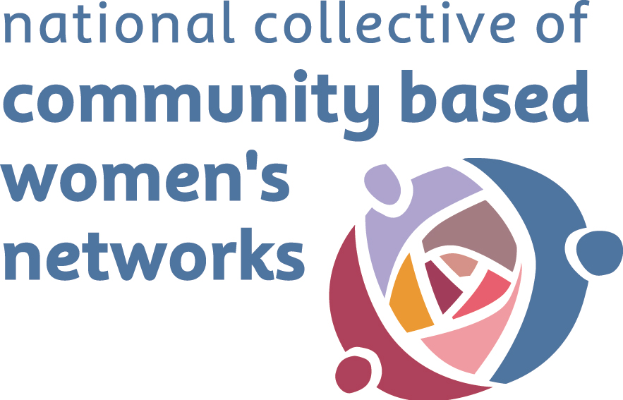
Wednesday 23rd February 2011
10am-4pm

Ashling Hotel, Parkgate Street, Dublin 1

Organised by the National Collective of Community based Women’s Networks and in celebration of Learning Communities Day –
part of the Aontas Adult Learners Festival

Admission is free but please return booking form below.

--------------------------------------------------------------------------------------------
Booking Form (please detach and return)
Name: ______________________________________________________________
Organisation: ______________________________________________________________
Telephone: ______________________________________________________________
Email address: ______________________________________________________________
Dietary requirements: _________________________________________________________
Access requirements: _________________________________________________________
Workshop choice: Global Feminism
or
Feminist Movement Building

There is no charge for this conference. To facilitate those who would otherwise be unable to attend, a contribution to the cost of travel and child/social care costs can be made (receipts will be needed).

Please indicate if you require: Travel costs________________ Child/social care ____________

Please return form to Elva O’Callaghan, NCCWN, Brookfield Enterprise Centre, Brookfield, Tallaght, Dublin 24, tel: 085-131 2983 or email: nccwn@eircom.net by 17th February 2011.

