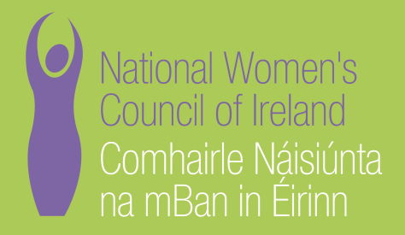

Application Form for the Post of
ESHTE Project Officer

In order to be considered for the post of ESHTE Project officer with the National Women’s Council of Ireland, candidates must submit this completed application form, to be received by 5pm on Weds, 19th September 2018.

Please email applications to Tara Brown ESHTE Project Coordinator tarab@nwci.ie
Selection will be based on the information in the application form alone and CVs will not be considered.
PERSONAL DETAILS

NAME:
ADDRESS:

________________________________________
TELEPHONE: ________________________________________
EMAIL: ________________________________________

RELEVANT EDUCATION AND TRAINING HISTORY
A relevant third level degree or equivalent third level qualification:

PRESENT (or if unemployed most recent) EMPLOYMENT – This post requires at least 2 years’ experience in a similar role in a Non-Governmental Organisation (NGO) or other relevant sector
Name and Address of employer

Post held:

Duties of Post:

Date Appointed: ___________ Period of notice: ________

PREVIOUS WORK EXPERIENCE
Please list, starting with the latest, any relevant previous positions you have held, with a brief description of duties and dates.
Employer:

Post held:
Period of Employment:

Reason for leaving:

Employer:
Post held:
Period of Employment:
Reason for leaving:

Employer:

Post held:

Period of Employment:

Reason for leaving:

RELEVANT COMPETENCIES FOR THE POST
The job description shows qualifications, experience and skills required or desirable to be able to carry out the responsibilities of this post. Please therefore address all these elements as listed in table below, drawing upon all of your experience, whether in paid employment or in a voluntary capacity. Please add additional space as necessary

PROFESSIONAL KNOWLEDGE EXPERIENCE AND SKILLS – Please limit each answer to no more than 200 words

Demonstrable knowledge and understanding of violence against women and feminist ethos, specifically the issue of sexual violence and harassment.

Demonstrable knowledge and understanding of engaging various stakeholders (in particular students) using social media and digital campaign strategies.

Demonstrable experience of successfully managing social media platforms, content creation and website management.

Excellent communications skills, both written and verbal, with an ability to communicate to different audiences, including report writing, writing for the media and research and writing policy documents.

Demonstrable experience of administration, including financial administration.

PLEASE DESCRIBE IN 200-300 WORDS WHY YOU ARE A GOOD FIT FOR THIS POSITION

REFEREES
Please give the names, addresses and phone numbers of two referees (one should be a current or most recent employer):

DECLARATION I declare that the information set forth in this application form is, to the best of my knowledge, true and complete.

Signature:

Date:

This is a part time position, 3 days per week, based in Dublin. Contract is for a period 6 months from October 2018 – March 2019.
Salary Scale: The successful candidate will commence on €37,000 pro rata. Candidates should note that salary will not be subject to negotiation.
The closing date for receipt of completed and signed application forms is 5pm on Weds 19th September 2018. Late applications will not be reviewed.

Interviews are scheduled to take place on 27th Sept 2018.

