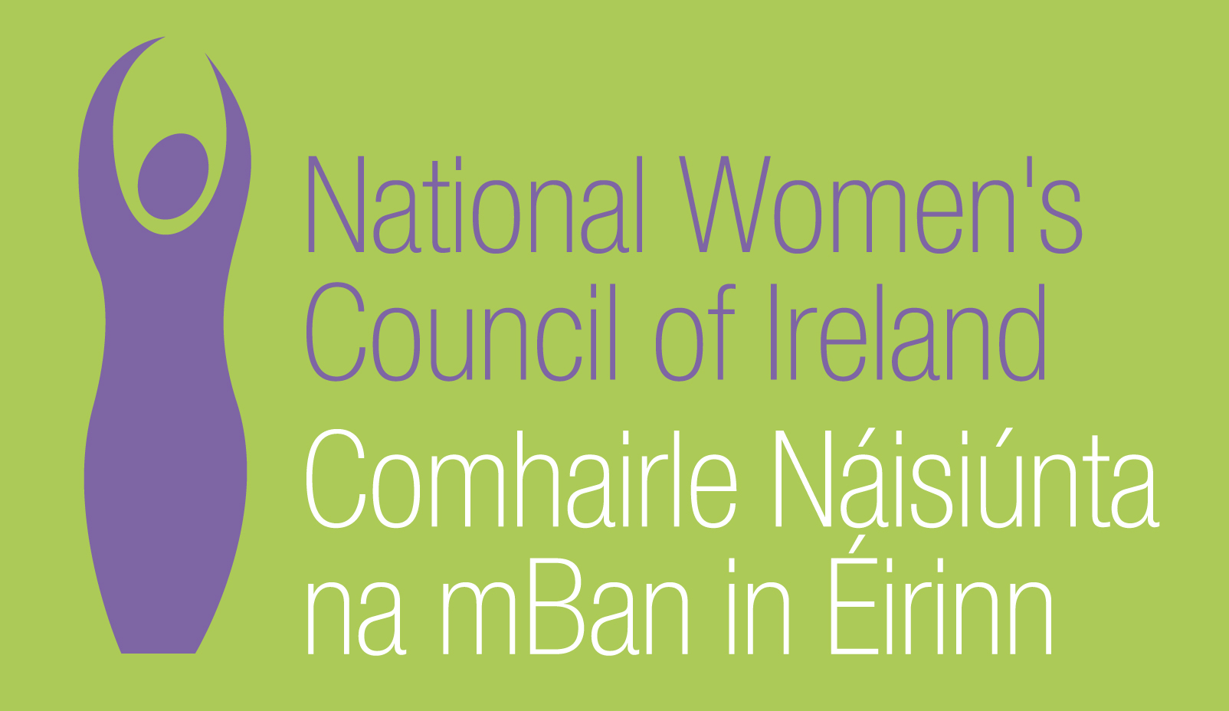

Application Form for the Post of
Digital Communications and Fundraising Officer

In order to be considered for the post of Digital Communications and Fundraising Officer
with the National Women’s Council of Ireland, candidates must submit this completed application form to be received by 5 pm, Wednesday, 15th July 2020.

Please send your completed form to Anne Gibney, anneg@nwci.ie

Please note a CV is not required and should not be submitted.
NWCI is an equal opportunities employer and welcomes applications from all interested parties including people from diverse backgrounds and under-represented groups including ethnic minority groups and people with disabilities. NWCI offers a number of flexible working arrangements.
Selection will be based on the information in the application form alone.

PERSONAL DETAILS

NAME:
ADDRESS:

________________________________________
TELEPHONE: ________________________________________
EMAIL: ________________________________________

RELEVANT EDUCATION AND TRAINING HISTORY
A relevant third level degree or equivalent third level qualification:

PRESENT (or if unemployed most recent) EMPLOYMENT – This post requires a minimum of 2 years’ experience in working in communications/digital communications/web marketing/fundraising

Name and Address of employer
Post held:
Duties of Post:

Date Appointed: ___________Period of notice: ________

PREVIOUS WORK EXPERIENCE
Please list, starting with the latest, any relevant previous positions you have held, with a brief description of duties and dates.
Employer:
Post held:
Period of Employment:
Reason for leaving:

Employer:
Post held:
Period of Employment:
Reason for leaving:

Employer:
Post held:
Period of Employment:

Reason for leaving:

RELEVANT COMPETENCIES FOR THE POST
The job description shows qualifications, experience and skills required or desirable to be able to carry out the responsibilities of this post. Please therefore address all these elements as listed in table below, drawing upon all of your experience, whether in paid employment or in a voluntary capacity. Please add additional space as necessary

PROFESSIONAL KNOWLEDGE EXPERIENCE AND SKILLS – Please limit each answer to no more than 200 words
Proven ability to plan and deliver digital fundraising campaigns, achieving desired targets and reporting on impact

Proven ability to write and edit highly engaging copy for different audiences across online communications, with demonstrable skills in being clear and concise.

Ability to undertake accurate analysis of relevant digital analytics or research and produce jargon free summaries.

Demonstrable experience of promoting and protecting an organisations’ brand on a variety of platforms

Excellent IT skills, including using Content Management Systems, email marketing systems, social media tools and website. Knowledge of HTML, Knowledge of CRM/Salesforce.

Strong commitment to feminism and good understanding of women’s rights, equality issues, the NGO sector and Irish political landscape.

Ability to work independently, in a fast pace environment and within competing deadlines

Experience of managing relationships with different stakeholders, working as part of a team and using collaborative and partnership approaches.

Ability to adopt creative and innovative approaches, testing and using new technologies

PLEASE DESCRIBE IN 200-300 WORDS WHY YOU ARE A GOOD FIT FOR THIS POSITION

REFEREES
Please give the names, addresses and phone numbers of two referees (one should be a current or most recent employer):

DECLARATION I declare that the information set forth in this application form is, to the best of my knowledge, true and complete.

Signature:

Date:
This is a fulltime position (35 hours/week) offered on a 12-month contract, based in Dublin.
Candidates should note that salary will not be subject to negotiation. Successful candidate will commence on first point of the scale.
Salary Scale: Officer
Point 1 37,000 Point 2 38,000 Point 3 39,000 Point 4 40,000 Point 5 41,000 Point 6 42,000 Point 7 43,000 Point 8 44,000 Point 9 45,000
The closing date for receipt of completed and signed application form is 5 pm, Wednesday, 15th July 2020.
Late applications will not be reviewed.
Interviews will take place on Friday, 24th July and Saturday, 25th July 2020.

