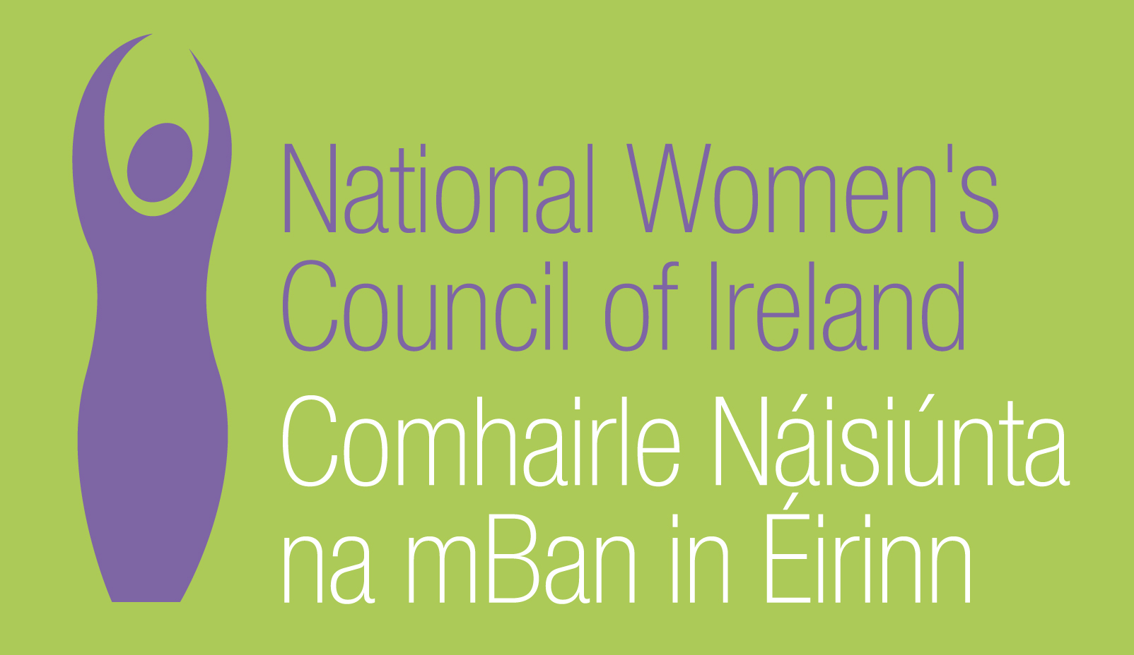

Application Form for the Post of
Women’s Health Officer

In order to be considered for the post of Women’s Health Officer with the National Women’s Council of Ireland, candidates must submit this completed application form to be received before 5pm, Thursday 4th April 2019.

3 signed copies of application should be submitted in hardcopy marked ‘Private & Confidential’ to:
Anne Gibney, Head of Finance and Operations, National Women’s Council of Ireland, 100 North King Street, Dublin 7
Please note a CV is not required, and should not be submitted.
Selection will be based on the information in the application form alone and CVs will not be considered.
PERSONAL DETAILS

NAME:
ADDRESS:

________________________________________
TELEPHONE: ________________________________________
EMAIL: ________________________________________

RELEVANT EDUCATION AND TRAINING HISTORY
A relevant third level degree or equivalent third level qualification:

PRESENT (or if unemployed most recent) EMPLOYMENT – This post requires at least 2 years’ experience in a similar role in a Non-Governmental Organisation (NGO) or other relevant sector
Name and Address of employer
Post held:
Duties of Post:

Date Appointed: ___________Period of notice: ________

PREVIOUS WORK EXPERIENCE
Please list, starting with the latest, any relevant previous positions you have held, with a brief description of duties and dates.
Employer:
Post held:
Period of Employment:
Reason for leaving:

Employer:
Post held:
Period of Employment:
Reason for leaving:

Employer:
Post held:
Period of Employment:

Reason for leaving:

RELEVANT COMPETENCIES FOR THE POST
The job description shows qualifications, experience and skills required or desirable to be able to carry out the responsibilities of this post. Please therefore address all these elements as listed in table below, drawing upon all of your experience, whether in paid employment or in a voluntary capacity. Please add additional space as necessary

PROFESSIONAL KNOWLEDGE EXPERIENCE AND SKILLS – Please limit each answer to no more than 200 words
Demonstrable knowledge and understanding of the specific health needs of women in all their diversity

Demonstrable knowledge and understanding of the Irish health system, its agencies and institutions

Demonstrable track record in event management

Excellent communications skills, both written and verbal, with an ability to communicate to different audiences, including report writing, writing for the media & social media and drafting of policy submissions

Experience of conducting consultations with groups / individuals to support policy development

Experience of representing organisation(s) at meetings / events

Clear understanding of and commitment to a feminist ethos

PLEASE DESCRIBE IN 200-300 WORDS WHY YOU ARE A GOOD FIT FOR THIS POSITION

REFEREES
Please give the names, addresses and phone numbers of two referees (one should be a current or most recent employer):

DECLARATION I declare that the information set forth in this application form is, to the best of my knowledge, true and complete.

Signature:

Date:
This position is for 5 days a week based in Dublin. Contract is initially for a period of 12 months.
Candidates should note that salary will not be subject to negotiation. Successful candidate will commence on first point of the scale. Salary for 5 days a week is €37,000.
Salary Scale: Officer
Point 1 37,000 Point 2 38,000 Point 3 39,000 Point 4 40,000 Point 5 41,000 Point 6 42,000 Point 7 43,000 Point 8 44,000 Point 9 45,000
The closing date for receipt of completed and signed application form is 5pm Thursday 4th April 2019.
Late applications will not be reviewed.

