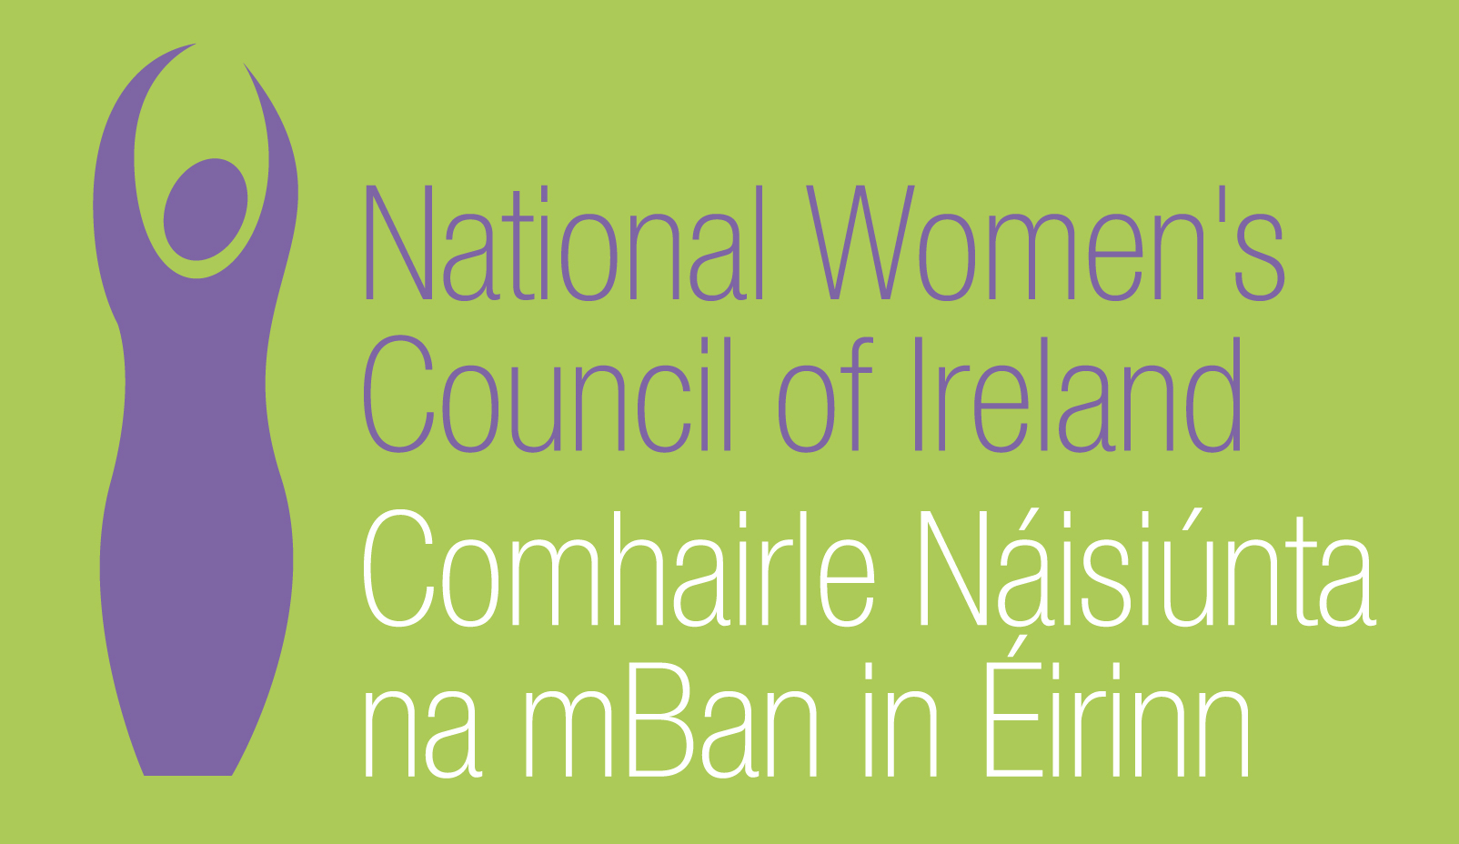

Application Form for the Post of
Policy Assistant, Women’s Health

In order to be considered for the post of Policy Assistant, Women’s Health with the National Women’s Council of Ireland, candidates must submit this completed application form, before 5pm on 20th April 2017. 3 Copies of application should be submitted in hardcopy marked ‘Private & Confidential’ to:
Anne Gibney, Head of Finance and Operations, National Women’s Council of Ireland, 100 North King Street, Smithfield, Dublin 7
Please note a CV is not required, and should not be submitted.

Selection will be based on the information in the application form alone and CVs will not be considered.
PERSONAL DETAILS

NAME:
ADDRESS:

________________________________________
TELEPHONE: ________________________________________
EMAIL: ________________________________________

RELEVANT EDUCATION AND TRAINING HISTORY
A relevant third level degree or equivalent third level qualification:

PRESENT (or if unemployed most recent) EMPLOYMENT – This post requires at least 2 years’ experience in a similar role in a Non-Governmental Organisation (NGO) or other relevant sector
Name and Address of employer

Post held:

Duties of Post:

Date Appointed: ___________Present salary: ___________Period of notice: ________

PREVIOUS WORK EXPERIENCE
Please list, starting with the latest, any relevant previous positions you have held, with a brief description of duties and dates.
Employer:

Post held:

Period of Employment:

Reason for leaving:

Salary on leaving:
Employer:

Post held:

Period of Employment:

Reason for leaving:

Salary on leaving:
Employer:

Post held:

Period of Employment:

Reason for leaving:

Salary on leaving:

RELEVANT COMPETENCIES FOR THE POST
The job description shows qualifications, experience and skills required or desirable to be able to carry out the responsibilities of this post. Please therefore address all these elements as listed in table below, drawing upon all of your experience, whether in paid employment or in a voluntary capacity. Please add additional space as necessary

PROFESSIONAL KNOWLEDGE EXPERIENCE AND SKILLS – Please limit each answer to no more than 200 words
Knowledge and understanding of women’s health and gender equality issues in Ireland

Analytical and organisational skills

Excellent communications skills, both written and interpersonal

Excellent IT skills

Experience of working with all forms of media including social media

Ability to work on own initiative as well as part of a team

Drive and commitment to feminist values

PLEASE DESCRIBE IN 200-300 WORDS WHY YOU ARE A GOOD FIT FOR THIS POSITION

REFEREES
Please give the names, addresses and phone numbers of two referees (one should be a current or most recent employer):

DECLARATION I declare that the information set forth in this application form is, to the best of my knowledge, true and complete.

Signature:

Date:

This position is for 2.5 days a week based in Dublin. Contract is for a period of one year
Candidates should note that salary will not be subject to negotiation. Successful candidate will commence on €28,000 pro rata.
Salary Scale: Assistant
The closing date for completed and signed application forms is Thursday 20th April at 5pm 2017. Late applications will not be reviewed.

Interviews will take place during the week commencing 2nd May 2017

