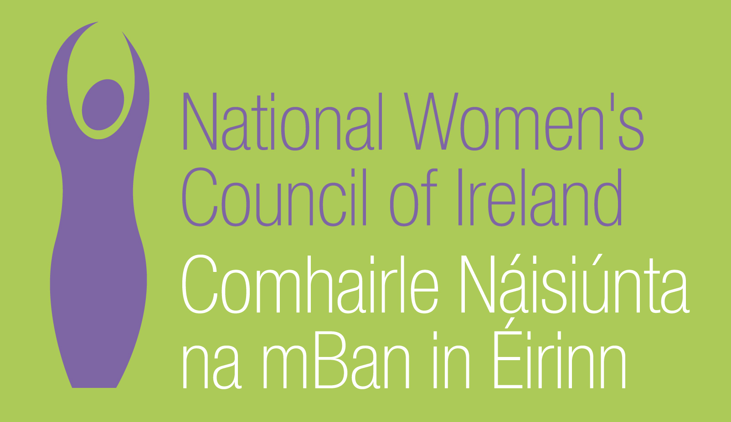

Application Form for the Post of
Women in Leadership Officer

In order to be considered for the post of Women in Leadership Officer
with the National Women’s Council of Ireland, candidates must submit this completed application form, before 5pm on 13th January 2017. 3 Copies of application should be submitted in hardcopy marked ‘Private & Confidential’ to:
Anne Gibney, Head of Finance and Operations, National Women’s Council of Ireland, 100 North King Street, Dublin 7
Please note a CV is not required, and should not be submitted.

Selection will be based on the information in the application form alone and CVs will not be considered.
PERSONAL DETAILS

NAME:
ADDRESS:

________________________________________
TELEPHONE: ________________________________________
EMAIL: ________________________________________

RELEVANT EDUCATION AND TRAINING HISTORY
A relevant third level degree or equivalent third level qualification:

PRESENT (or if unemployed most recent) EMPLOYMENT – This post requires at least 3 years’ experience in a similar role in a Non-Governmental Organisation (NGO) or other relevant sector

Name and Address of employer

Post held:

Duties of Post:

Date Appointed: ___________Present salary: ___________Period of notice: ________

PREVIOUS WORK EXPERIENCE
Please list, starting with the latest, any relevant previous positions you have held, with a brief description of duties and dates.
Employer:

Post held:

Period of Employment:

Reason for leaving:

Salary on leaving:

Employer:

Post held:

Period of Employment:

Reason for leaving:

Salary on leaving:

Employer:

Post held:

Period of Employment:

Reason for leaving:

Salary on leaving:

RELEVANT COMPETENCIES FOR THE POST
The job description shows qualifications, experience and skills required or desirable to be able to carry out the responsibilities of this post. Please therefore address all these elements as listed in table below, drawing upon all of your experience, whether in paid employment or in a voluntary capacity. Please add additional space as necessary

PROFESSIONAL KNOWLEDGE EXPERIENCE AND SKILLS – Please limit each answer to no more than 200 words
A Clear feminist and social justice analysis and understanding of women’s inequality

Experience of promoting an organisation to a diverse audience

Experience of policy development

Experience of working to increase women’s participation in public life

Ability to build relationships and strategic alliances

Excellent communication skills, both written and verbal

Ability to analyse the external environment as it relates to gender, equality, the NGO sector, and political economic and social environment

Ability to represent the NWCI in policy making fora

Ability to develop creative approaches to delivering change

PLEASE DESCRIBE IN 200-300 WORDS WHY YOU ARE A GOOD FIT FOR THIS POSITION

REFEREES
Please give the names, addresses and phone numbers of two referees (one should be a current or most recent employer):

DECLARATION I declare that the information set forth in this application form is, to the best of my knowledge, true and complete.

Signature:

Date:

This position is for 4 days a week based in Dublin. Contract is for a period of one year

Candidates should note that salary will not be subject to negotiation. Successful candidate will commence on first point of the scale.
Salary Scale: Officer

Point 1 37,000 Point 2 38,000 Point 3 39,000 Point 4 40,000 Point 5 41,000 Point 6 42,000 Point 7 43,000 Point 8 44,000 Point 9 45,000

The closing date for completed and signed application forms is 5pm on 13th January 2017. Late applications will not be reviewed.
Interviews will take place on 31st January 2017

