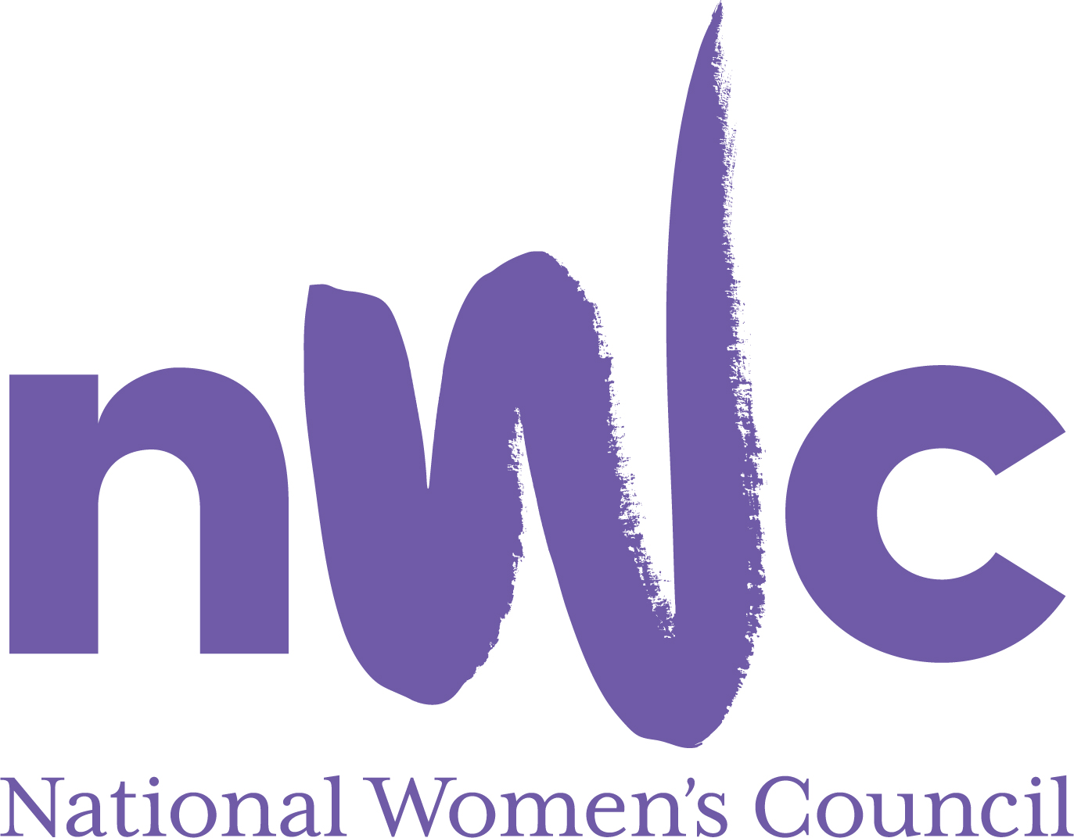

Application Form for the Post of

Head of Development & Policy
In order to be considered for the post of Head of Development & Policy with the National Women’s Council (NWC), candidates must submit this completed application form to be received by midnight 7th May 2023

Please send your completed form to Susan McCormack, susanmcc@nwci.ie

Please note a CV is not required and will not be accepted as a substitute for a completed application form.
This is a 5 day a week position offered on an initial fixed term 12-month contract, based in Dublin, 2 days a week. We work a hybrid model with Tuesdays and Wednesdays from the office and maybe more days if the role requires and the rest of the week working remotely.
The salary for this position will be €54,325. The closing date for receipt of completed and signed application form is midnight on 7th May 2023. Late applications will not be reviewed. Interviews will take place on the week beginning 15th May
NWC is an equal opportunities employer and welcomes applications from all interested parties including people from diverse backgrounds and under-represented groups including ethnic minority groups and people with disabilities. NWC offers a number of flexible working arrangements.
Selection will be based on the information in the application form alone.
PERSONAL DETAILS

NAME:
ADDRESS:

___________________________________________
TELEPHONE:
EMAIL: _________________

RELEVANT EDUCATION AND TRAINING HISTORY
A relevant third level degree in social policy, management, or related area, or equivalent third level qualification:

PRESENT (or if unemployed most recent) EMPLOYMENT (This post requires a minimum of 5 years’ experience in a senior management role in a Non-Governmental Organisation or other relevant sector)
Name and Address
of employer
Post held:
Duties of Post:
Date Appointed: __________________
Period of notice required to give if still employed here: ___________________

PREVIOUS WORK EXPERIENCE
Please list, starting with the latest, any previous relevant positions you have held, with a brief description of duties and dates.
Employer:
Post held:
Period of Employment:
Employer:
Post held:
Period of Employment:
Employer:
Post held:
Period of Employment:
RELEVANT COMPETENCIES FOR THE POST
The job description shows qualifications, experience and skills required or desirable to be able to carry out the responsibilities of this post. Please therefore address all these elements as listed in table below, drawing upon all of your experience, whether in paid employment or in a voluntary capacity. Please add additional space as necessary

PROFESSIONAL KNOWLEDGE EXPERIENCE AND SKILLS – Please limit each answer to no more than 200 words

A Clear feminist and social justice analysis, understanding of the inequalities women experience, the Irish political system and civil society landscape

Extensive experience of working with statutory bodies and a diversity of sectors for the purpose of campaigning, influencing, and shaping of Irish government policy and legislation.

Strategic Planning and organisational development at a senior level

Ability to Identify opportunities for cross collaboration and new opportunities to further NWC goals

Ability to represent the NWC in policy making fora at local, national, and international levels and in the media.

Proven ability to manage people at a senior level and support the prioritisation of objectives ensuring a high level of accountability and empowerment.

Experience of Identifying and developing income generation opportunities, compiling, and submitting funding applications with staff team

Excellent communication and writing skills including ability to communicate complex policy issues in a clear and accessible manner.

Excellent IT skills, social media tools and website and the willingness to learn new technologies.

Ability to work independently, prioritise workload in a fast-paced environment and within competing deadlines.

Ability to develop creative and participative approaches to delivering change

Flexibility and initiative

PLEASE DESCRIBE IN 200-300 WORDS WHY YOU ARE A GOOD FIT FOR THIS POSITION

REFEREES
Please give the names, addresses and phone numbers of two referees (one should be a current or most recent employer):

DECLARATION I declare that the information set forth in this application form is, to the best of my knowledge, true and complete.

Signature:

Date:

