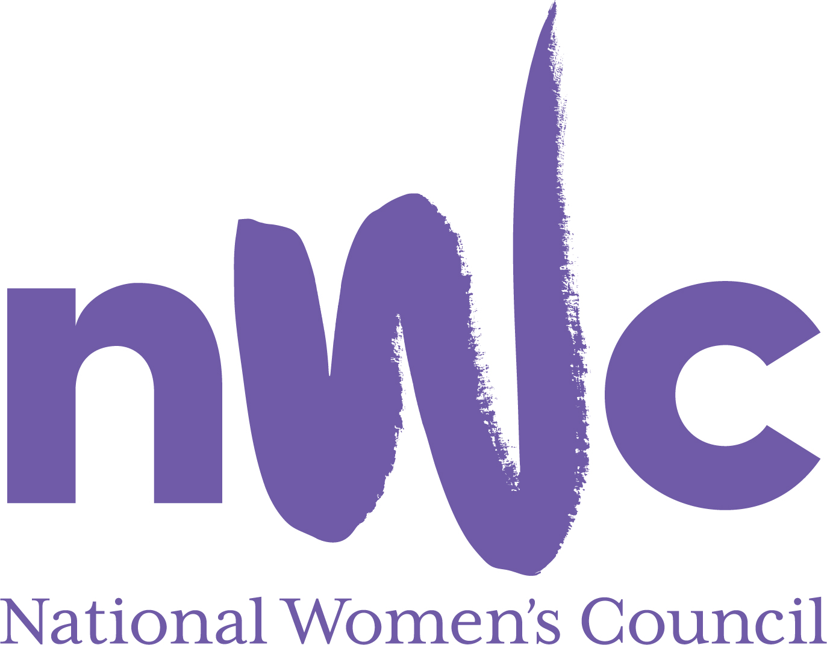

Application Form for the Post of

Head of Mobilisation and Campaigns

In order to be considered for the post of Head of Mobilisation and Campaigns with the National Women’s Council (NWC), candidates must submit this completed application form to be received by midnight 19th July 2021.

Please send your completed form to Susan McCormack, susanmcc@nwci.ie

Please note a CV is not required and should not be submitted.
NWCI is an equal opportunities employer and welcomes applications from all interested parties including people from diverse backgrounds and under-represented groups including ethnic minority groups and people with disabilities. NWCI offers a number of flexible working arrangements.
Selection will be based on the information in the application form alone.
PERSONAL DETAILS

NAME:
ADDRESS:

___________________________________________
TELEPHONE:
EMAIL: _________________

RELEVANT EDUCATION AND TRAINING HISTORY
A relevant third level degree or equivalent third level qualification:

PRESENT (or if unemployed most recent) EMPLOYMENT (This post requires a minimum of 5 years’ relevant experience)
Name and Address
of employer
Post held:
Duties of Post:
Date Appointed: __________________ Period of notice: ________

PREVIOUS WORK EXPERIENCE
Please list, starting with the latest, any previous relevant positions you have held, with a brief description of duties and dates.
Employer:
Post held:
Period of Employment:
Reason for leaving:
Employer:
Post held:
Period of Employment:
Reason for leaving:
Employer:
Post held:
Period of Employment:
Reason for leaving:

RELEVANT COMPETENCIES FOR THE POST
The job description shows qualifications, experience and skills required or desirable to be able to carry out the responsibilities of this post. Please therefore address all these elements as listed in table below, drawing upon all of your experience, whether in paid employment or in a voluntary capacity. Please add additional space as necessary

PROFESSIONAL KNOWLEDGE EXPERIENCE AND SKILLS
PROFESSIONAL KNOWLEDGE EXPERIENCE AND SKILLS – Please limit each answer to no more than 200 words

A Clear feminist and social justice analysis, understanding of the inequalities women experience, the Irish political system and civil society landscape

Delivering large scale national campaigns, achieving desired targets and reporting on impact

Mobilising and collaborating with diverse organisations, individuals and sectors to achieve common goals

Strategic planning and organisational development

Communicating on and offline to diverse audiences for the purposes of engaging and driving impact.

Ability to lead teams, manage others and support the prioritisation of objectives in a fast-paced environment within competing deadlines

Excellent communication and writing skills including ability to communicate complex policy issues in a clear and accessible manner.

Excellent IT skills, including using Content Management Systems, email marketing systems, social media tools and website and the willingness to learn new technologies.

Ability to represent the NWC in policy making fora at national and international levels

Ability to develop creative and participative approaches to delivering change

Negotiation, conflict management and facilitation

Flexibility and initiative

PLEASE DESCRIBE IN 200-300 WORDS WHY YOU ARE A GOOD FIT FOR THIS POSITION

REFEREES
Please give the names, addresses and phone numbers of two referees (one should be a current or most recent employer):

DECLARATION I declare that the information set forth in this application form is, to the best of my knowledge, true and complete.

Signature:

Date:

This is a 4 day a week position offered on an initial fixed term 12-month contract, based in Dublin. Due to Covid restrictions we are working from home until further notice.
Candidates should note that salary will not be subject to negotiation. Successful candidate will commence on first point of the scale. The salary for this position will be €53,000 being €42,400 for 4 days p.w.
The closing date for receipt of completed and signed application form is midnight 19th July 2021.
Late applications will not be reviewed. Interviews will take place on the week beginning 26th July 2021

