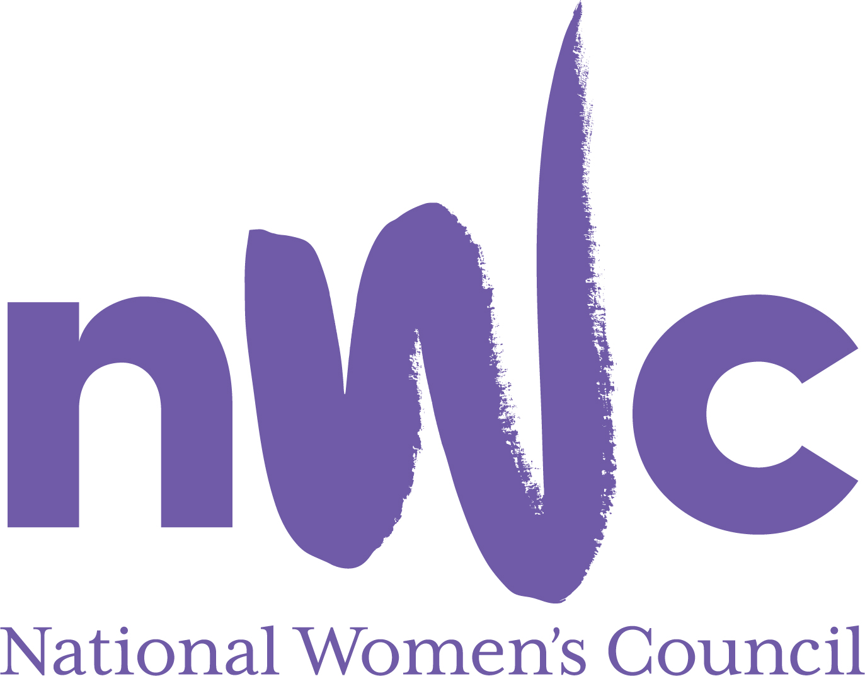

Application Form for the Post of

Violence Against Women Officer

In order to be considered for the post of Violence Against Women Officer with the National Women’s Council (NWC), candidates must submit this completed application form to be received by midnight XXXX

Please send your completed form to Susan McCormack, susanmcc@nwci.ie

Please note a CV is not required and should not be submitted.
This is a 4 day a week position offered on an initial fixed term 12-month contract, based in Dublin 2 days a week. We work a hybrid model with Tuesdays and Wednesdays from the office and maybe more days if the role requires and the rest of the week working remotely.
The salary for this position will be €30,340
The closing date for receipt of completed and signed application form is midnight 24TH May 2023
Late applications will not be reviewed.
Interviews will take place online on 2nd June 2023

NWC is an equal opportunities employer and welcomes applications from all interested parties including people from diverse backgrounds and under-represented groups including ethnic minority groups and people with disabilities. NWC offers a number of flexible working arrangements.
Selection will be based on the information in the application form alone.
PERSONAL DETAILS

NAME:
ADDRESS:

___________________________________________
TELEPHONE:
EMAIL: _________________

RELEVANT EDUCATION AND TRAINING HISTORY
A relevant third level degree in social policy or related area, or equivalent third level qualification:

PRESENT (or if unemployed most recent) EMPLOYMENT (This post requires a minimum of 2 years’ experience in a similar role in a Non-Governmental Organisation or other relevant sector)
Name and Address
of employer
Post held:
Duties of Post:
Date Appointed: __________________
Period of notice required to give if still employed here: ___________________

PREVIOUS WORK EXPERIENCE
Please list, starting with the latest, any previous relevant positions you have held, with a brief description of duties and dates.
Employer:
Post held:
Period of Employment:
Reason for leaving:
Employer:
Post held:
Period of Employment:
Reason for leaving:
Employer:
Post held:
Period of Employment:
Reason for leaving:

RELEVANT COMPETENCIES FOR THE POST
The job description shows qualifications, experience and skills required or desirable to be able to carry out the responsibilities of this post. Please therefore address all these elements as listed in table below, drawing upon all of your experience, whether in paid employment or in a voluntary capacity. Please add additional space as necessary

PROFESSIONAL KNOWLEDGE EXPERIENCE AND SKILLS
PROFESSIONAL KNOWLEDGE EXPERIENCE AND SKILLS – Please limit each answer to no more than 200 words

A Clear understanding of and commitment to a feminist ethos

A clear understanding of gender-based violence and violence against women in all its forms

Demonstrable knowledge and understanding of the Istanbul convention

Experience of preparing policy papers, submissions, presentations, briefings and information materials on VAW

Ability to represent the NWC in policy making fora at local, national and international levels and in the media.

Demonstrable experience of policy development and advocacy work with government and institutions

Excellent communication and writing skills including ability to communicate complex policy issues in a clear and accessible manner.

Excellent IT skills, social media tools and website and the willingness to learn new technologies

Programme/project management experience

PLEASE DESCRIBE IN 200-300 WORDS WHY YOU ARE A GOOD FIT FOR THIS POSITION

REFEREES
Please give the names, addresses and phone numbers of two referees (one should be a current or most recent employer):

DECLARATION I declare that the information set forth in this application form is, to the best of my knowledge, true and complete.

Signature:

Date:

