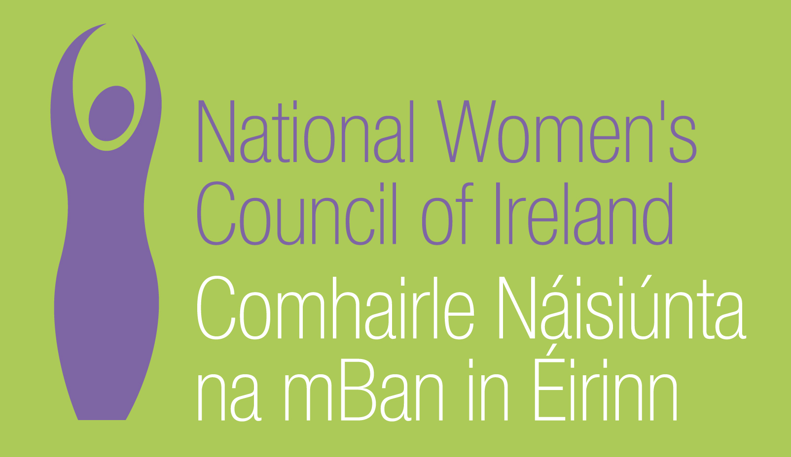

Application Form for the Post of
Head of Policy

In order to be considered for the post of Head of Policy with the National Women’s Council of Ireland, candidates must submit this completed application form to be received before new extended deadline, 20th October. 3 signed copies of application should be submitted in hardcopy marked ‘Private & Confidential’ to:
Anne Gibney, Head of Finance and Operations, National Women’s Council of Ireland, 100 North King Street, Dublin 7
Please note a CV is not required, and should not be submitted.

Selection will be based on the information in the application form alone and CVs will not be considered.
PERSONAL DETAILS

NAME:
ADDRESS:

________________________________________
TELEPHONE: ________________________________________
EMAIL: ________________________________________

RELEVANT EDUCATION AND TRAINING HISTORY
A relevant third level degree or equivalent third level qualification in social policy, management or related area

PRESENT (or if unemployed most recent) EMPLOYMENT – This post requires at least 3-5 years’ experience in a Senior Management role in a Non-Governmental Organisation (NGO) or other relevant sector
Name and Address of employer
Post held:
Duties of Post:

Date Appointed: ___________Period of notice: ________

PREVIOUS WORK EXPERIENCE
Please list, starting with the latest, any relevant previous positions you have held, with a brief description of duties and dates.
Employer:
Post held:
Period of Employment:
Reason for leaving:

Employer:
Post held:
Period of Employment:
Reason for leaving:

Employer:
Post held:
Period of Employment:
Reason for leaving:

RELEVANT COMPETENCIES FOR THE POST
The job description shows qualifications, experience and skills required or desirable to be able to carry out the responsibilities of this post. Please therefore address all these elements as listed in table below, drawing upon all of your experience, whether in paid employment or in a voluntary capacity. Please add additional space as necessary

PROFESSIONAL KNOWLEDGE EXPERIENCE AND SKILLS – Please limit each answer to no more than 200 words
Proven ability to develop & manage high performance teams

Experience in Strategic planning and organisational development

Extensive experience of working with statutory or regulatory bodies with the ability to influence the shaping of Irish government policy.

Excellent communication skills, both written and verbal, and ability to build relationships / strategic alliances

Knowledge and understanding of feminism and intersectional approach to women’s equality issues

Experience in developing and writing funding submissions at national and EU levels for large scale projects

Strong policy development and analysis

PLEASE DESCRIBE IN 200-300 WORDS WHY YOU ARE A GOOD FIT FOR THIS POSITION

REFEREES
Please give the names, addresses and phone numbers of two referees (one should be a current or most recent employer):

DECLARATION I declare that the information set forth in this application form is, to the best of my knowledge, true and complete.

Signature:

Date:

This position is for 5 days a week based in Dublin. Contract is initially for a period of one year

Candidates should note that salary will not be subject to negotiation. Successful candidate will commence on first point of the scale. Salary for 5 days a week is €53,000
Salary Scale: Head of:
Point 1: €53,000, Point 2: €54,000, Point 3: €55,000, Point 4: €56,000, Point 5 €57,000, Point 6 €58,000, After 3 yr. gap €61,000, After 6 yr. gap €64,000

The closing date for receipt of completed and signed application form is 5pm 20th October 2017
Late applications will not be reviewed.
Interviews will take place on week commencing 6th November 2017

