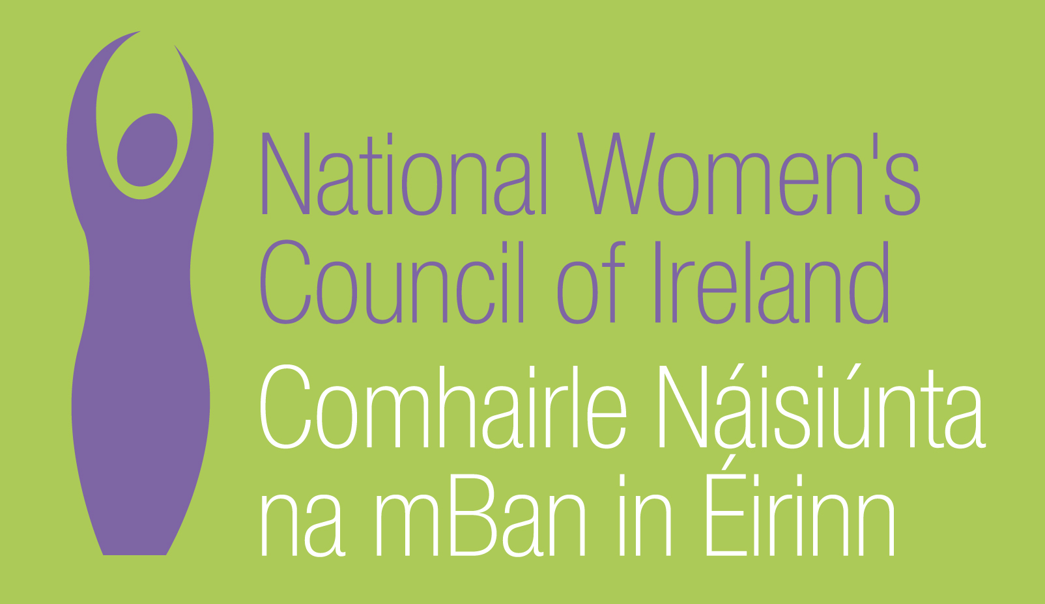

NWCI Application Form for the Post of
Communications Assistant

In order to be considered for the post of Communications Assistant with the National Women’s Council of Ireland (NWCI) candidates must submit this completed application form, to be received by 5pm on Monday, 31 July 2017. 3 Copies of application should be submitted in hardcopy marked ‘Private & Confidential’ to: Anne Gibney, Head of Finance and Operations, National Women’s Council of Ireland, 100 North King Street, Smithfield, Dublin 7
Selection will be based on the information in the application form alone and CVs will not be considered.
PERSONAL DETAILS

NAME:
ADDRESS:

________________________________________
TELEPHONE: ________________________________________
EMAIL: ________________________________________

RELEVANT EDUCATION AND TRAINING HISTORY
A relevant third level degree or equivalent third level qualification:

PRESENT (or if unemployed most recent) EMPLOYMENT – This post requires at least 1 year experience in a similar role
Name and Address of employer

Post held:

Duties of Post:

Date Appointed: ___________Present salary: ___________Period of notice: ________

PREVIOUS WORK EXPERIENCE
Please list, starting with the latest, any relevant previous positions you have held, with a brief description of duties and dates.
Employer:

Post held:

Period of Employment:

Reason for leaving:

Salary on leaving:
Employer:

Post held:

Period of Employment:

Reason for leaving:

Salary on leaving:
Employer:

Post held:

Period of Employment:

Reason for leaving:

Salary on leaving:

RELEVANT COMPETENCIES FOR THE POST
The job description shows qualifications, experience and skills required or desirable to be able to carry out the responsibilities of this post. Please therefore address all these elements as listed in table below, drawing upon all of your experience, whether in paid employment or in a voluntary capacity. Please add additional space as necessary

PROFESSIONAL KNOWLEDGE EXPERIENCE AND SKILLS – Please limit each answer to no more than 200 words

Excellent oral and written communications skills

Experience in working with social media

Eye for detail

Good organisational skills

Good IT skills

Any additional information you would like to give in relation to desirable skills and experience as outlined in job description

PLEASE DESCRIBE IN 200-300 WORDS WHY YOU ARE A GOOD FIT FOR THIS POSITION

REFEREES
Please give the names, addresses and phone numbers of two referees (one should be a current or most recent employer):

DECLARATION I declare that the information set forth in this application form is, to the best of my knowledge, true and complete.

Signature:

Date:

This is a temporary, part- time position (6 months), based in Dublin. The contract might be extended, subject to funding.
Salary: Assistant - 28,000 Euros/pro rata (3 days). Candidates should note that salary will not be subject to negotiation.
The closing date for receipt of completed and signed application forms is 5pm on Monday, 31 July 2017. Late applications will not be reviewed. Interviews are scheduled to take place on 16/17 August 2017.

