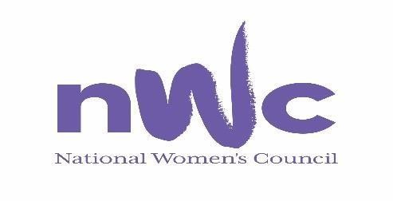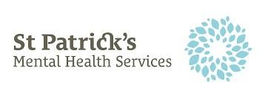
What is the Women’s Mental Health Network?
The Women’s Mental Health Network (WMHN) is a network of people and organisations with a committed interest in women’s mental health issues. The WMHN is co-convened by St Patrick’s Mental Health Services and the National Women’s Council.
What will the network offer?
- An information-providing and information-sharing webpage, initially hosted on both NWCI and SPMHS websites
- A mailing list to provide members with updates
- Networking events hosted collaboratively by SPMHS and NWCI

How do I become a member?

To become a member of the Network we ask that you:
- read the terms of reference and the key principles below, and
- confirm by email to fayw@nwci.ie that you would like to join.

You can withdraw your membership at any stage by just letting us know via email to the same address.

Terms of Reference

Purpose
To develop a national network of people and organisations with a committed interest in women’s mental health issues.
The network will have the following aims:
- To provide a forum for information-sharing and networking among interested parties.
- To advance interdisciplinary and multi-agency collaboration to progress shared aims and goals in the promotion of women’s mental health issues.

Scope
The network is intended as a networking and collaborative forum for parties interested in women’s mental health issues. Key issues which may fall under this purview include:
- Gender-sensitive healthcare
- Trauma-informed care
- Gender-based violence
- Perinatal and postnatal mental health
- Mental health across the lifespan
- Addiction and dual diagnosis
- Mental health needs of marginalised women
- Mental health of healthcare workers
- Impacting socioeconomic factors
- Access and information needs
- Stigma
The network is not intended as a forum for advertising of a corporate nature, for lobbying purposes, or as a representative body.

Network functions and activities will include:
- An information-providing and information-sharing webpage, hosted on both NWC and SPMHS websites
- A mailing list to provide members with updates and newsletters
- Networking events hosted collaboratively by SPMHS and NWCI

Roles
The network may require the following governing roles – Chair, Secretary, Membership Coordinator, Communications Coordinator. The Chair will sit in the first instance with a founding member from SPMHS. The other roles may be filled by nominated individuals from amongst the other founding members in the first instance, and where vacancies remain expressions of interest may be sought within the membership.

Membership
Membership is open to any individual or organisation who:
- shares a common understanding of the underlying principles of the network’s Key Principles statement, and
- whose role or involvement with women’s mental health issues aligns with these principles.

Membership is free and can be withdrawn by members at any stage. A list of members with their contact details will be retained by both NWC and SPMHS founding members. Information for members will be available on a corresponding webpage on both the SPMHS and NWC websites.

Resources
SPMHS and NWC will provide necessary resources that arise including meeting or networking spaces and communications support. The network is intended as a low-cost endeavour and where costs arise a shared budget will be agreed, for example catering for networking events.

Review
These terms of reference will be reviewed on a 2-yearly basis via meeting or teleconference, unless more urgent needs arise.

Next review date: January 2023

Key Principles
The Women’s Mental Health Network values the following principles as fundamental to its ethos, and holds a common understanding and agreement of these principles as the basis for participation:

- While women and men experience mental health difficulties to equal degrees, there are important differences as regards needs, experiences and causative factors. Awareness and responsiveness to these differences will improve effectiveness of services and health outcomes.

- Gender inequalities have a powerful impact on mental health and wellbeing. Issues related to women’s mental health cannot be considered without acknowledging the relevance of the socioeconomic and socio-cultural contexts within which women live.

- Gender-based violence and mental health difficulties are fundamentally linked, and mental health services have a key role to play in tackling and eliminating gender-based violence.

- The right to enjoy the highest attainable level of mental health is a human right. Everyone should have access to good mental health services as a basic right.

- Mental health policy, strategy, and services should be grounded in human rights, and developed in consultation with the people in need of or accessing mental health services.

- Collaboration and cooperation amongst different voices and sectors working in relation to women’s mental health issues is positive and necessary to promote and enable positive change and progress.

For further information and queries please contact:

fayw@nwci.ie
Fay White
Women’s Health Officer
National Women’s Council

